Shams University

Faculty of Engineering

Operating system

Assignment

Submitted by: Mohamed Ahmed Ali Ismail

B.N:33805

Section: 2

Project Support:

1-Memory Allocate with Methods:

1. First Fit.
2. Best Fit.
3. Worst Fit.

2-Memory Deallocate

3-Show The current Process in the Memory.

First Fit Method :

1-Run The Exe.file

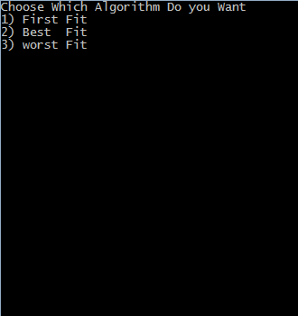

2- Enter Number “1”

3-Enter The Number of Processes you want to Allocate

4-Enter The Number of the Holes and the address and the size of each Hole

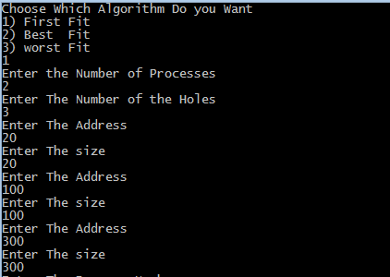

5-Enter The Process Number (additional) and its size .

6- Then the state of The Memory will be occur .

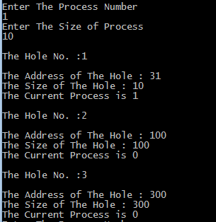

7- Then Enter The Next Process

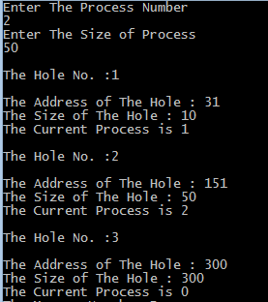

8-After That The Memory will show the current Process in it



9-Then You asked to Deallocate The Process you Want just enter the Process Number

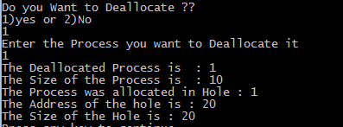

Best Fit Method :

1-Run The Exe.file



2- Enter Number “2”

3-Enter The Number of Processes you want to Allocate

4-Enter The Number of the Holes and the address and the size of each Hole

5-Enter The Process Number (additional) and its size .

6- Then the state of The Memory will be occur .

7- Then Enter The Next Process

8-After That The Memory will show the current Process in it

9-Then You asked to Deallocate The Process you Want just enter the Process Number

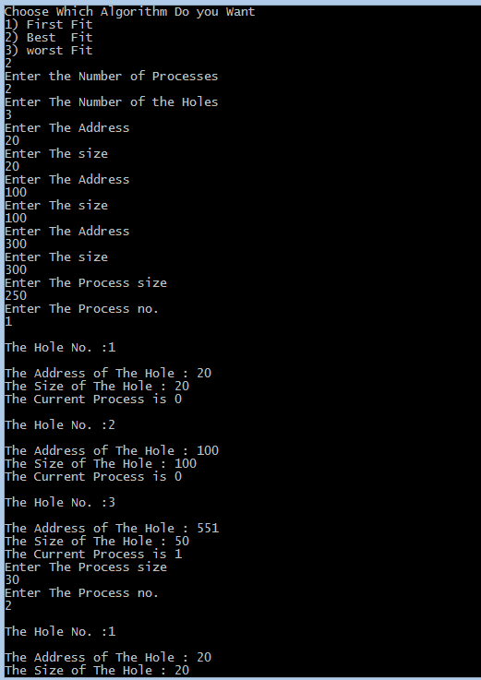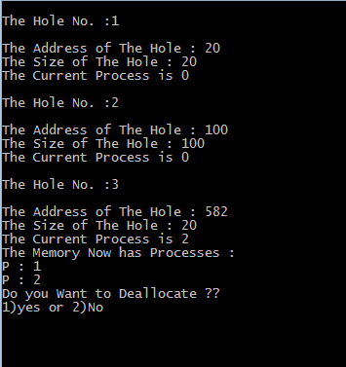

Worst Fit

1-Run The Exe.file



2- Enter Number “2”

3-Enter The Number of Processes you want to Allocate

4-Enter The Number of the Holes and the address and the size of each Hole

5-Enter The Process Number (additional) and its size .

6- Then the state of The Memory will be occur .

7- Then Enter The Next Process

8-After That The Memory will show the current Process in it

9-Then You asked to Deallocate The Process you Want just enter the Process Number

