

Elemental Balance Assessment
  - Personalised wellness guidance
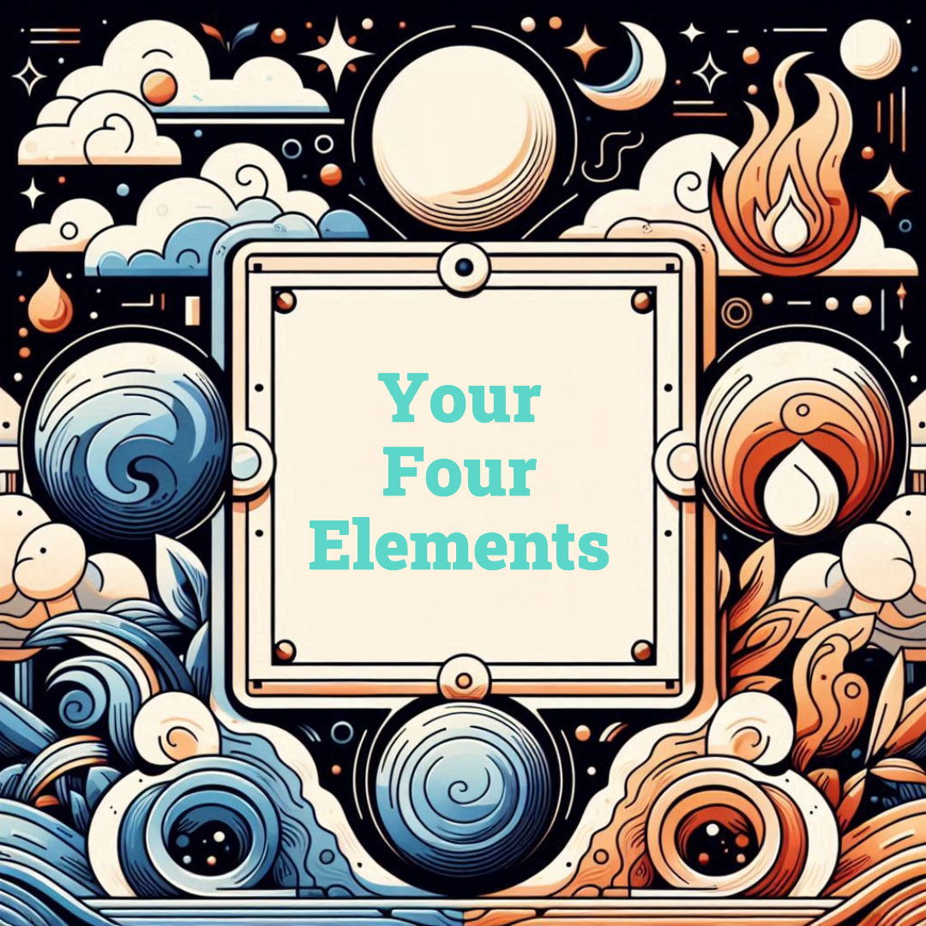
November 23, 2025
Generated for: Test User

1. Personal Details
Name: Test User
Date of Birth: 1990-01-01
Time of Birth: 12:00
Place of Birth: New York, USA
Phone: 555-0123
Email: test@example.com

2. Table of Contents
1. Personal Details
2. Elemental Analysis
3. Daily Plan
4. Elemental Quality Assessment

3. Elemental Analysis

Element Percentages
Fire: 25% Earth: 25% Air: 25% Water: 25%

Fire - 25% (Balanced)

The Transformer

Description
Fire is the element of transformation...

Scientific Correlation
Associated with metabolism...

Imbalance Effects
Burnout, inflammation...

Remedies
Diet | Cooling foods...
Lifestyle & Exercise | Swimming...
Herbal / Energy Support | Sandalwood...

Water - 36% (High)

The Feeler

Description
Water represents emotion and intuition...

4. Daily Plan

Morning
Activity | Wake up early
Breakfast | Light meal

Evening
Wind down with reading

5. Elemental Quality Assessment
The distribution on planets in the zodiacal wheel shows how we respond to stimuli, and especially how we act under tension. The presence of planets in a particular sign indicates how that sign expresses their element, meaning the mode of behavior they use to express the element needs. There are three qualities: Cardinal, Fixed, and Mutable.

Modalities Percentages
Cardinal: 33% Fixed: 33% Mutable: 34%

Cardinal - 33%
The Initiator
Description: Cardinal signs start things...
Traits: Active, ambitious

Fixed - 33%
Fixed signs stabilize...

Summary
This is a test summary of the report.

Disclaimer
This is a test disclaimer.

