# Title: Automatic call log workflow across all Android OS versions.

|  |  |  |  |  |  |  |  |  |  |
| --- | --- | --- | --- | --- | --- | --- | --- | --- | --- |
| OS Version | Call flow | OUTGOING CALL | | | | INCOMING CALL | | | |
|  |  | In-App | App in BG | App killed | App closed | In-App | App in BG | App killed | App closed |
| Lollipop | via Dialler | Pass | Pass | Pass | Pass | Pass | Pass | Pass | Pass |
|  | via Freshcaller | Pass | NA | NA | NA | NA | NA | NA | NA |
|  |  |  |  |  |  |  |  |  |  |
| Marshmallow | Via Dialler | Pass | Pass | Pass | Pass | Pass | Pass | Pass | Pass |
|  | Via Freshcaller | Pass | NA | NA | NA | NA | NA | NA | NA |
|  |  |  |  |  |  |  |  |  |  |
| Nougat | Via Dialler | Pass | Pass | Pass | Pass | Pass | Pass | Pass | Pass |
|  | Via Freshcaller | Pass | NA | NA | NA | NA | NA | NA | NA |
|  |  |  |  |  |  |  |  |  |  |
| Oreo | via Dialler | Pass | Pass | Pass | Pass | Pass | Pass | Pass | Pass |
|  | via Freshcaller | Pass | NA | NA | NA | NA | NA | NA | NA |
|  |  |  |  |  |  |  |  |  |  |
| Pie | via Dialler | Pass | Pass | Pass | Pass | Pass | Pass | Pass | Pass |
|  | via Freshcaller | Pass | NA | NA | NA | NA | NA | NA | NA |
|  |  |  |  |  |  |  |  |  |  |
| Android 10 | via Dialler | Pass | Pass | Pass | Pass | Pass | Pass | Pass | Pass |
|  | via Freshcaller | Pass | NA | NA | NA | NA | NA | NA | NA |

#### **Note**: When the app is in killed or closed state, call log pop up will be invoked for both incoming and outgoing calls. But after adding or discarding the call log the App will not be launched.

### **KNOWN LIMITATIONS**

### **Battery saver restrictions**

#### *Case 1)* **Android 6 and above → Call log prompts won't appear if the device has battery-saver ON and if Freshsales is optimised for battery usage when the app is minimized or killed**

***Case 2)* Additionally for Android 9 and above → If Freshsales is restricted for background battery usage (setting named 'Background restriction'), call log prompts won't appear when the app is minimized or killed**

For both cases, the user has to disable battery optimization for Freshsales. To do so, Freshsales has an in-app setting 'Battery optimization'.

#### Launch Freshsales app

#### Tap on the three-dot indicator on the home screen

#### Settings → Call preferences → 'Battery optimization'

1. **Redirects to a battery optimization system screen which lists all the applications which are not optimised.**
2. **User has to select 'All apps', go to Freshsales and disable battery optimization.**

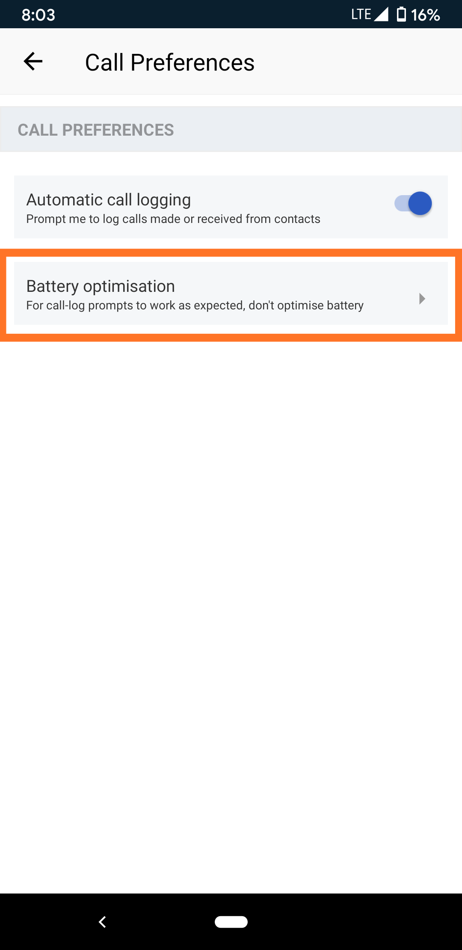          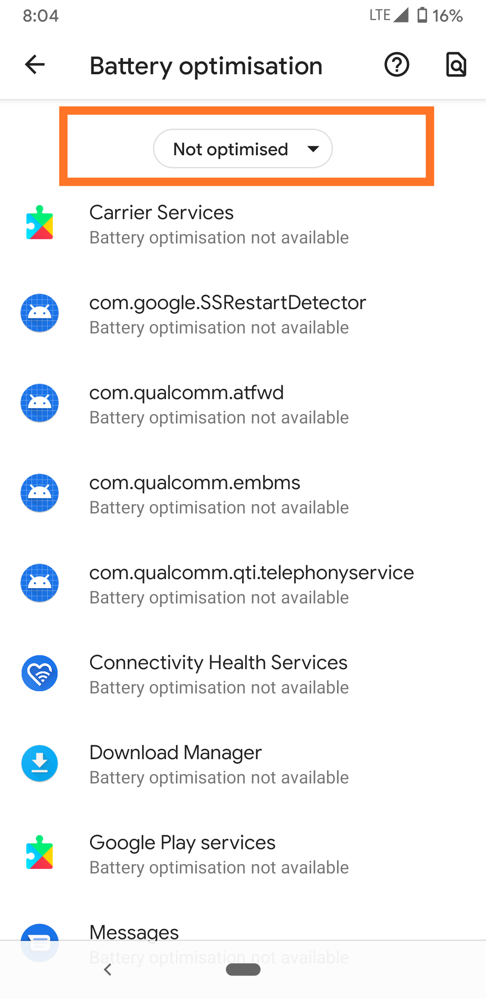          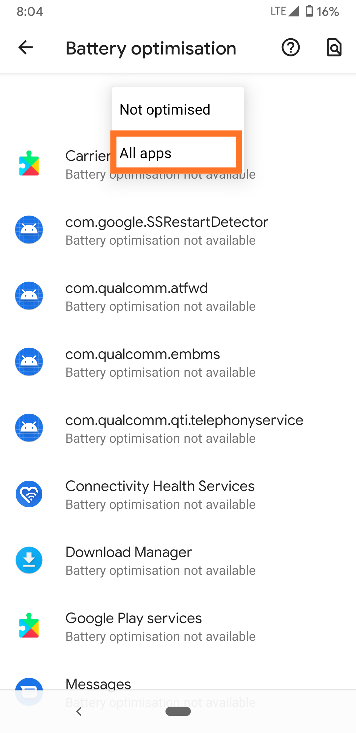       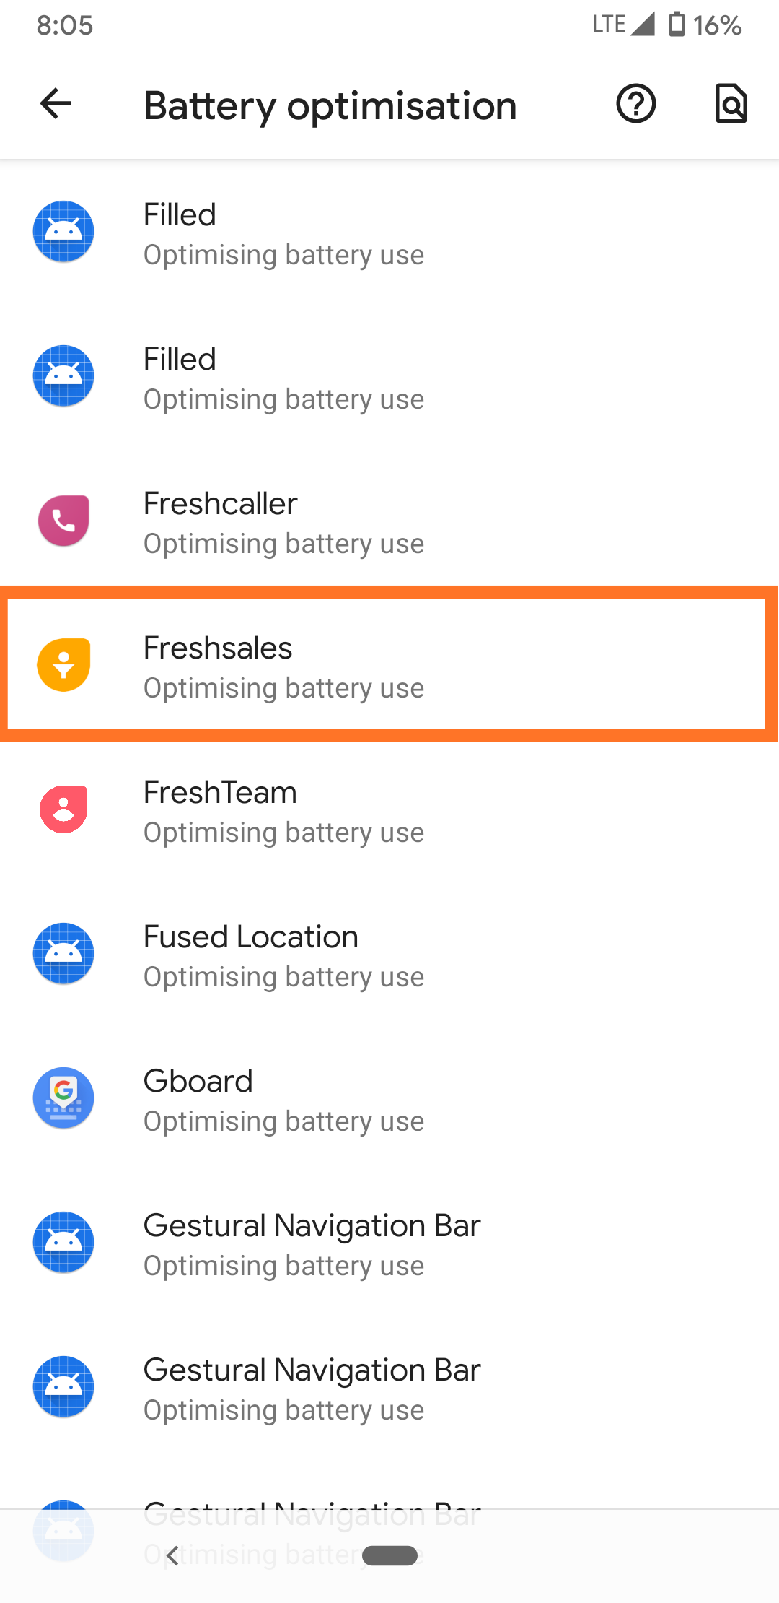       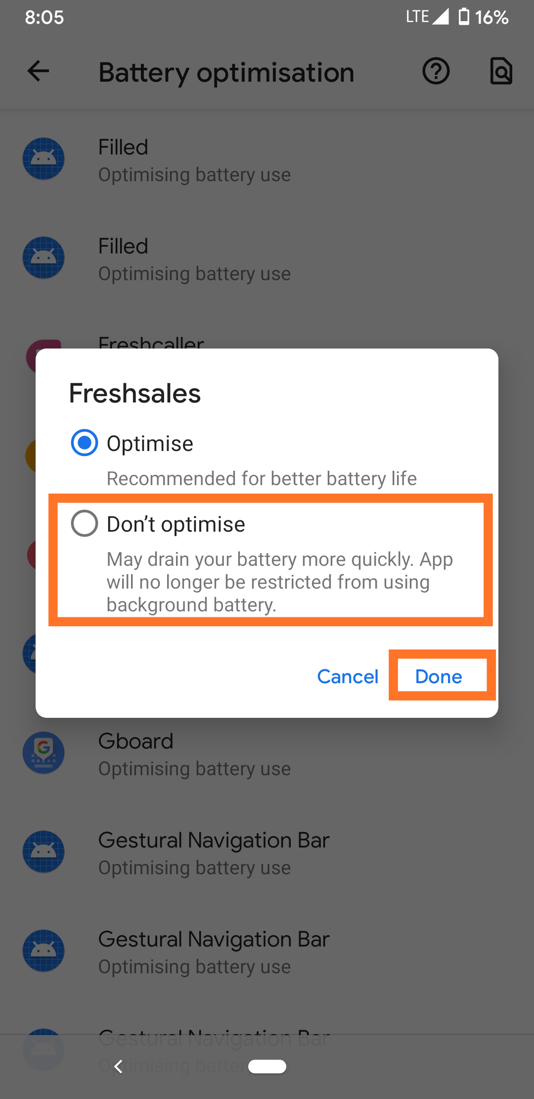

Note: For some phones, the battery optimization screen with the list of all apps will have toggles. User has to turn **OFF** battery optimization for Freshsales.

### **Autostart permission**

* **Enable the "Auto-start" setting to receive call logs when the app is killed from the recent apps (or) when the app was closed by a consecutive double back press from Freshsales home-screen**

#### Launch Freshsales app

#### Tap on the three-dot indicator on the home screen

#### Settings → Call preferences → 'Enable autostart permission'

#### Redirects to a autostart system screen shown below with all the installed applications

#### Turn on the setting for Freshsales

#### Note: Freshsales has an in-app setting only for these well-known third-party OEMs which require the autostart permission → *Xiaomi, Vivo, Oppo, Honor, Letv*

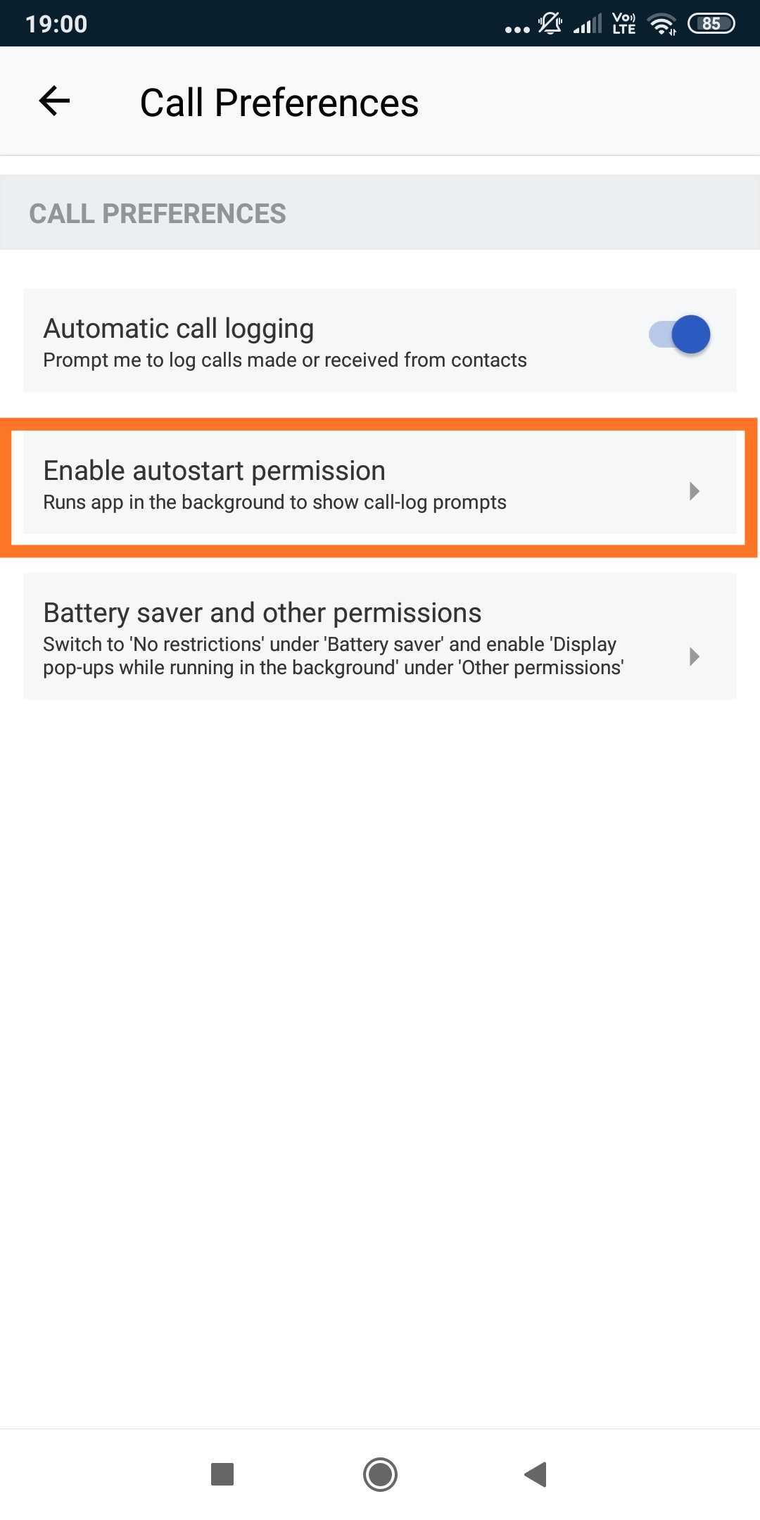                         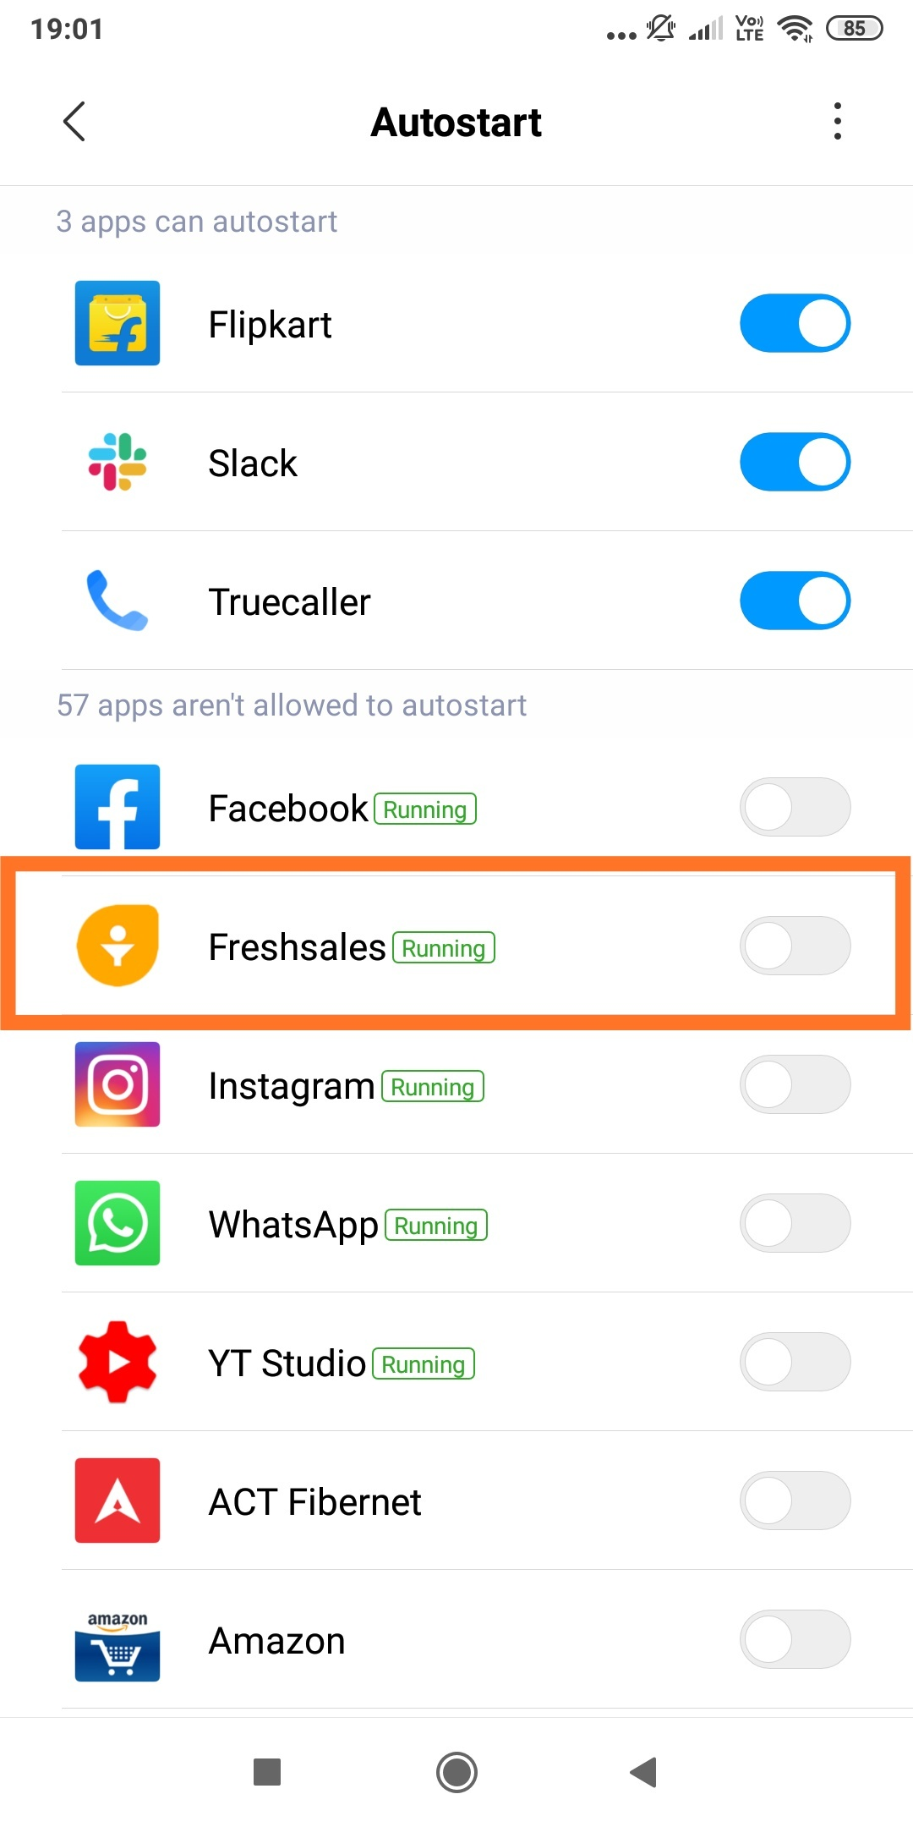

#### **Permissions specific to Xiaomi devices**

#### **Android 8**

#### Enable the "Start in Background" permission to receive call logs

#### Launch Freshsales app

#### Tap on the three-dot indicator on the home screen

#### Settings → Call preferences → 'Battery-saver and other permissions'

#### Redirects to the page shown below (App info page of Freshsales)

#### Tap on 'Other permissions and enable 'Start in background'

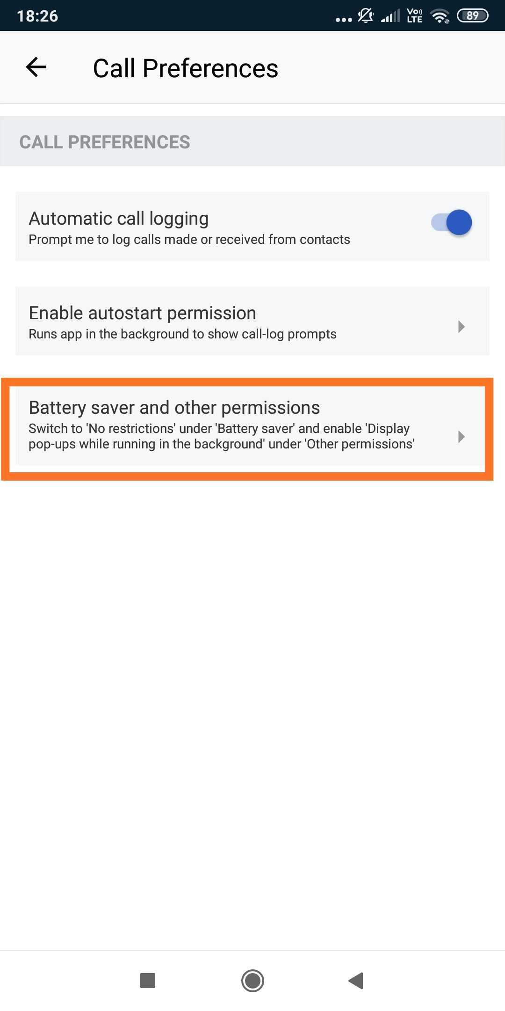                     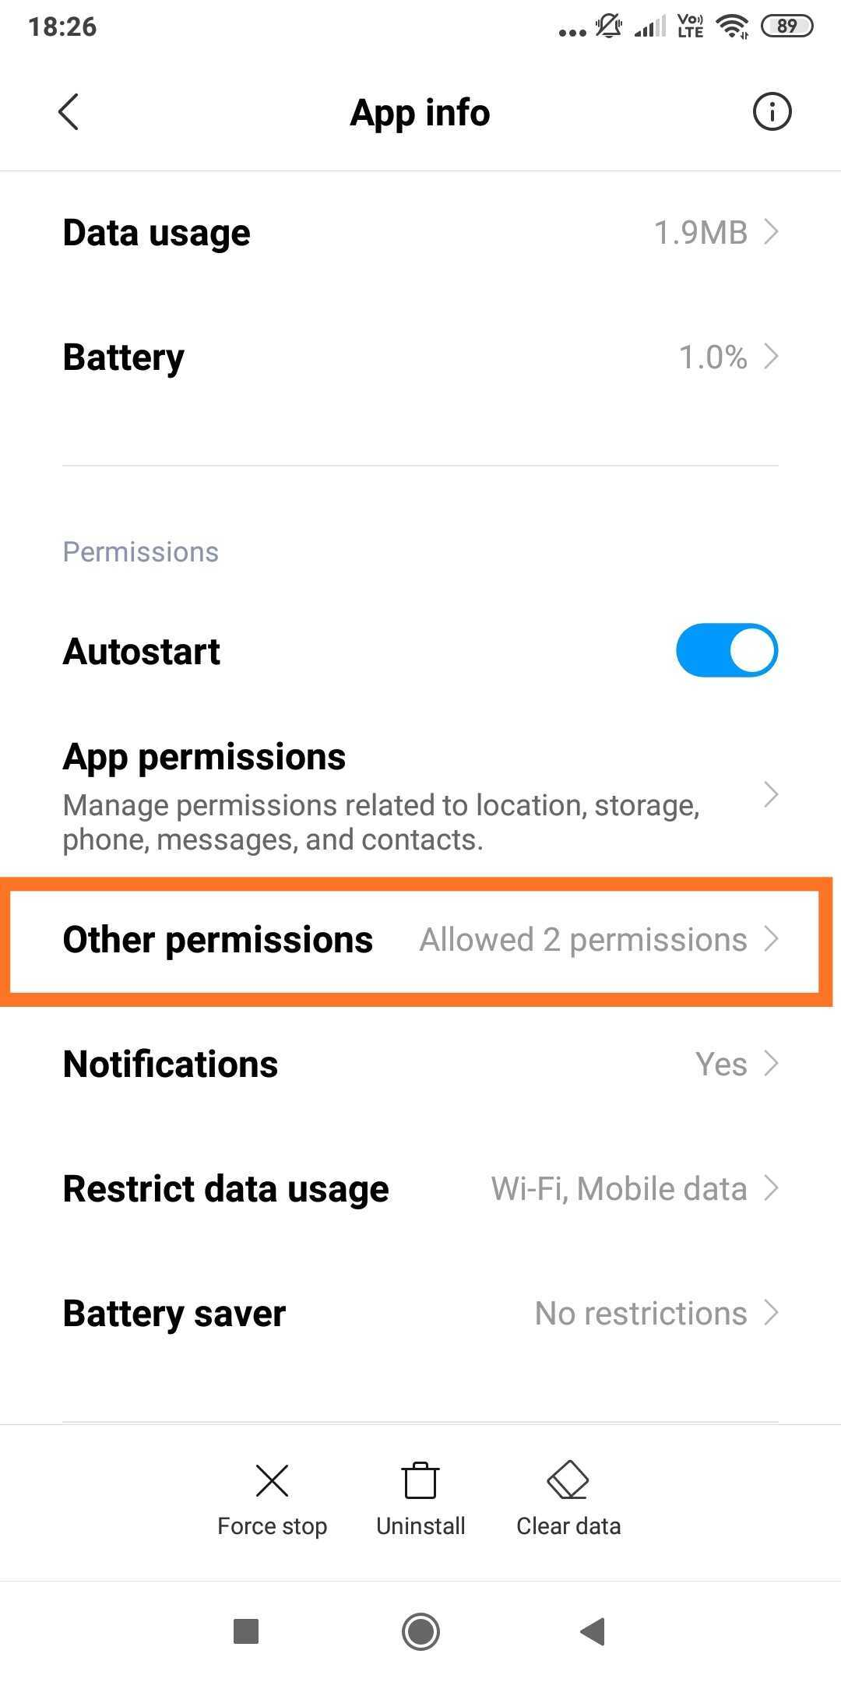                   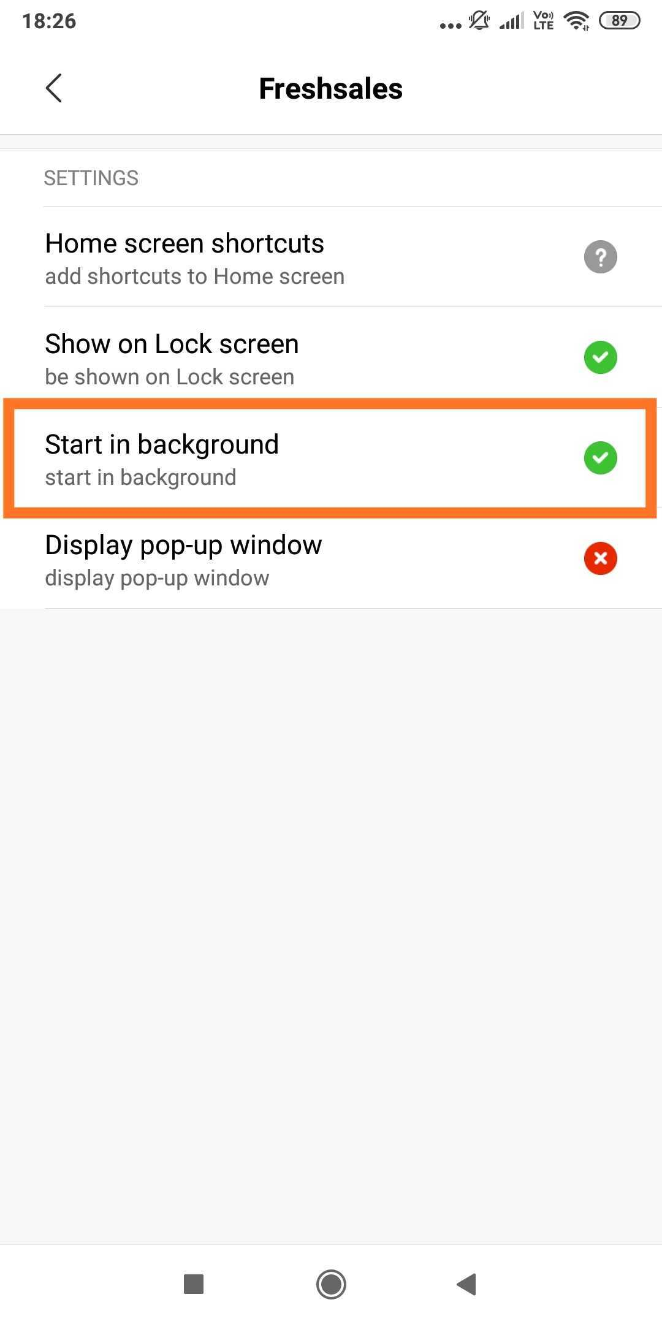

#### **Android 9**

#### Enable "Display pop-up windows while running in the background" permission to receive call logs

#### Launch Freshsales app

#### Tap on the three-dot indicator on the home screen

#### Settings → Call preferences → 'Battery-saver and other permissions'

#### Redirects to the page shown below (App info page of Freshsales)

#### Tap on 'Other permissions and enable 'Display pop-up windows while running in the background'

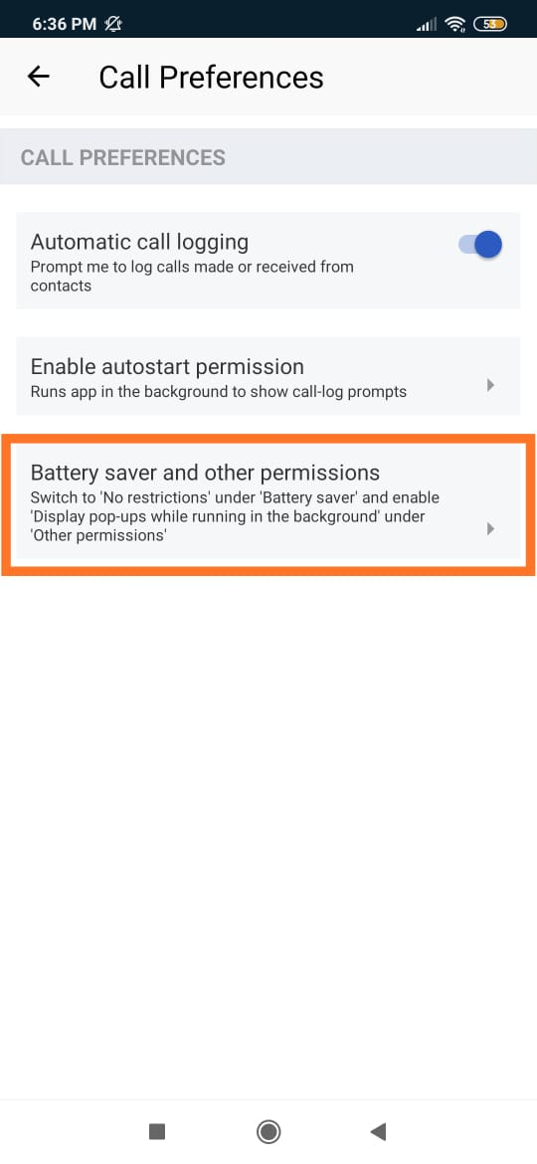                    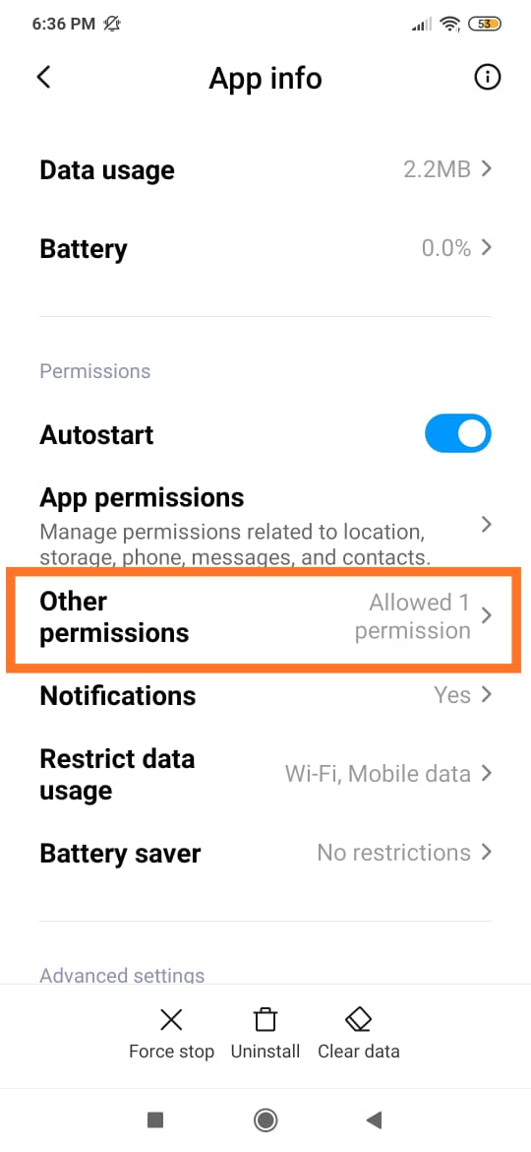                          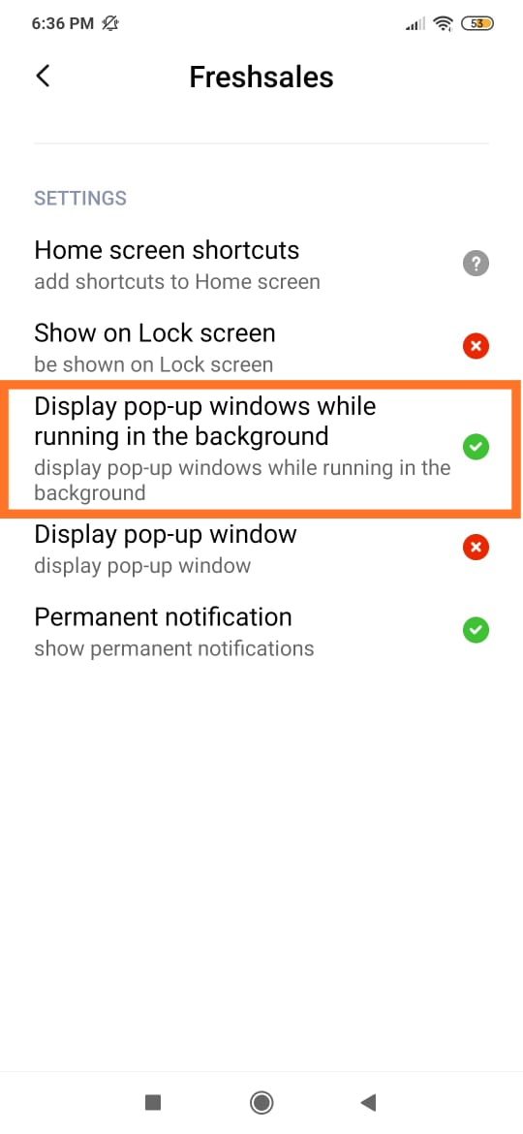

#### **Battery saver restrictions (different for Xiaomi)**

#### In the app info page of Freshsales (page in Point 4), there's a setting called 'Battery saver'.

#### Tap on 'Battery saver' and choose 'No restrictions'

                       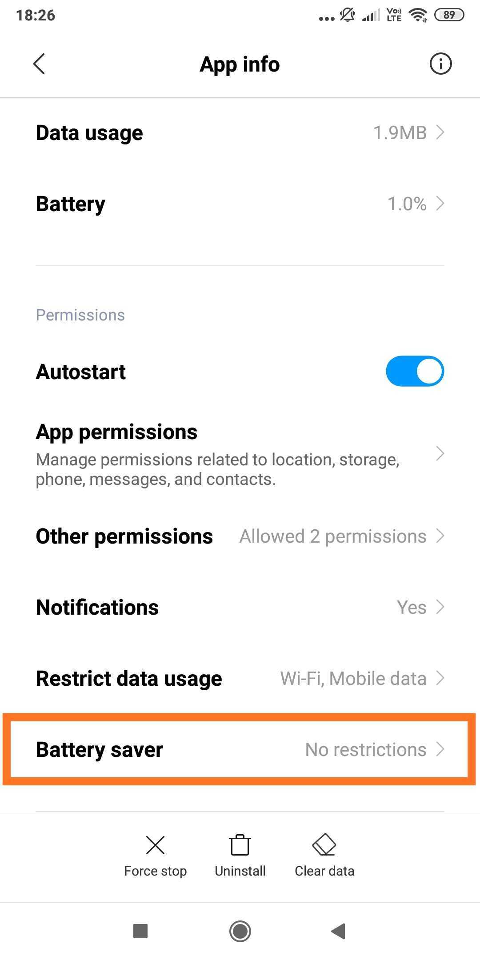                         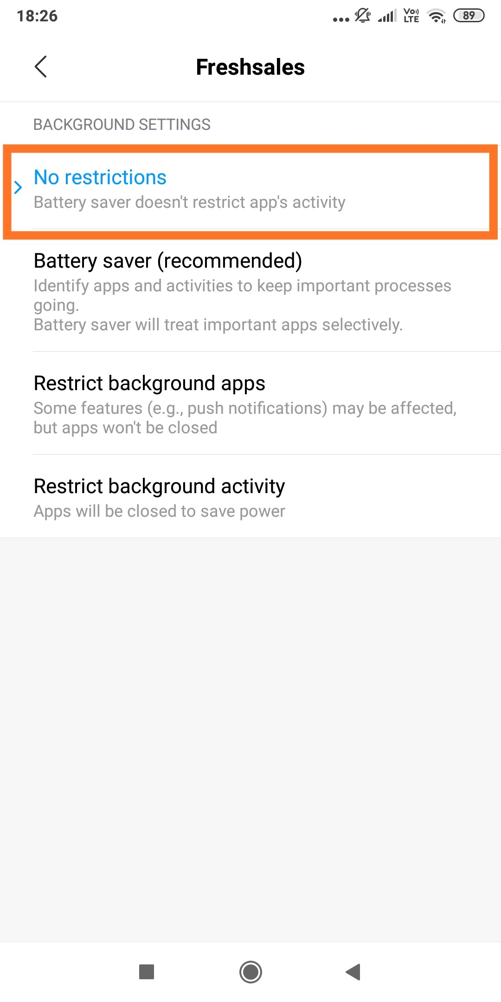

#### **Android 10 devices (all manufacturers)**

#### "Display over other apps" permission is required for Android 10 devices to bring up call logs. Without this permission, even if the app has all the other usual permissions (telephone and call log), call log cannot be launched.

#### *The primary setting for Automatic call logs on Android 10 will not be ON until this permission is granted.*



 