# Title: Byebuggers Sprint 2

**Sprint Planning snapshots**

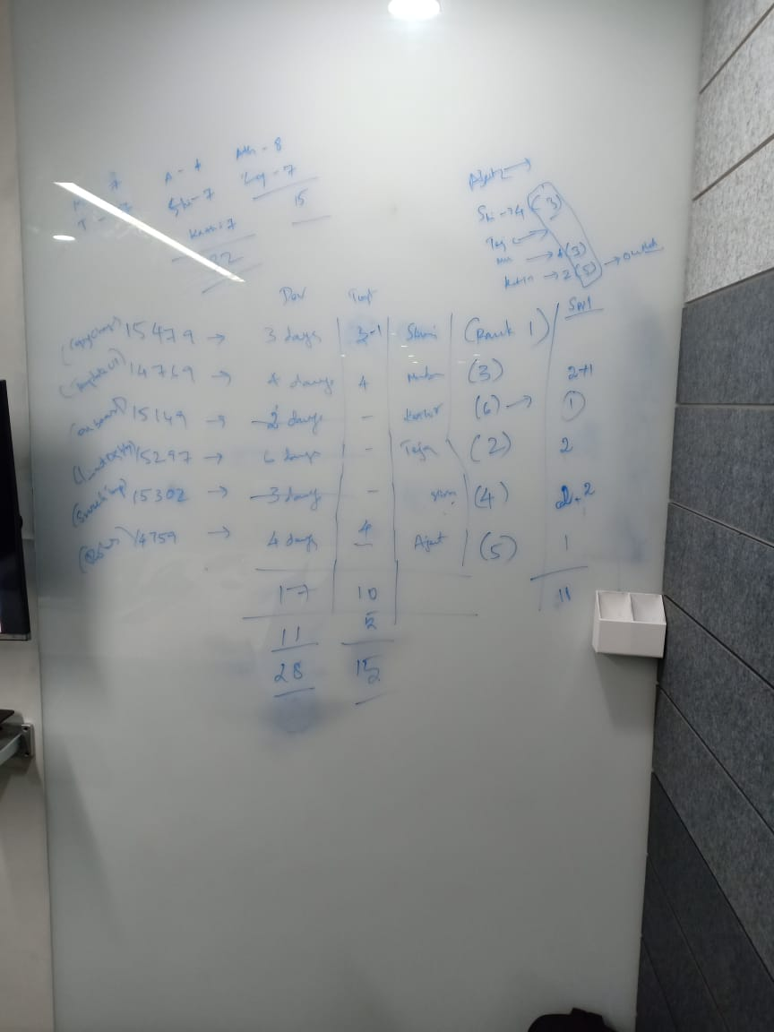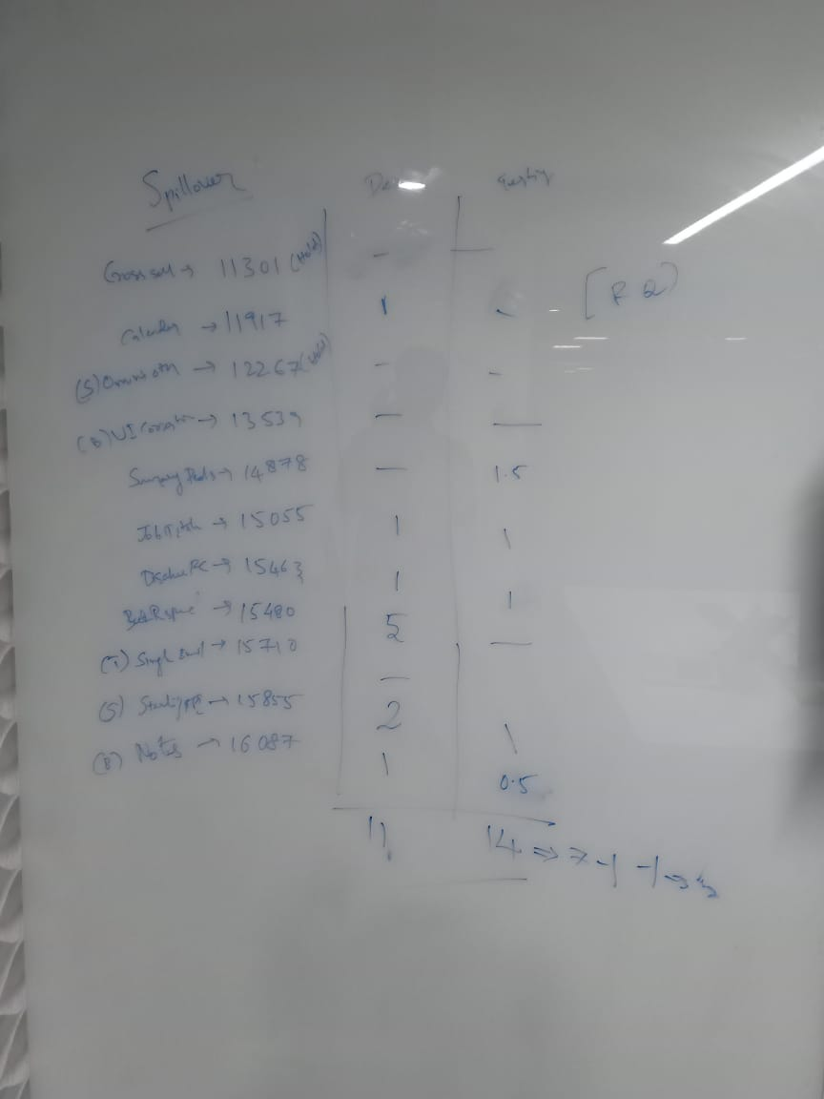

**MOM on Daily Stand ups**

|  |  |
| --- | --- |
| Week 1 | Week 2 |
| MOM on Daily Stand up - Day 1 | MOM on Daily Stand up - Day 6 |
| MOM on Daily Stand up - Day 2 | MOM on Daily Stand up - Day 7 |
| MOM on Daily Stand up - Day 3 | MOM on Daily Stand up - Day 8 |
| MOM on Daily Stand up - Day 4 | MOM on Daily Stand up - Day 9 |
| MOM on Daily Stand up - Day 5 | MOM on Daily Stand up - Day 10 |

To view our sprint Retrospect [click here](https://confluence.freshworks.com/pages/viewpage.action?pageId=230092066)