# Title: Cache benchmarking for custom field dropdown choices

**1) Redis vs Memcached**

|  |  |  |  |
| --- | --- | --- | --- |
|  | Attempt 1 | Attempt 2 | Attempt 3 |
| redis.hget | 0.002793s | 0.002569s | 0.003431s |
| memcached.get | 0.003040s | 0.002762s | 0.004063 |
| redis.hmget | 0.000378s | 0.000348s | 0.000377s |
| memcached.get_multi | 0.000794s | 0.000805s | 0.000799s |

**2) Redis Pipeline** (Redis hget and hmget for mutiple key fetch)

|  |  |  |  |
| --- | --- | --- | --- |
|  | Attempt 1 | Attempt 2 | Attempt 3 |
| redis.hget multiple keys | 0.007685s | 0.009765s | 0.009468 |
| redis.hget-pipelined multiple keys | 0.001913 | 0.001698s | 0.001862 |
| redis.hmget multiple keys | 0.000921 | 0.001350s | 0.001274 |
| redis.hmget-pipelined multiple keys | 0.000809 | 0.000675 | 0.000691 |

**3) Redis eval**

|  |  |  |  |
| --- | --- | --- | --- |
|  | Attempt 1 | Attempt 2 | Attempt 3 |
| redis.hmget multiple keys | 0.001336s | 0.001171s | 0.001291s |
| redis.hmget multiple keys with eval | 0.000866s | 0.000851s | 0.000796s |

**4) Mysql** (Jmeter / Benchmark results)

|  |  |  |  |
| --- | --- | --- | --- |
|  | Attempt 1 | Attempt 2 | Attempt 3 |
| Mysql choice id get with Indexed table | 0.0006620s | 0.0005946s | 0.0006045s |
| Mysql choice id get without Indexed table | 0.0012903s | 0.0013932s | 0.001350s |
| Mysql choice id get without Indexed table, in query | 0.0006647s | 0.0006713s | 0.0005934s |
| Mysql choice id get without Indexed table, in query | 0.0012709s | 0.001281s | 0.0012633s |

Query plan with indexed columns:

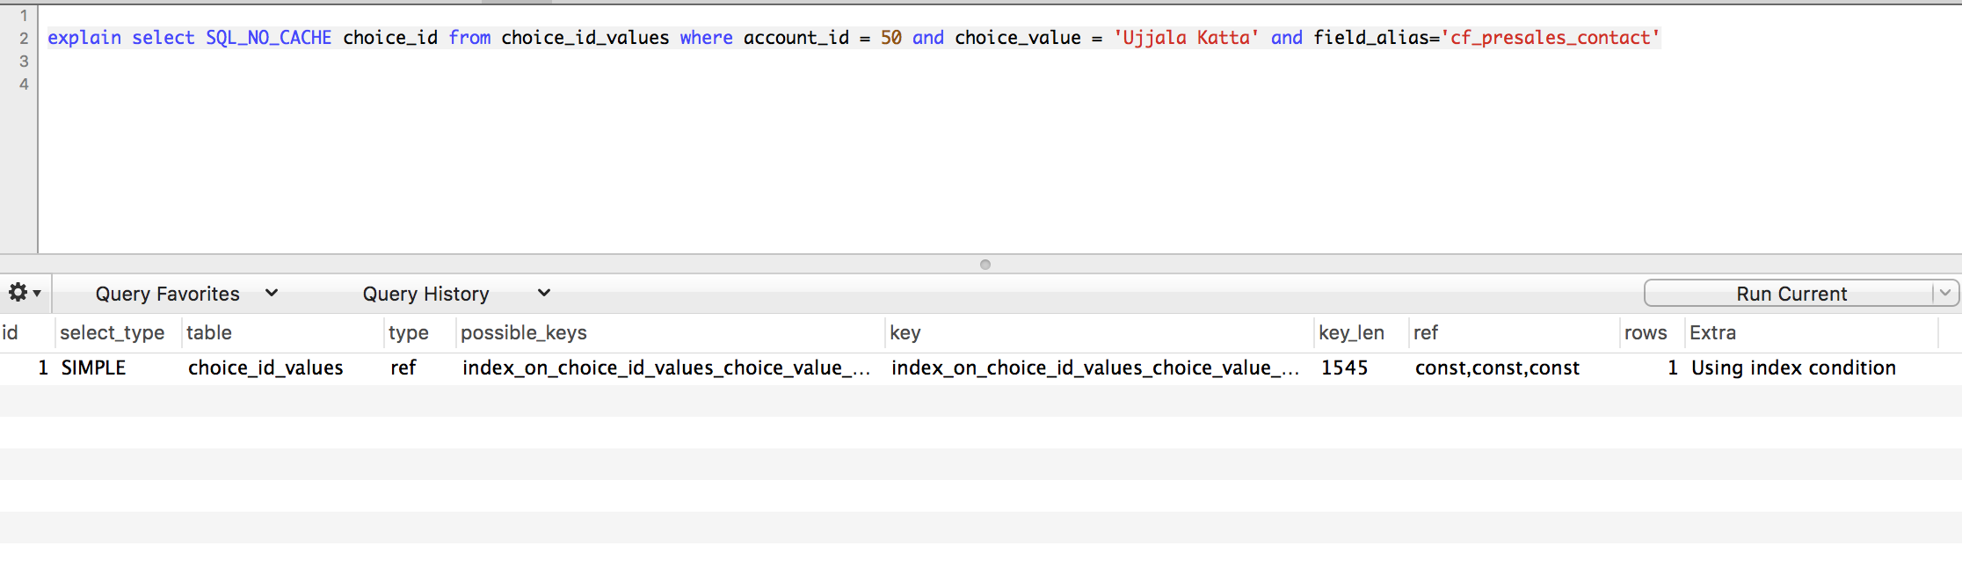

Query plan without indexed columns:

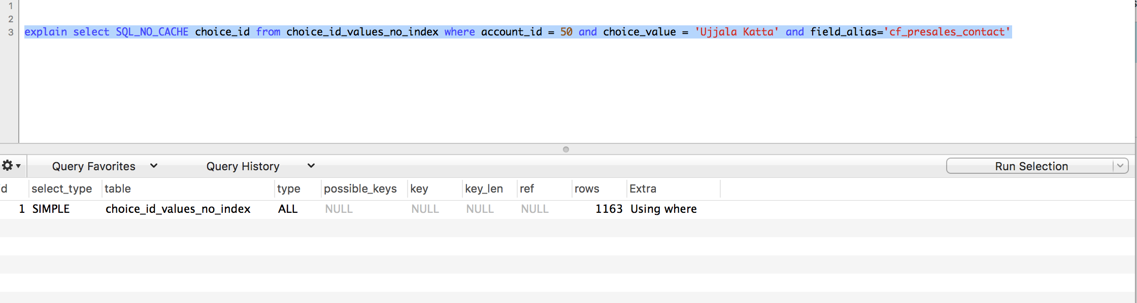

Script File:

[choice_benchmark_1.rb](/display/freshsales/Cache+benchmarking+for+custom+field+dropdown+choices?preview=%2F219350137%2F219350466%2Fchoice_benchmark_1.rb)