# Title: Common token

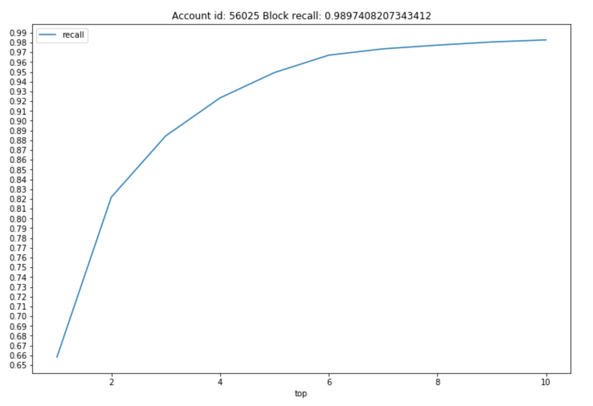

Account id: 56025  
Block size 15  
Number of leads  
 DescribeResult(nobs=1852, minmax=(0, 41), mean=9.25, variance=35.41072393300919, skewness=0.9214198456740275, kurtosis=0.8326248011441519)  
Top 10  
Recall of positive pairs 0.9897408207343412  
Total token: 399532  
Token less than size 15 : 386913  
Tokens of size of size 1: 217963

Block recall: 0.989

----------------------------------------------------------------------------------------------------------------------------------------------------------------------------------------

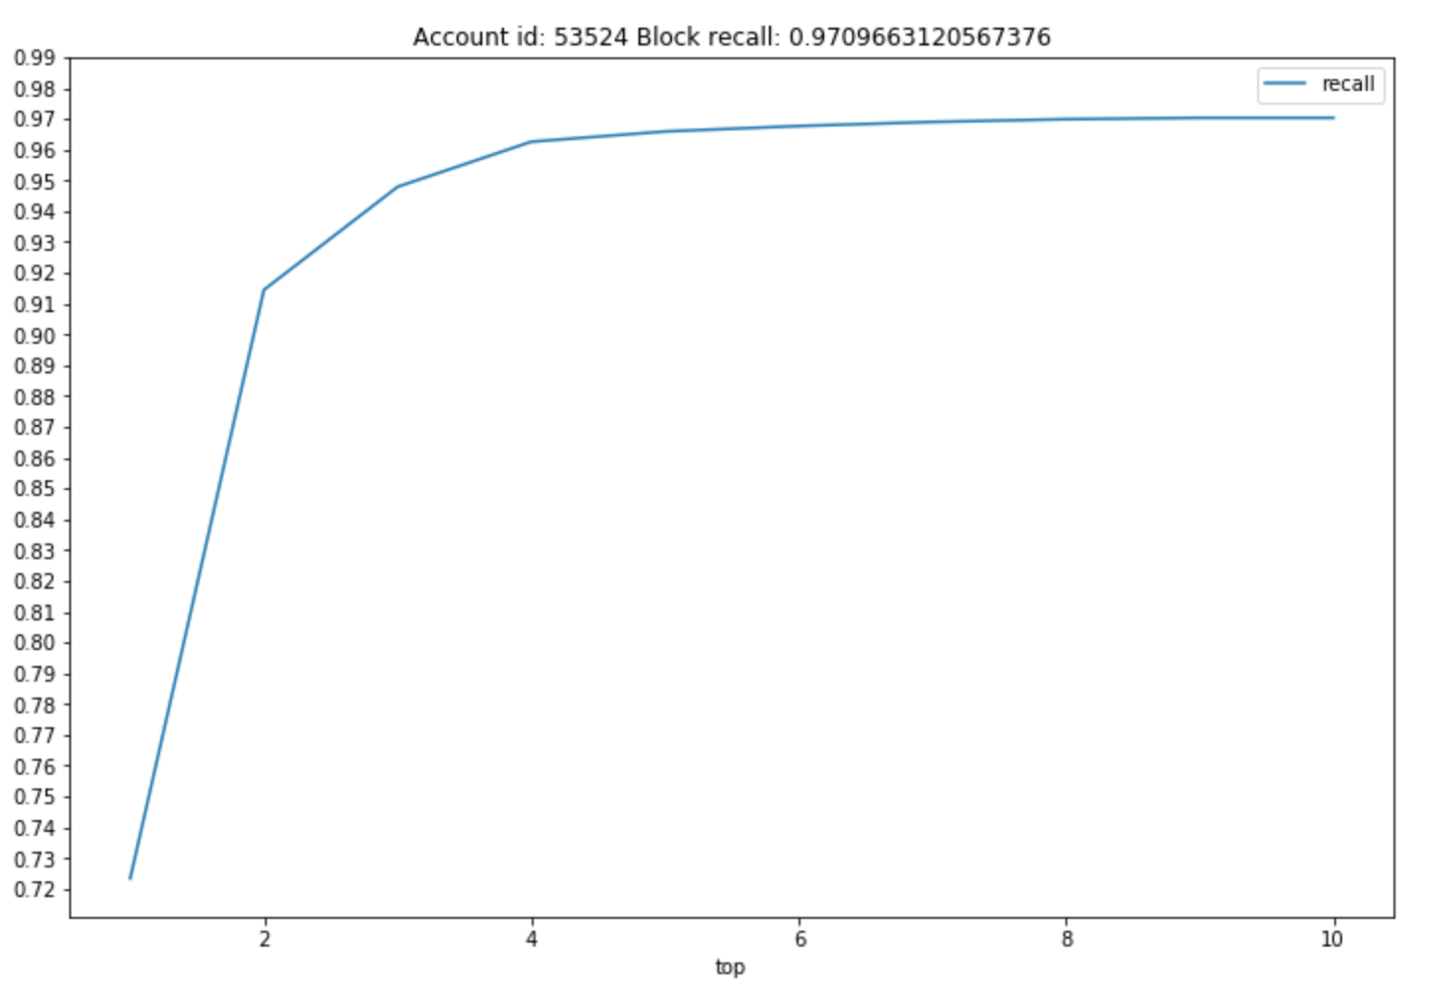

Account id: 53524  
Block size 15  
Number of leads  
 DescribeResult(nobs=4512, minmax=(0, 41), mean=6.693484042553192, variance=30.929081895555544, skewness=1.5454536716278917, kurtosis=2.8155118110359174)  
Top 10  
Recall of positive pairs 0.9703014184397163  
Total token: 434619  
Token less than size 15 : 419116  
Tokens of size of size 1: 253025  
Block recall: 0.9709663120567376

----------------------------------------------------------------------------------------------------------------------------------------------------------------------------------------

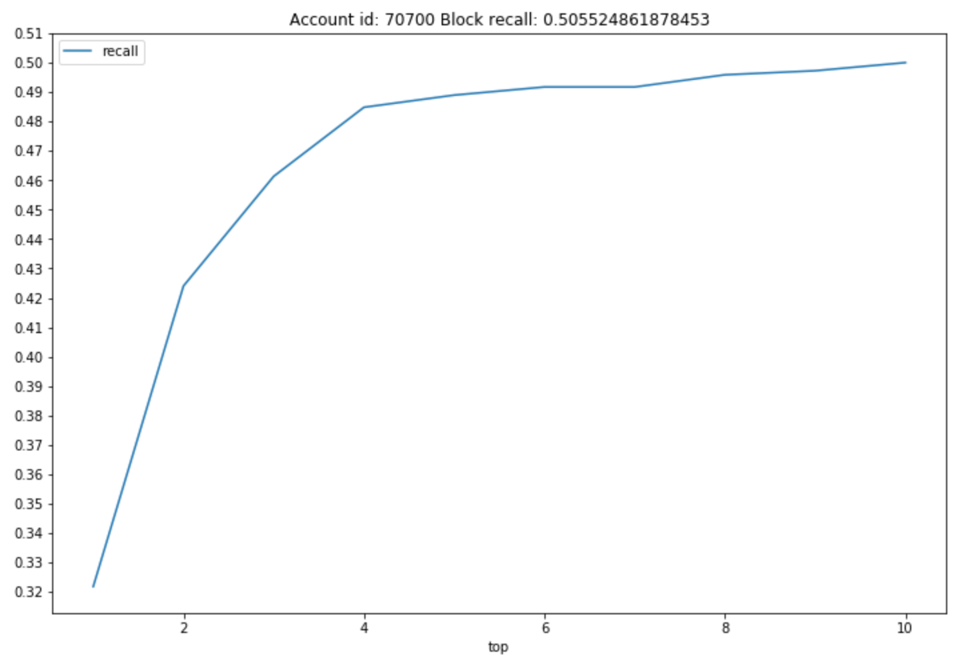

Account id: 70700  
Block size 15  
Number of leads  
 DescribeResult(nobs=724, minmax=(0, 30), mean=5.777624309392265, variance=27.135819521178632, skewness=1.2553968720912134, kurtosis=1.6658012085776681)  
Top 10  
Recall of positive pairs 0.5  
Total token: 1998700  
Token less than size 15 : 1977692  
Tokens of size of size 1: 1738634  
Block recall: 0.505524861878453

----------------------------------------------------------------------------------------------------------------------------------------------------------------------------------------

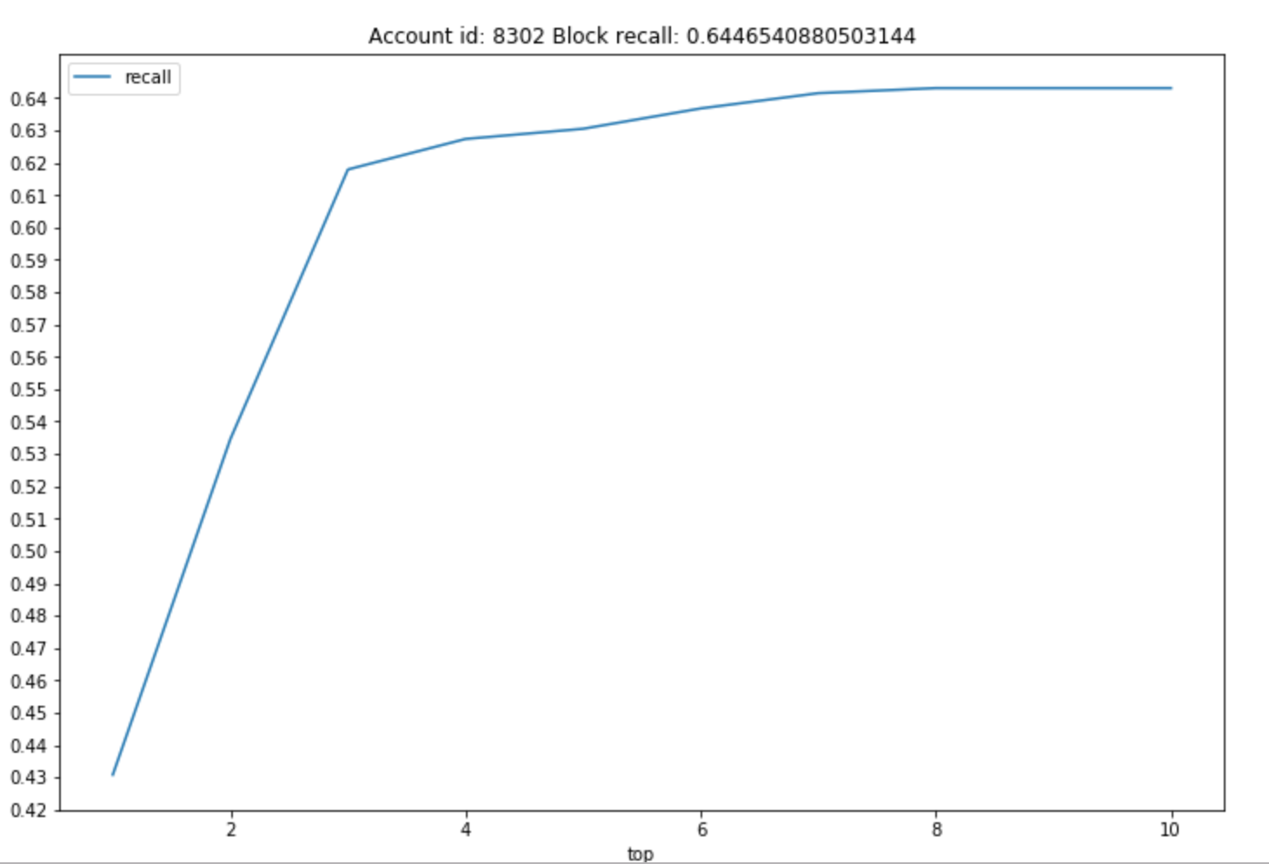

Account id: 8302  
Block size 15  
Number of leads  
 DescribeResult(nobs=636, minmax=(0, 37), mean=6.382075471698113, variance=27.080560095082458, skewness=1.480024229250777, kurtosis=3.445682701409238)  
Top 10  
Recall of positive pairs 0.6430817610062893  
Total token: 845393  
Token less than size 15 : 833945  
Tokens of size of size 1: 707912  
Block recall: 0.6446540880503144

----------------------------------------------------------------------------------------------------------------------------------------------------------------------------------------

(Test set is very small. Only 2 secondary were not found. Both of them only had common email)

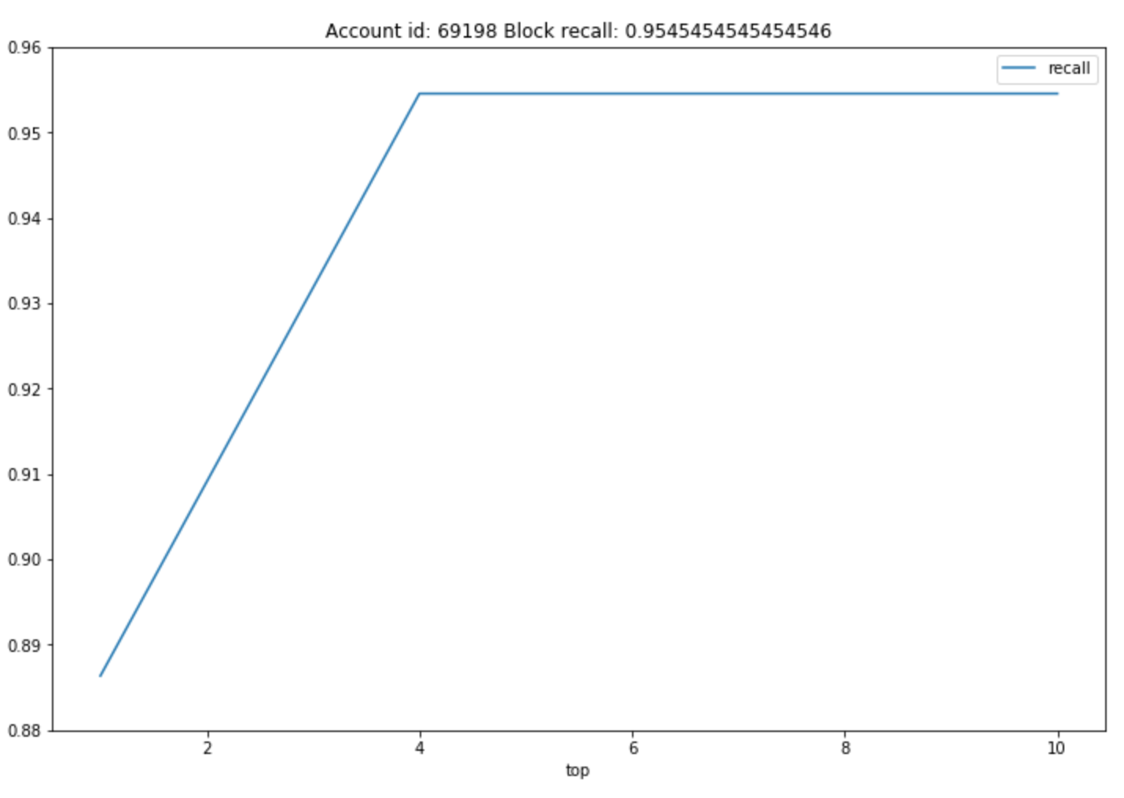

Account id: 69198   
Block size 15  
Number of leads  
 DescribeResult(nobs=44, minmax=(2, 44), mean=16.15909090909091, variance=85.11363636363639, skewness=0.7377081434226648, kurtosis=0.673672115890803)  
Top 10  
Recall of positive pairs 0.9545454545454546  
Total token: 31135  
Token less than size 15 : 30307  
Tokens of size of size 1: 23198  
Block recall: 0.9545454545454546