# Title: Contact De-duplication

### Team: Bharathi, Srivatsa, Suvrat, Swami, Ajeet, Aditi, Srivatsan

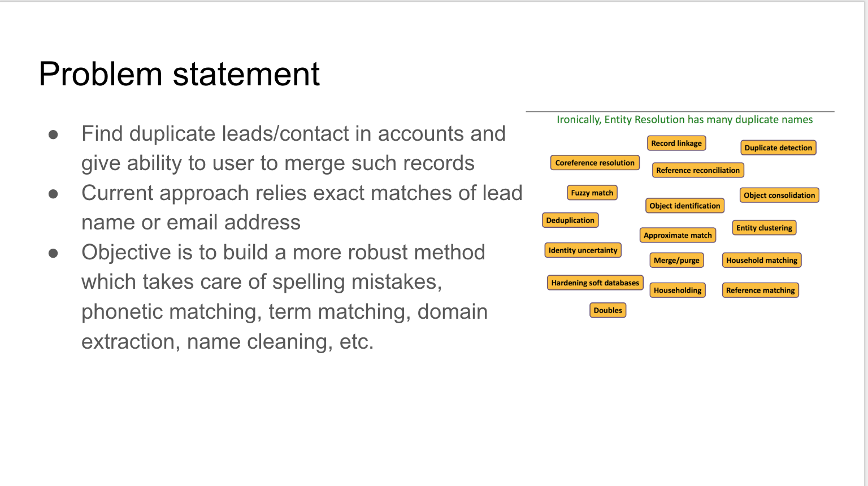

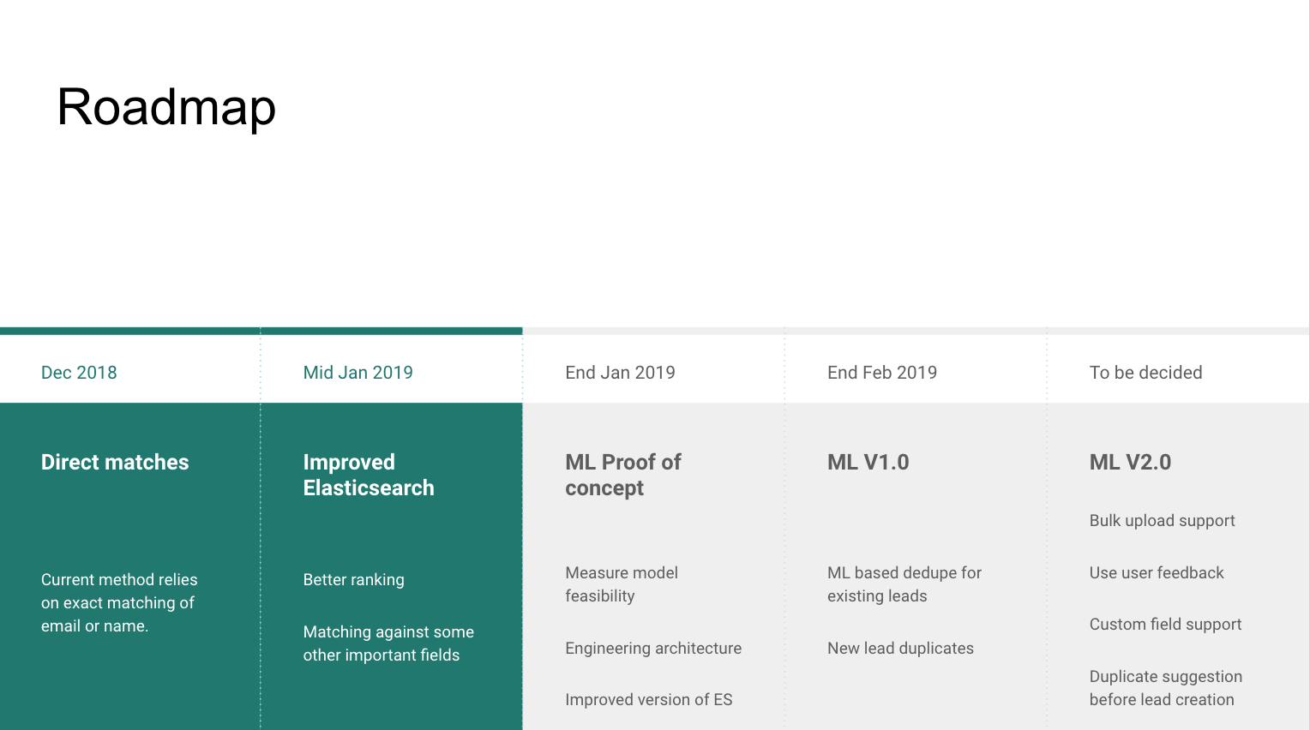

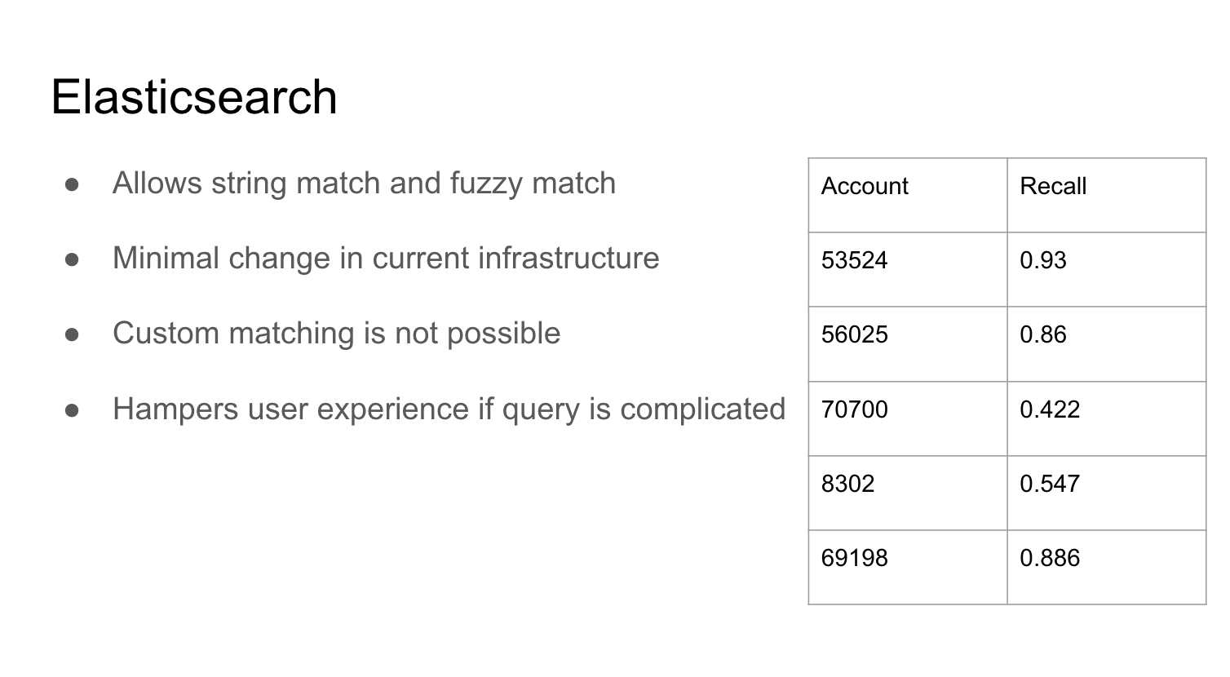

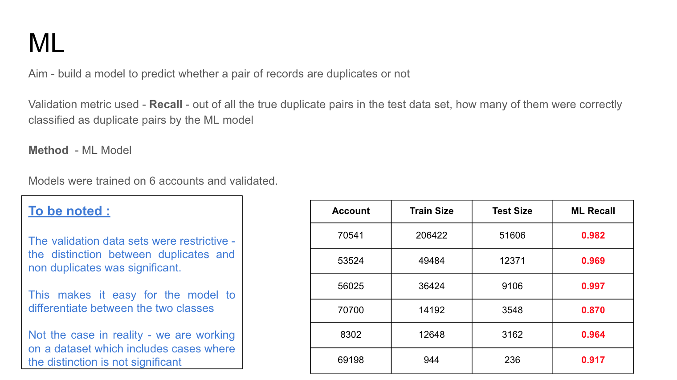

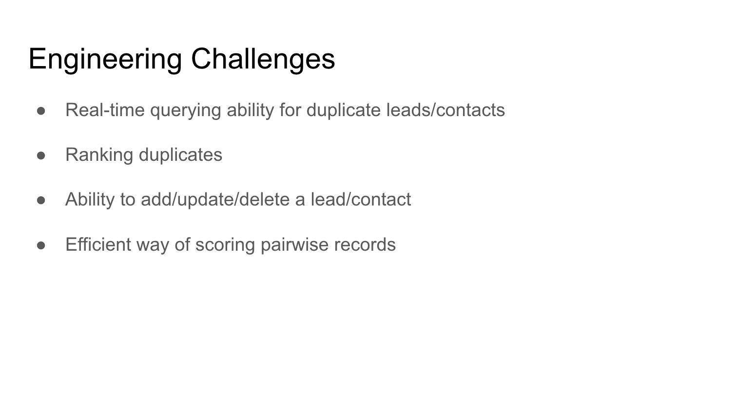

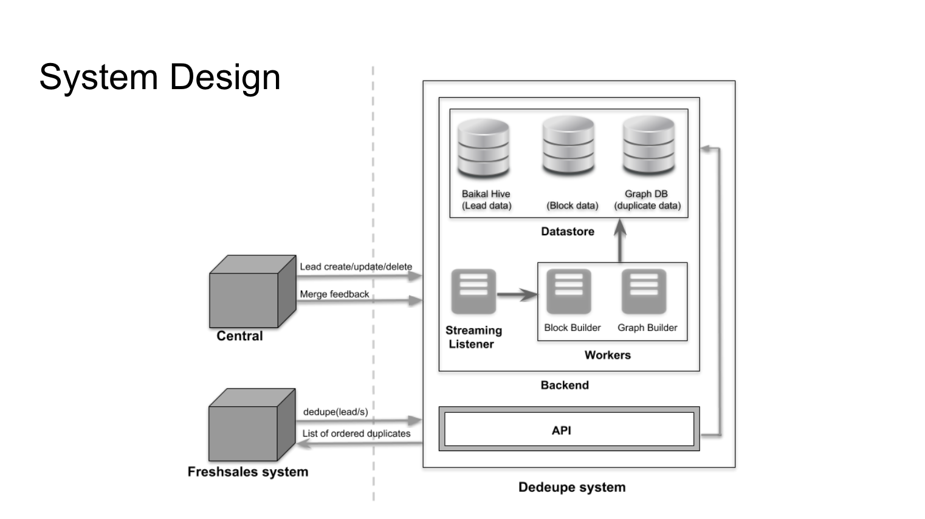

#### Thanks to Vijay, Madhava and Irfan for helping on various things

#### References:

Main project page - <https://confluence.freshworks.com/x/yxVQD>

Engineering architecture  (WIP) - <https://confluence.freshworks.com/x/KRhQD>

Train/Test dataset creation methodology - <https://confluence.freshworks.com/x/zRVQD>