# Title: Developer Guide for custom modules

**1. If you are writing a code where you are looping through the Modules using "Lead", "Contact", "SalesAccount" and "Deal" strings, we should start using module_customizations table data instead.**

=> You can refer the below screenshots to see the variation in accessing the specifics about the modules i.e, Accessing forms, records and serializer etc.  
=> We moved specifics about the modules inside the ModuleCustomization Model so that Developers can easily handle the code for both Default and Custom modules  without keeping any checks for custom/not.  
=> You can add your own instance methods inside ModuleCustomization Model similar like es_index_name, serializer_name etc during your implementations for better code maintenance.  
  
=> If you wish to handle only the default modules, you can still write like the below "New Code" by replacing "current_account.module_customizations" with "ModuleCustomization.cached_default_modules"  
=> If you wish to handle only the default modules, you can still write like the below "New Code" by replacing "current_account.module_customizations" with "ModuleCustomization.cached_custom_modules"

**Old Code:**

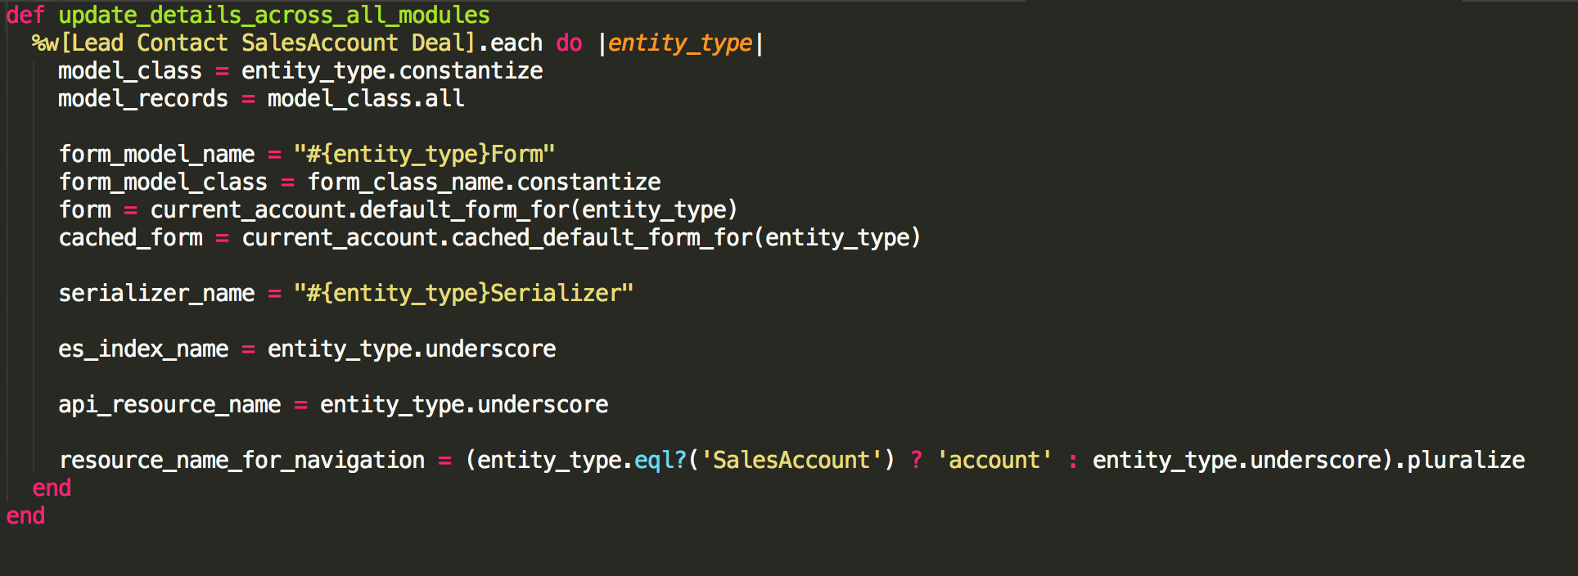

**New Code:**

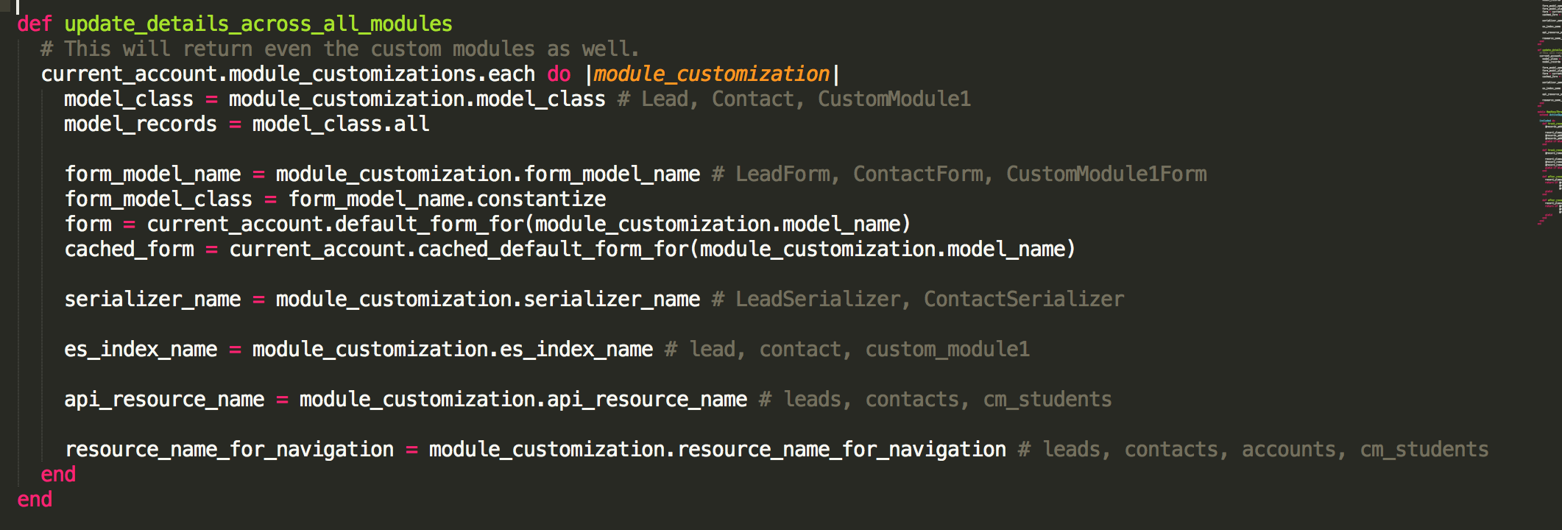

**2. Increasing the custom modules limit:**

 Most of the implementation of custom modules runs around the constant MAX_CUSTOM_MODULES_ALLOWED which is set during application initialization. So, there will be very minimum places where you might have to make changes to support more custom modules.

1. Write a Migration to add the 3 (1 - default fields, 2 - custom fields) tables for each new module.    
   Reference:   
   <https://github.com/freshdesk/freshsales/blob/master/db/migrate/20190404085003_create_custom_module_tables.rb>  
   <https://github.com/freshdesk/freshsales/blob/master/db/migrate/20190404085004_create_custom_field_tables_for_custom_modules.rb>
2. Add  Index in Elastic search for the new modules. Before adding the index you need to specify the shard_count in elasticsearch.yml for Development and in stack settings for Staging/Production.   
   Reference:  
   <https://github.com/freshdesk/freshsales/blob/master/db/migrate/20190404085005_add_custom_module_indices_in_es.rb>
3. Increase the count from 10 to desired number for the constant MAX_CUSTOM_MODULES_ALLOWED inside custom_module_loading.rb
4. Add the Model for the new custom modules inside app/models/custom_module.rb
5. Add a constant for strong the forms inside memcache_keys.rb similar like ACCOUNT_CUSTOM_MODULE1_FORMS
6. Add privileges for the new module inside privileges.yml and privileges_dendencies.yml