# Title: Feature: Secondary entities listing in Landing pages

## Scope:

To evaluate and implement listing of all secondary entities such as tasks, appointments, notes, documents, sales activities in landing pages of primary entities as infinite scrollable list.

## Proposal:

1. We are proposing to use elasticsearch to achieve this. We didn’t opt for MySQL for this because,
   * Data of all secondary entities are stored in multiple tables. It is difficult to join all tables and paginate across rows of data at scale.
   * In future, we want to provide search in secondary entities as well. Currently, we support search only in primary entities.
   * Also, we want to provide ability to filter leads/contact/sales account/deal based on secondary entities.
2. From ES, We will fetch secondary entities of an entity - Lead/Contact/Sales Account/Deal.
3. On click, We will fetch the data of that entity from MySQL and render it in a modal.

## Open Questions:

1. We need to arrive at a schema for ES for secondary entity - Task, Appointment, Notes, Sales Activities and Documents. Do we go with single schema for all entities or different schema for each entity? Single schema is preferred. Alternatively, we can store these entities as part of schema of their targetable - lead, contact, sales account, deal.
2. We need to figure out how to filter entities(only task) for overdue and upcoming(tasks and appointments).

## Schema:

## TBD Mock:

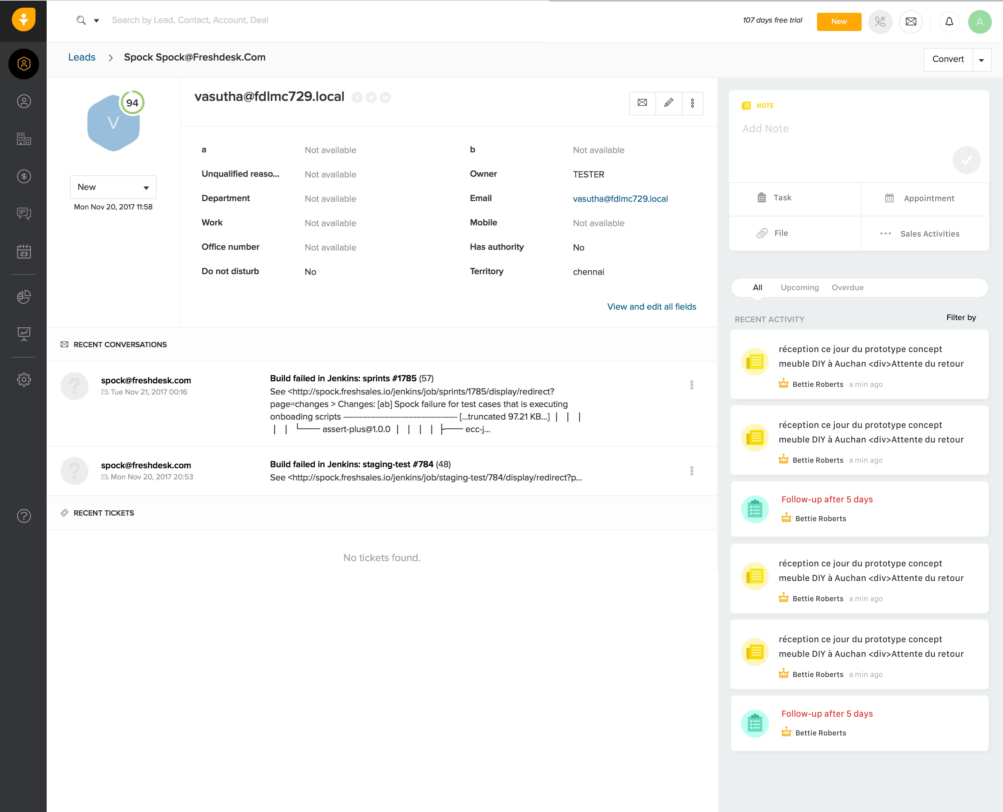

**Note**: Note the final mock. Just an indicator.