# Title: Field Permission higher level Implementation tech doc:

**Requirements and Impact Area:**

Field permission gives the admin to have the granule control over fields based on roles created in the system.  Along with default roles in the system, the admin may create custom roles and define field permissions such as 'Readonly, Editable and Hidden' based on the roles of the user.

The requirement doc is given below.

**Database Schema:**

Each **Role** may have many **field_permissions** defined as there are multiple entities (lead, contact, deal, sales_account, custom_module1.....). Database schema and relations are given below.

**Field Permission Schema: (field_permissions)**

|  |  |  |
| --- | --- | --- |
| column name | type | other |
| id | BIGINT | NOT NULL |
| account_id | BIGINT | NOT NULL |
| role_id | BIGINT | NOT NULL (Foreign key of roles) |
| entity_id | BIGINT | NOT NULL (Foreign key of module_customizations) |
| read_only_fields | MEDIUMTEXT |  |
| hidden_fields | MEDIUMTEXT |  |
| created_at | DATETIME |  |
| updated_at | DATETIME |  |

**Role Schema:**

|  |  |
| --- | --- |
| column name | type |
| id | BIGINT |
| account_id | BIGINT |
| name | VARCHAR |
| privileges | VARCHAR |
| description | TEXT |
| default_role | TINYINT |
| created_at | DATETIME |
| updated_at | DATETIME |
| scopes | TEXT |
| creator_id | BIGINT |
| updater_id | BIGINT |
| editable | TINYINT |
| limits | TEXT |
| meta_data | TEXT |

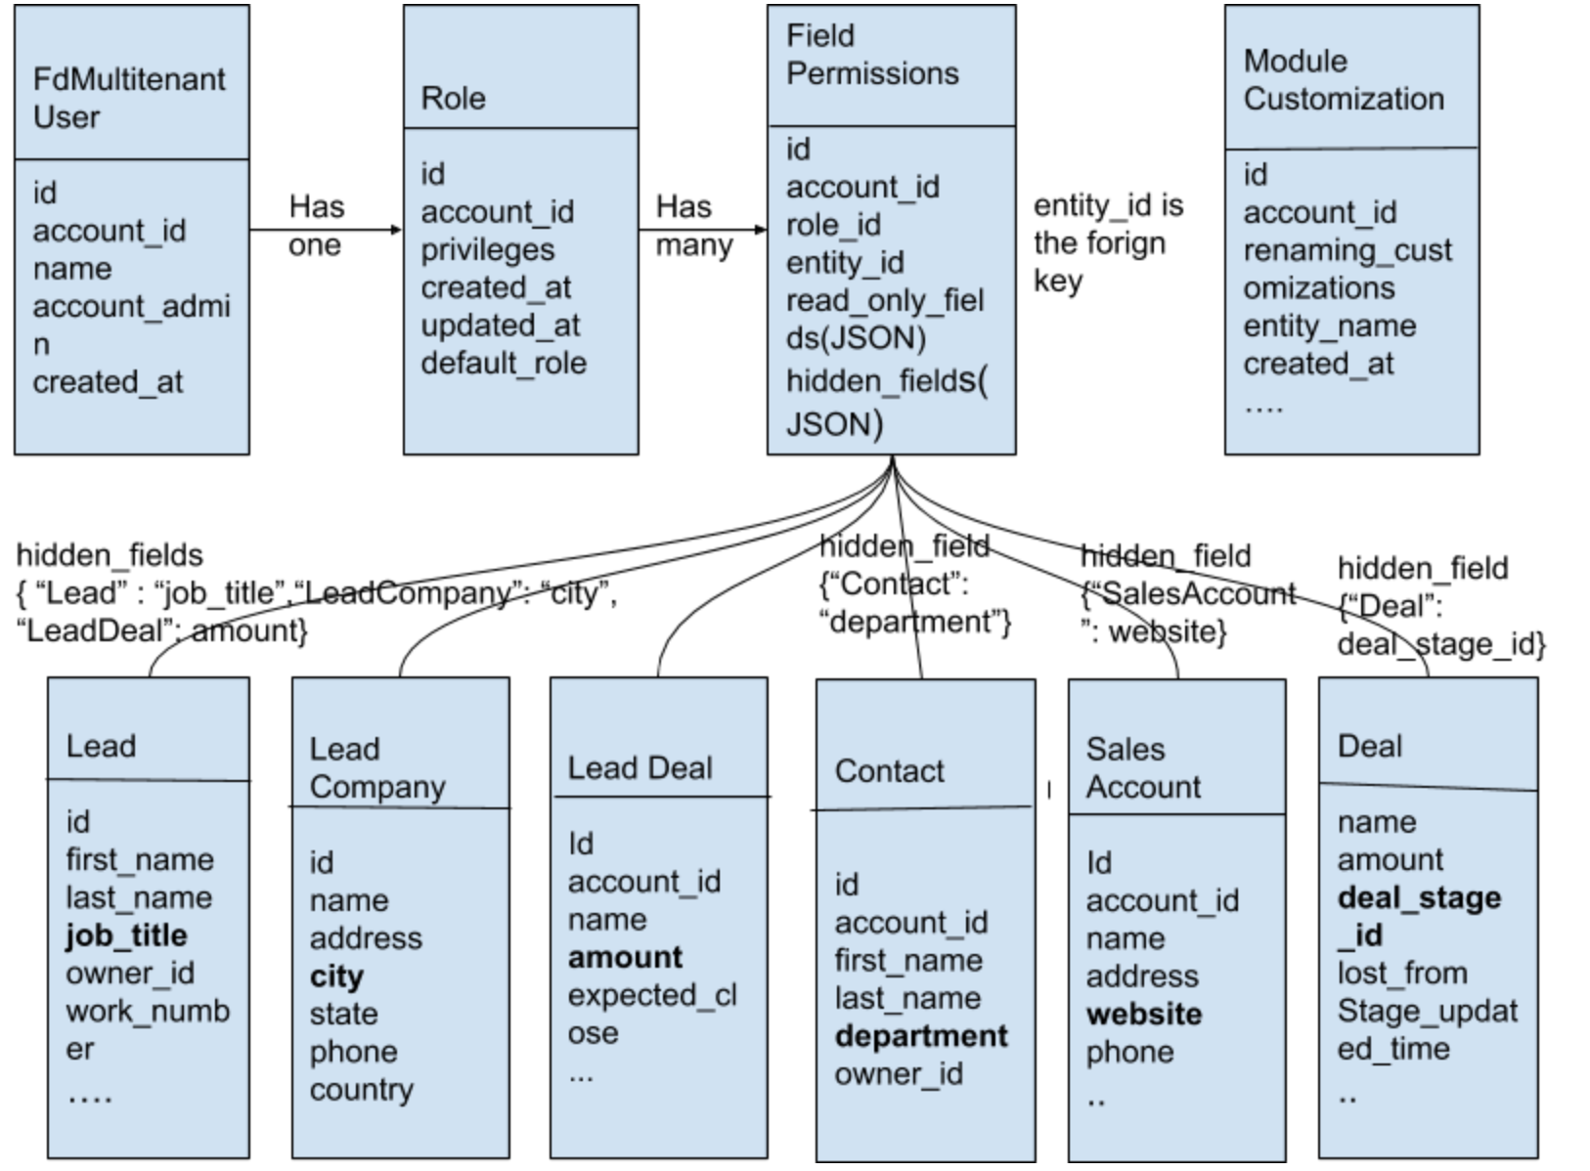

**Field Permission table sample data**:

|  |  |  |  |  |  |  |  |  |
| --- | --- | --- | --- | --- | --- | --- | --- | --- |
| id | account_id | role_id | entity_id | read_only_fields | hidden_fields | created_at | updated_at |  |
| 1 | 1578486838 | 2 | 1 | {"Lead":["owner_id","cf_lead_dropdown"]} | {"Lead":["job_title"],"LeadCompany": ['city'], "LeadDeal": ["amount"]} | 2019-07-02 11:47:11 | 2019-07-02 11:47:11 |  |

In this table, we store all the Read-only fields and Hidden fields based on the role of the user. Role_ID is the foreign key in the field_permission table.

**Role table sample data.**

|  |  |  |  |  |  |
| --- | --- | --- | --- | --- | --- |
| id | account_id | name | privileges | description | default_role |
| 1 | 1578486838 | Restricted User | 37877386372697230773971456041800219958068977322900426988161858738862256352894565653140589372852799362740169952967 | Can create ... | 1 |

**Lead table: sample data** (Just mentioned 6 columns for examples)

|  |  |  |  |  |  |
| --- | --- | --- | --- | --- | --- |
| id | account_id | first_name | last_name | job_title | owner_id |
| 1 | 1578486838 | john | cena | wrestler | 2 |

**Module Customization sample data**

|  |  |  |  |  |
| --- | --- | --- | --- | --- |
| id | account_id | entity_name | renaming_customizations | created_at |
| 1 | 1578486838 | Lead | en: {singular: "prospect", plural: "prospects"} | 2019-07-02 11:47:11 |

**How it works:**

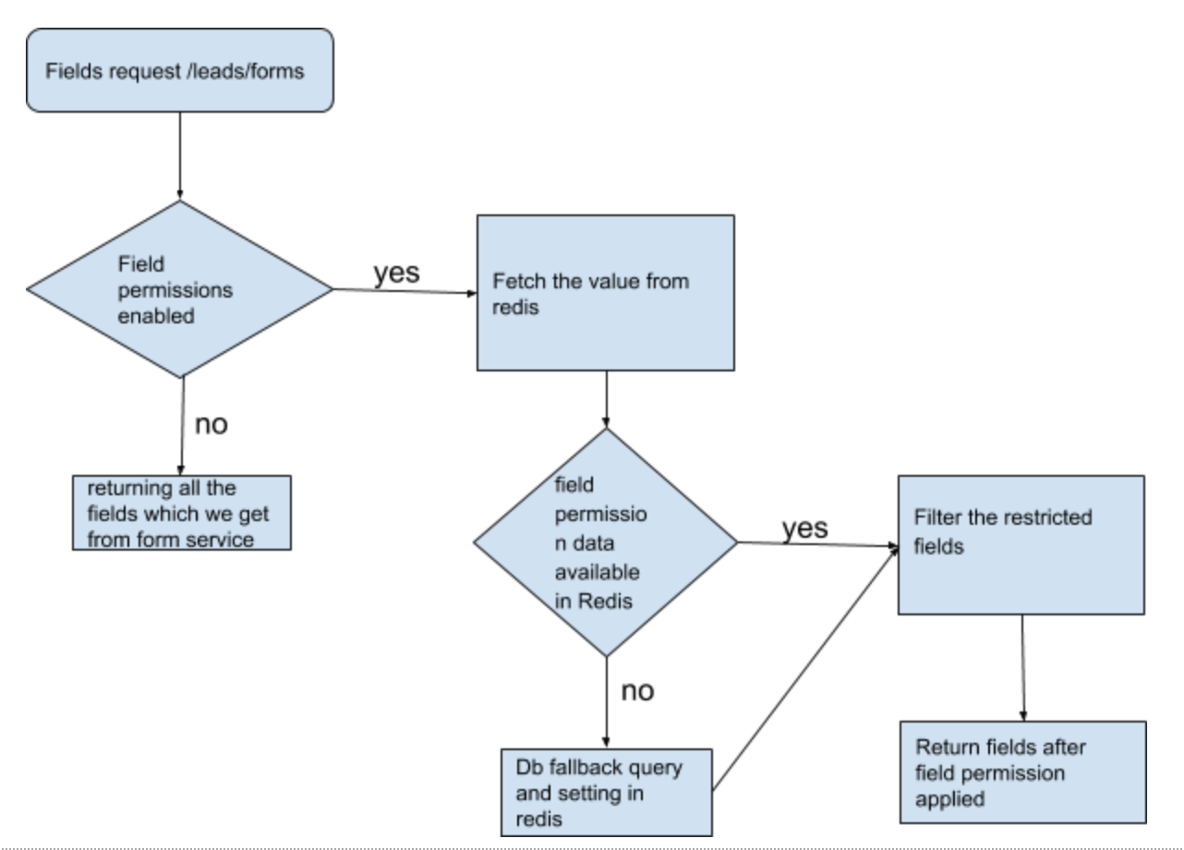

**Implementation in Custom Reports:**

  All Editable and Read-only fields will be shown in reports.

**Hidden fields:**

1. If the field is made hidden and then user is creating a report, hidden fields will not be shown in reports anywhere(filters, tabular data and chart data).
2. If the field is already selected in report, then the field is made hidden for that user, we show appropriate message stating that "*You cannot access this report as you don't have permissions for the following field(s): < field(s) >. Ask your admin to give you access, or delete this report.*"  
     
   Eg: User has created a report with a field named **test field** in filters or tabular data or charts data. Then, field **test field** is made hidden in the role of this user. When this user is trying to view or edit the report, we show the appropriate message stating "*You cannot access this report as you don't have permissions for the following field(s):* ***test field****. Ask your admin to give you access, or delete this report.*"

**Scheduling a report:**

          If report is scheduled which is having hidden fields, we send an error email stating that

                "*Your scheduled report < report name > failed because you don’t have access to the following field(s):* ***test field****.*

*Ask your admin to give you access, or delete this report.*"

          and we will stop the scheduled email.

**Exporting a report:**

          We won't show *export as CSV/export as PDF* option in the report which is having hidden fields.

**Notes:**

* All restricted fields are stored in the '**field_permissions'** table whenever it is defined by admin.
* When 'lead forms' are loaded we loop through the fields and filter out all restricted fields from it. We use Redis cache in between to store the restricted fields for immediate access.