# Title: Freddy FSA BLR - Aug 2019

## 

|  |
| --- |
| **Aspirations - Q3 2019 - aug update** Freddy-Freshsales, BLR 30 Aug 2019 |
|  |

|  |  |  |
| --- | --- | --- |
| **Squad/Team-name-here** | **Name** | **Git home (if applicable)** |
| Freddy | Bharathi | <https://github.com/freshdesk/fs_accout_dedupe> |
| Freddy | Srivatsa |  |
| Freddy | Suvrat |  |
| Freddy | Shreeranjini |  |
| Freshsales | Kathirvalavan |  |
| Freshsales | Arun |  |
| Freshsales - QA | Logesh |  |
| Freshsales | Sivalingam |  |
| Freddy | Swaminathan |  |
| Freshsales | Sudharshan |  |
| Freshsales - Product | Aditi |  |
| Freshsales - Product | Srivatsan |  |

## Timeline

| # | Feature | Time | Comment |
| --- | --- | --- | --- |
| 1 | Development | 2nd week of July to 4th week of Aug | Backend code and model development. |
| 2 | Dev-ops | 4th week of Aug | New app creation for deployment |
| 3 | QA | 4th week of Aug - 2nd week Sept. | QA cases prepared. Testing to begin next week |
| 4 | Next initiative research (forecasting) | 2nd week of Aug - ongoing | Narrow down on problem. List of subproblems created. |
| 5 | Deployment | 2nd week of Sept | Update database, cache with information before running consumer |
| 6 | Go live | 3rd week of Sept |  |
| 7 | Exploratory analysis for forecasting problem | Starts from 1st week of Sept |  |

## **Success metrics - KPIs (Key Performance Indicators)**

| # | Goal area (direction/theme) | Individual goals (list of features) | Metrics |
| --- | --- | --- | --- |
| 1 | Lead organisation | * (Q3) Smart connections | * Increase discoverability of leads/contacts associated with Accounts |

### **Smart connections**

PROBLEM: There is no easy way to find duplicates for an account in Freshsales

AS A : User/Sales agent

I WANT TO: Have a quick view of all the duplicates of any accounts I own

SO THAT**:** 1)I can have visibility regarding how many instances of this account are in the system currently

                  2) ensure that multiple people are not reaching out to the same account

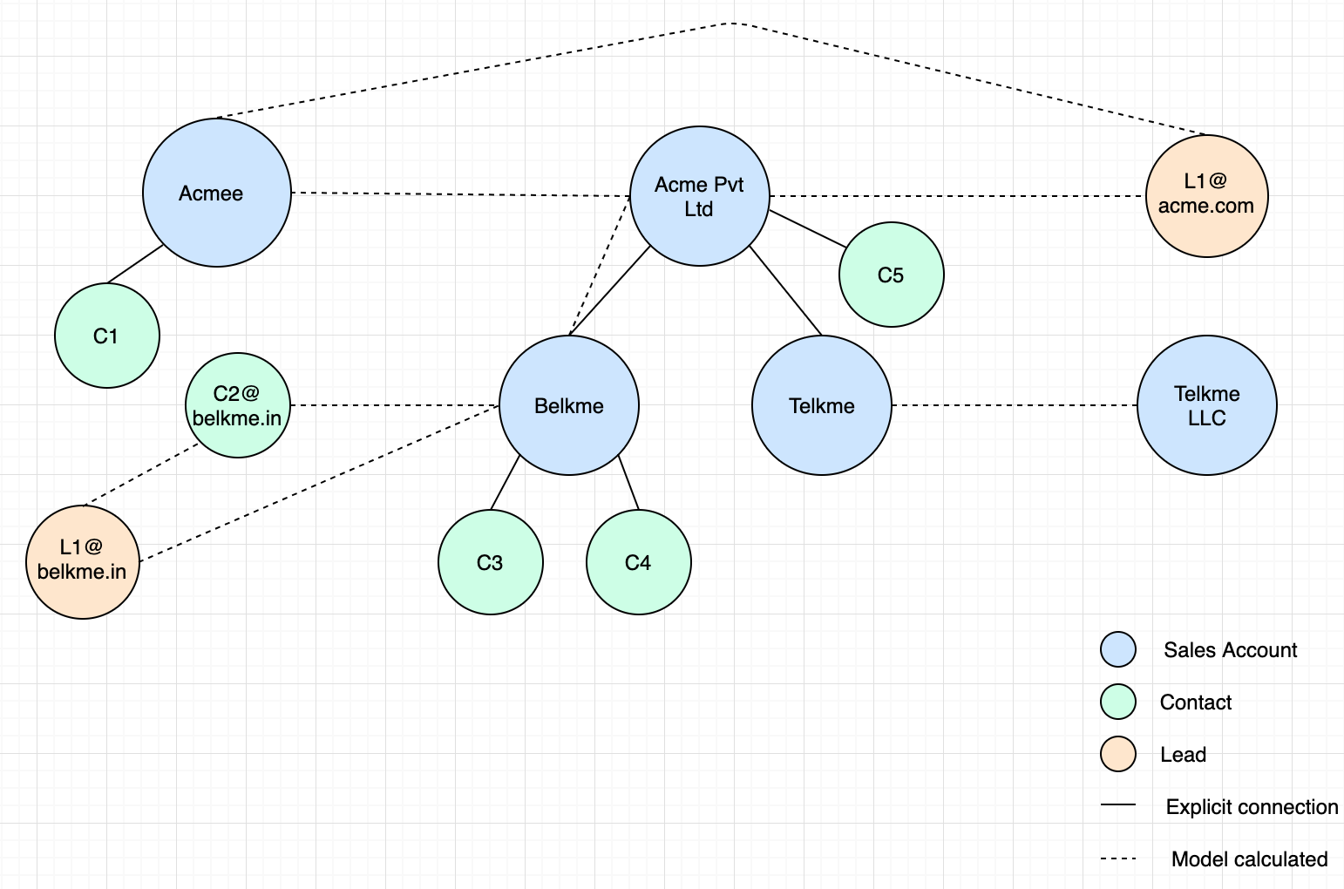

## **Smart connections -**

## **Cases that are resolved:**

|  |
| --- |
| Use case |
| Match contacts with similar email domains |
| Match contact/leads email domain with Sales account website |
| Use Sales account's associated contacts email to find connections |
| Handle cases if email given instead of company name |
| Explicit parent-child connections not to be shown as connections |
| Build connection network on top of lead/contact graph |

|  |  |  |
| --- | --- | --- |
| What this solves | Primary Company Name | Secondary Company Name |
| abbreviations vs full names | IBM | International Business Machines |
| phonetic similarity | Carneggie Mellon | Karneggie Mellon |
| differences in arrangement of words and mismatch | Comp Sci Dept at Carneggie Mellon | Department of Computer Science at Carneggie Mellon |
| spelling mistakes and missing words | Carnegie Mello | Carneggie Mellon University |
| domain names vs company names | [suvrat.hiran@freshworks.com](mailto:suvrat.hiran@freshworks.com) | Freshworks |
| foreign language vs English | АО СЗРИА | AO SZRIA |
| foreign language vs English | Азбука вкуса | Azbuka Vkusa |
| foreign language vs English and word order mismatch | Compañía Logística | Logistics Company |
| foreign language vs foreign language | 苹果公司 | 苹果公司 |
| foreign language word order mismatch | 伯克希尔 哈撒韦公司 | 哈撒韦公司 伯克希尔 |

## **Forecasting -**

|  |
| --- |
| Questions |
| 1. How many leads have to be generated per product/territory/owner? 2. How many leads have to be converted per product/territory/owner? 3. How many deals have to be created per product/territory/owner? 4. How much deal $ has to be in the pipeline per product/territory/owner? 5. How much deal $ per customer is needed per product/territory/owner (ARPU)? 6. How much has recent changes contributed to sales growth? - New products, hires/fires, process changes, discounts etc - how much can we find out from db and how much can we ask as input from user/admin? 7. Is there an anomaly in this month’s sales? Insight 8. Feature to clean up data for a more accurate forecast - similar to dedupe, depends on data 9. What is the goal to be set for a particular product/territory/owner? 10. Mid-month suggestion: Should the goal for a product/territory/owner be revised? 11. How much of this product/territory/owner’s goal will be achieved? 12. More data collection at signup time (similar to other CRMs) - to decide on most-needed data - so that models can be grouped based on this     1. Industry     2. Business models - subscription or one-time etc 13. Growth rate as a metric - what has it been historically? What will it be based on current forecast? Growth rate as a sales goal. 14. Potential for continued/future purchase from a particular customer 15. Customer lifetime value |

## **Previous Aspirations Link:**

[**Fuzzy de-duplication of leads and contact - May 2019**](https://confluence.freshworks.com/display/freshsales/Fuzzy+de-duplication+of+leads+and+contact+-+May+2019)

## **Quarterly Goals:**

|  |  |  |
| --- | --- | --- |
| Goals | Status | Comments |
| Smart connections | Live |  |
| R&D Forecasting | End Exploratory analysis |  |

## **Learnings (Innovation/R&D/Architecture/Design/...)**

(Please list items that you/your team's accomplishments that they are proud of and share it Engineering Org wide)

|  |  |  |  |
| --- | --- | --- | --- |
| Item | Description | Impact | Comments |
| Patent | Patent on deduplication system |  | Patent targeted to move to outside counsel by end of Sept |

## **Do you have any specific asks? (any help needed to address constraints, unblocking, ...)**

**(Please keep this list engineering related - this section is optional)**

|  |  |  |
| --- | --- | --- |
| Ask | Impact | Recurring |

## **Appreciation**

(Please list appreciations for your team/squad by you/team members/others)

|  |  |  |  |
| --- | --- | --- | --- |
| Name | Appreciated by | Impact | In their own words |

## **Demo/Deep dives**