# Title: Freddy FSA BLR - July 2019

## 

|  |
| --- |
| **Aspirations - Q3 2019 - mid year update** Freddy-Freshsales, Dedupe, 09/07/2019 |
|  |

|  |  |  |
| --- | --- | --- |
| **Squad/Team-name-here** | **Name** | **Git home (if applicable)** |
| Freddy | Bharathi | <https://github.com/freshdesk/fs_dedupe> |
| Freddy | Srivatsa |  |
| Freddy | Suvrat |  |
| **Freddy** | **Shreeranjini** |  |
| Freshsales | Ajeet |  |
| Freshsales - QA | Logesh |  |
| Freshsales | Sivalingam |  |
| Freshsales - Devops | Madhav |  |
| Freshsales - Devops | Sivakumar |  |
| Freddy | Swaminathan |  |
| Freshsales | Sudharshan |  |
| Freshsales - Product | Aditi |  |
| Freshsales - Product | Srivatsan |  |

## Timeline

### 

| # | Feature | Time | Comment |
| --- | --- | --- | --- |
| 1 | Dynamic score updater | 1st week of June - 3rd week of June | We have ability to update duplicate score for specific account/criteria |
| 2 | New spark consumer for metric calculation and analysis | 2nd week of May - End of May | Fetches duplicate feedback, calculate all metrics and store in HDFS |
| 3 | Monitoring improvement | 3rd week of June |  |
| 4 | Handling of new payload format | 2nd week of June | Payload format to central was updated. |
| 5 | Model extension to support foreign language | 4th week of May |  |
| 6 | Functionality research - Smart connections | 2nd week of June - 1st week of July | Considerable amount was spent on thinking through how smart connections would work. |

## **Success metrics - KPIs (Key Performance Indicators)**

| # | Goal area (direction/theme) | Individual goals (list of features) | Metrics |
| --- | --- | --- | --- |
| 1 | Lead organisation | * (H1) To de-duplicate leads using fuzzy matching techniques * (Q3) Smart connections | * Lead/Contact deduplication   + Acceptance rate - 30%   + Merge rate - 92%   + Number of merges compared to previous system - 2.8x * Increase discoverability of leads/contacts associated with Accounts |

### **Smart connections**

PROBLEM: There is no easy way to find duplicates for an account in Freshsales

AS A : User/Sales agent

I WANT TO: Have a quick view of all the duplicates of any accounts I own

SO THAT**:** 1)I can have visibility regarding how many instances of this account are in the system currently

                  2) ensure that multiple people are not reaching out to the same account

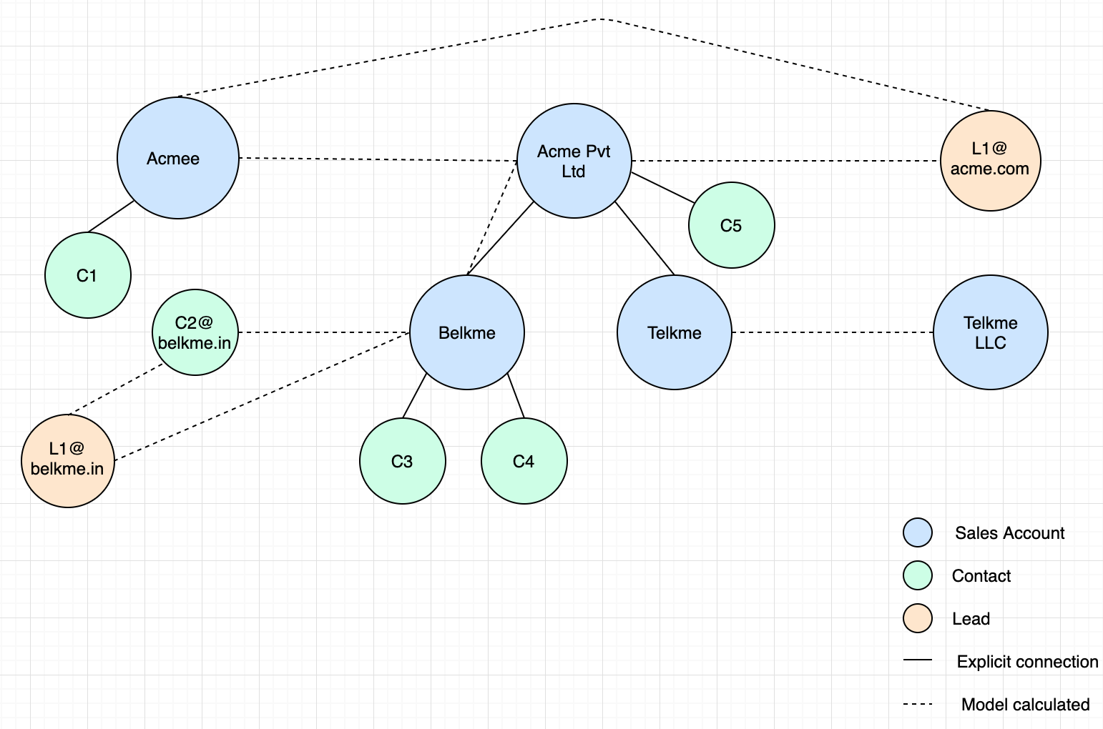

## **Cases that are resolved:**

|  |  |  |
| --- | --- | --- |
| What this solves | Primary Company Name | Secondary Company Name |
| abbreviations vs full names | IBM | International Business Machines |
| phonetic similarity | Carneggie Mellon | Karneggie Mellon |
| differences in arrangement of words and mismatch | Comp Sci Dept at Carneggie Mellon | Department of Computer Science at Carneggie Mellon |
| spelling mistakes and missing words | Carnegie Mello | Carneggie Mellon University |
| domain names vs company names | [suvrat.hiran@freshworks.com](mailto:suvrat.hiran@freshworks.com) | Freshworks |
| foreign language vs English | АО СЗРИА | AO SZRIA |
| foreign language vs English | Азбука вкуса | Azbuka Vkusa |
| foreign language vs English and word order mismatch | Compañía Logística | Logistics Company |
| foreign language vs foreign language | 苹果公司 | 苹果公司 |
| foreign language word order mismatch | 伯克希尔 哈撒韦公司 | 哈撒韦公司 伯克希尔 |

## **Previous Aspirations Link:**

[**Fuzzy de-duplication of leads and contact - May 2019**](https://confluence.freshworks.com/display/freshsales/Fuzzy+de-duplication+of+leads+and+contact+-+May+2019)

## **Quarterly Goals:**

|  |  |  |
| --- | --- | --- |
| Goals | Status | Comments |
| Smart connections | In progress |  |
| R&D Forecasting | Yet to start |  |

## **Learnings (Innovation/R&D/Architecture/Design/...)**

(Please list items that you/your team's accomplishments that they are proud of and share it Engineering Org wide)

|  |  |  |  |
| --- | --- | --- | --- |
| Item | Description | Impact | Comments |
| Patent | We are working with legal team to apply for patent on deduplication system |  | Patent is forwarded from Ramesh's team to legal team. |

## **Do you have any specific asks? (any help needed to address constraints, unblocking, ...)**

**(Please keep this list engineering related - this section is optional)**

|  |  |  |
| --- | --- | --- |
| Ask | Impact | Recurring |

## **Appreciation**

(Please list appreciations for your team/squad by you/team members/others)

|  |  |  |  |
| --- | --- | --- | --- |
| Name | Appreciated by | Impact | In their own words |
| Srivatsa | Suvrat | Faster and bug free productionisation of models | Srivatsa has taken initiative to understand engineering challenges involved in productionisation of ML models. He has taken ownership to write ready to ship models, helping the team cut down delivery time. This also help us avoid issues of code translation from experimentation. |

## **Demo/Deep dives**