# Title: Freddy FSA BLR - Oct - 2019

## 

|  |
| --- |
| **Aspirations - Q3 2019 - oct update** Freddy-Freshsales, BLR 11 Oct 2019 |
|  |

|  |  |  |
| --- | --- | --- |
| **Squad/Team-name-here** | **Name** | **Git home (if applicable)** |
| Freddy | Bharathi | <https://github.com/freshdesk/fs_accout_dedupe> |
| Freddy | Srivatsa |  |
| Freddy | Padmanabh |  |
| Freddy | Suvrat |  |
| Freddy | Shreeranjini |  |
| Freshsales | Kathirvalavan |  |
| Freshsales | Arun |  |
| Freshsales - QA | Logesh |  |
| Freshsales | Sivalingam |  |
| Freddy | Swaminathan |  |
| Freshsales | Sudharshan |  |
| Freshsales - Product | Aditi |  |
| Freshsales - Product | Srivatsan |  |

### **Smart connections is Live ( All 3 PODs US, EU and AUS) along with new UI interface for dedupe**

PROBLEM: There is no easy way to find contacts/leads which belong to same sales account in Freshsales

AS A : User/Sales agent

I WANT TO: Have a quick view of all the duplicates of any accounts I own

SO THAT**:** 1)I can have visibility regarding how many instances of this account are in the system currently

                  2) ensure that multiple people are not reaching out to the same account

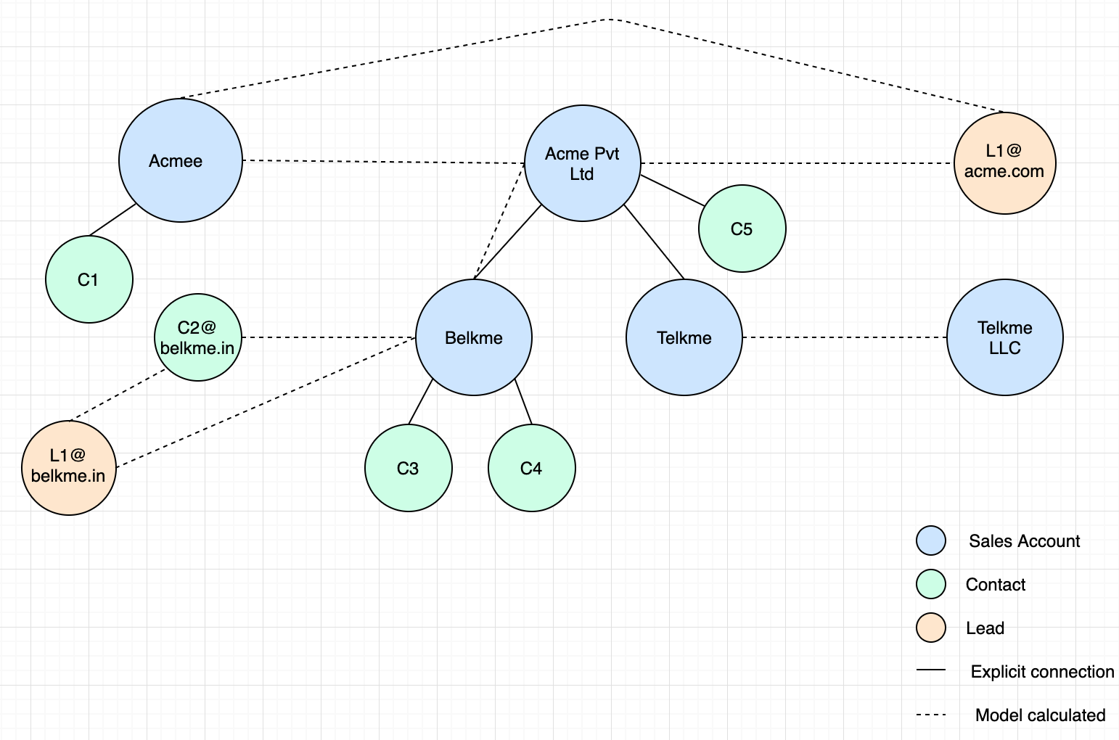

**Draft for the Patent on Dedupe system is complete (Received today morning, 11th Oct)**

## Timeline

| # | Feature | Time | Comment |
| --- | --- | --- | --- |
| 1 | QA | 2nd week - sept end | Achieved with close collaboration with FS QA team.  UI had an overhaul and therefore more intensive QA was done. |
| 2 | Devops | 3rd week sept - 1st week oct | Achieved with close collaboration with team member based out in Chennai  Separate stack for dedupe and smart connections was changed to single stack. New redis box was started. |
| 3 | Bug fixes | 3rd week - 4th week sept | While on QA few bugs were identified and rectified |
| 4 | Data seeding | 2nd to 5th Oct | Staging testing and stabilisation (4th and 5th)  Existing records in the system were seeded to graph DB |
| 5 | Go live | 8th Oct 9 PM | Ensured zero downtime for existing system  All team members were available during launch to ensure smooth deployment |
| 6 | Exploratory analysis (forecasting) | 2nd week of sept - 1st week Oct | We have identified data issues. Sub problems are identified within broader forecasting area. |
| 7 | Model POC (Forecasting) | 1st week Oct -  Oct end | Get benchmark numbers. Two models are being explored in parallel. |
| 8 | Model (Deal size estimator) | 3rd week Oct - 1st week Dec | Stretch goal would be to make model ready for prod development. Work in parallel with product team to see how this can be taken live |
| 9 | Feedback monitoring system | 3rd week of Oct - 3rd week of Nov | Create an app  for account level analysis of dedupe |

## **Success metrics - KPIs (Key Performance Indicators)**

| # | Goal area (direction/theme) | Individual goals (list of features) | Metrics |
| --- | --- | --- | --- |
| 1 | Lead organisation | * (Q3) Smart connections | * Increase discoverability of leads/contacts associated with Accounts   + ~46% jump in association of leads/contacts to sales accounts (based on 2 days of stats) |

## **Smart connections -**

## **Cases that are resolved:**

|  |
| --- |
| Use case |
| Match contacts with similar email domains |
| Match contact/leads email domain with Sales account website |
| Use Sales account's associated contacts email to find connections |
| Handle cases if email given instead of company name |
| Explicit parent-child connections not to be shown as connections |
| Build connection network on top of lead/contact graph |

|  |  |  |
| --- | --- | --- |
| What this solves | Primary Company Name | Secondary Company Name |
| abbreviations vs full names | IBM | International Business Machines |
| phonetic similarity | Carneggie Mellon | Karneggie Mellon |
| differences in arrangement of words and mismatch | Comp Sci Dept at Carneggie Mellon | Department of Computer Science at Carneggie Mellon |
| spelling mistakes and missing words | Carnegie Mello | Carneggie Mellon University |
| domain names vs company names | [suvrat.hiran@freshworks.com](mailto:suvrat.hiran@freshworks.com) | Freshworks |
| foreign language vs English | АО СЗРИА | AO SZRIA |
| foreign language vs English | Азбука вкуса | Azbuka Vkusa |
| foreign language vs English and word order mismatch | Compañía Logística | Logistics Company |
| foreign language vs foreign language | 苹果公司 | 苹果公司 |
| foreign language word order mismatch | 伯克希尔 哈撒韦公司 | 哈撒韦公司 伯克希尔 |

## **Forecasting -**

|  |
| --- |
| Sub problem and data challenges |
| 1. Lead/Deal amount is not entered(or incorrectly entered) in the system. Cannot forecast revenue if potential deal amount is missing. Sub-problem: Deal size Estimator  2. Large number of deals whose sales cycle is ~0 days. Since these deals dont exist in the system at the time of prediction, revenue forecast will be inaccurate. Sub-problem: short-deals revenue Forecasting  3. Created at and closed dates are not always the exact start and. close dates of a sales journey  4. Many sales journeys start and go to close to win state within a couple of days without any activity , again not not correctly reflecting the patterns to close the deals to a win state  5. Inconsistencies in marked closed date of a deal.  6. Lot of time difference(in yrs) between the date at which a deal moves to closed stage and the closed_date |

## **Previous Aspirations Link:**

## **Quarterly Goals:**

|  |  |  |
| --- | --- | --- |
| Goals | Status | Comments |
| Forecasting | Production ready Models for deal size estimator and revenue forecasting. |  |
| Feedback monitoring system | Live |  |
| Patent on smart connections | File internally |  |

## **Learnings (Innovation/R&D/Architecture/Design/...)**

(Please list items that you/your team's accomplishments that they are proud of and share it Engineering Org wide)

|  |  |  |  |
| --- | --- | --- | --- |
| Item | Description | Impact | Comments |
| Patent | Patent on deduplication system |  | Draft of the patent complete |

## **Do you have any specific asks? (any help needed to address constraints, unblocking, ...)**

**(Please keep this list engineering related - this section is optional)**

|  |  |  |
| --- | --- | --- |
| Ask | Impact | Recurring |

## **Appreciation**

(Please list appreciations for your team/squad by you/team members/others)

|  |  |  |  |
| --- | --- | --- | --- |
| Name | Appreciated by | Impact | In their own words |

## **Demo/Deep dives**