# Title: Freddy-FSA-CHN

| **Aspirations - Q[3] 2019 - Mid of quarter update** Deal insights, Freddy Freshsales,  30/08/2019 |
| --- |
| Mission: To provide sales intelligence to improve the productivity of sales people. |

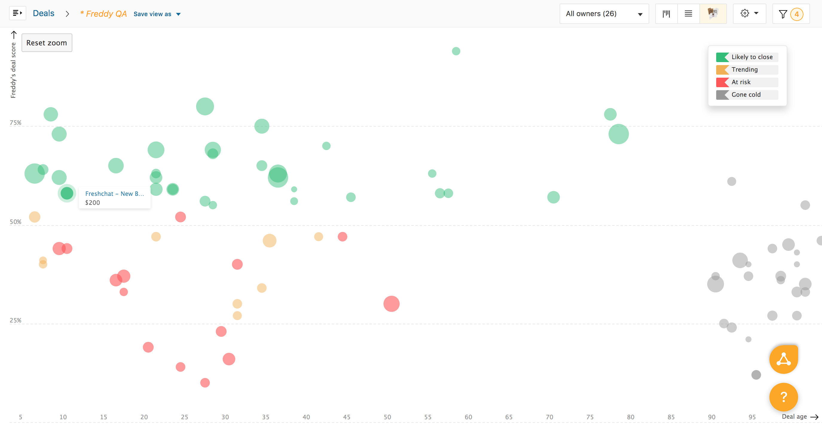

|  |  |
| --- | --- |
| **Squad/Team-name** | **Name** |
| Freddy Freshsales | Sarthak Dev |
| Freddy Freshsales | Jagadeesh Rajarajan |
| Freddy Freshsales | Sai charan |
| Freshsales Engineering | Sivalingam |
| Freshsales Engineering | Mudhabir |
| Freshsales UX | Pawan |
| Freshsales UX | Arun Murugan |
| Freshsales - Devops | Madhav |
| Freshsales - Devops | Sivakumar |
| Freddy Freshsales | Swaminathan |
| Freshsales Engineering | Sudharshan |
| Freshsales - Product | Aditi |
| Freshsales - Product | Srivatsan |
| Freshsales Engineering | Venkata Surya teja |
| Freshsales - QA | Logesh |

## **Success metrics - KPIs (Key Performance Indicators)**

**Correlation of Deal Outcome with Predicted TAGs** (at the time of Deal Closure):

|  |  |  |  |  |
| --- | --- | --- | --- | --- |
| Deal tag | # Deals Tagged | # Deals WON | # Deals Lost | # WIN ratio |
| Likely to WIN | 426 | 256 | 170 | 60.09% |
| Trending UP | 27 | 9 | 18 | 33.33% |
| Slipping Down (At risk) | 75 | 20 | 55 | 26.67% |
| Gone Cold | 266 | 21 | 244 | 7.89% |

## Plan to Boost the predictability of **Likely to WIN: (60% → 80%)**

|  |  |  |
| --- | --- | --- |
| Action Item | Estimated lift in the accuracy of predictions | Expected Completion Date |
| Including SA specific Attributes and Team Related Attributes | 5-10 % | Sep 30th |
| Removing OOO Emails and adding them as specific signals | 2-3 % | DONE |
| Removing Meeting related emails and adding them as specific signals | 5-10 % | Sep 15th |
| Email sentiment model | 5-10 % | Sep 15th |

## **Previous Aspirations Link:**[**Lead & Deal insights - July 2019**](https://confluence.freshworks.com/pages/viewpage.action?pageId=223779859)

## **Quarterly Goals & Progress:**

| Goals | Status | Comments |
| --- | --- | --- |
| Fixing for Missing Data on Emails, Calls etc.. | DONE (In Production) | This was causing wrong predictions for the TAGS: Gone Cold and At Risk. |
| Fixing the interpretability Messages | DONE (In Production) | There were cases where the interpretability messages didn't make sense. We had corrected such messages based on user feedback. |
| OOO Detection Model | DONE (In Production) | Need UI changes in product to display these as freddy's capabilities/skills. |
| Unsubscribe Detection Model | Models are ready for Deployment |  |
| Meeting Detection Model | Models are ready for Deployment |  |

## **Rest of the quarter Goals**

| Goals |
| --- |
| Activating Deal Insights for all eligible Freshsales customers |
| Automating Deal Insight engineering workflow using AWS Sagemaker |
| Lead Insights |

## **Learnings from Content:**

