# Title: Freshsales Architecture Diagram

# Architecture Diagram for freshsales.io

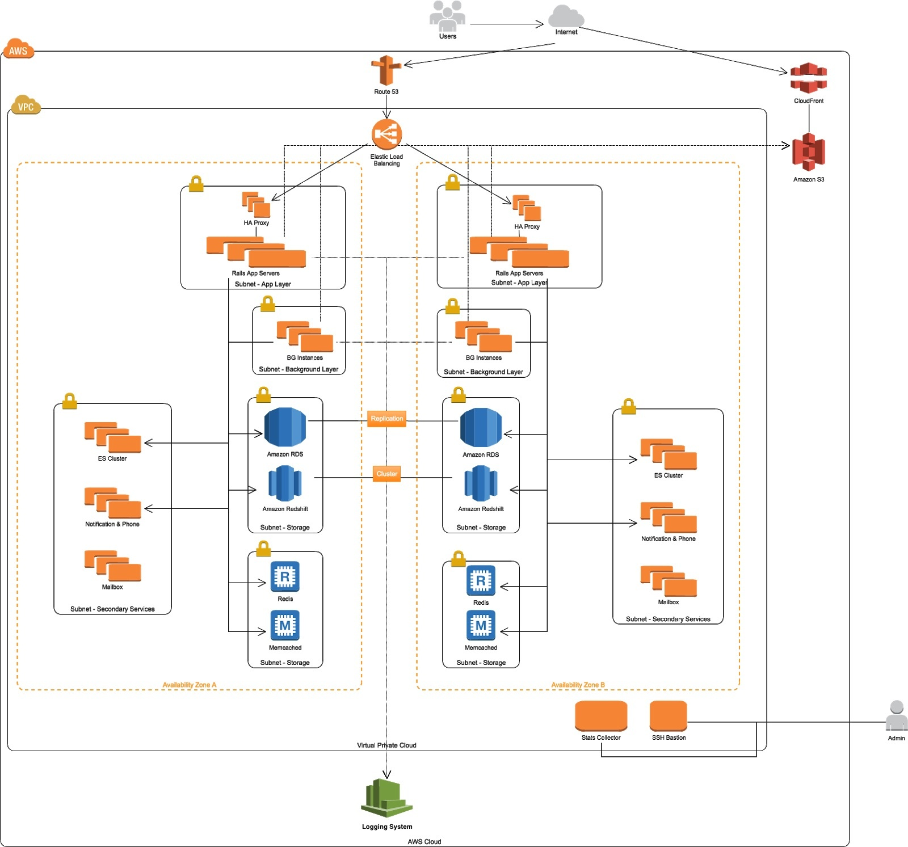

## NOTES

* + Main components of the freshsales
    - Rails App Server ( Ruby on Rails servers )
    - BG instances ( for executing the sidekiq jobs )
    - MySQL instances ( hosted as Amazon RDS )
    - Redis cluster ( Common cluster maintained by external team )
    - Memcache
    - Elastic Search clusters
    - Amazon Redshift ( for analytics )
    - Other common services including Central ( as mentioned in the 2nd diagram )
  + Production instances are present in 4 DataCenters.
  + **In each datacenter,**
    - Rails Apps server + BG instances are in 2 availability zones in **Active-Active** mode.
    - MySQL ( as Amazon RDS ) in one of the availability zone is Primary and in another it is Secondary. ( **Active-Passive** mode )
  + **Routing (refer to 2nd diagram)**:
    - **freshsales.io urls** are routed through Route53 to ELBs which forward it to the Rails application server through HA Proxies.
    - CRM accounts are routed by Edge Proxies => HA Proxy => Rails application server.

# Architecture Diagram including CRM

