# Title: Freshsales Chrome Extension

Freshsales chrome extension is built to allow sales agent to access their tasks/appointments or know about their contacts/leads present in the system and if not add them quickly into their Freshsales account. More on what the extension does are available at <https://support.freshsales.io/support/solutions/articles/232731-how-to-use-freshsales-google-chrome-extension-> and to install, here is the link: <https://chrome.google.com/webstore/detail/freshsales-for-gmail/ccicbbehhkhkcapfnooijdolaanagema?hl=fr>

## **Tech TL;DR:**

FreshSales chrome extension is build using Ember (version: 3.x, PS: And Ember 3.x is awesome ). As an ember app, we build the package into a *dist* path which is then packaged and published into the chrome store. Also a node based automation script has been written to lessen the burden of the entire build process. You can take a look at the same under the freshsales-browser-extension repo.

If you are looking for building chrome extension, this is the best place to start: <https://developer.chrome.com/extensions/getstarted>

## **Tech in detail:**

### Ember App:

Built with Ember 3.x and is super fast in terms of rendering the UI. Folder structure is the default blueprint created by the ember CLI plus a chrome-ext folder that holds the necessary meta files required for publishing the extension into the chrome store (background.js, content.js, manifest.json, etc).

###### Areas of improvement:

1. Move the chrome-ext meta files folder into a common ember addon repo that will be reused for other products, potentially clubbed with the packager addon as well.

### Packager:

Written in node, to combine the Ember production build, the git release tag, and bundler that helps zip the ember build and the meta files to a .zip that's required by chrome webstore. And this is all run under a simple single line command like `npm run build <environment> <release-type>`.

environment: development (default) | staging | production - Used for ember build command.

release-type: patch (default) | minor | major - Follows semver release.

###### Areas of improvement:

1. Write the same as an internal ember addon and release it for distribution across the org. (useful for eliminating redundant codebase for packaging for other products)
2. Merge the node based build into ember-cli's brocolli based build process so that an `ember chrome-package` like command can do all of the process.

## **Releases:**

### Version 1.x:

Here's a rough sketch of how the FreshSales chrome extension works. Though this was the first version which involved a non-performant event based communication between the gmail layer and the ember app, we moved that part into the ember app totally.

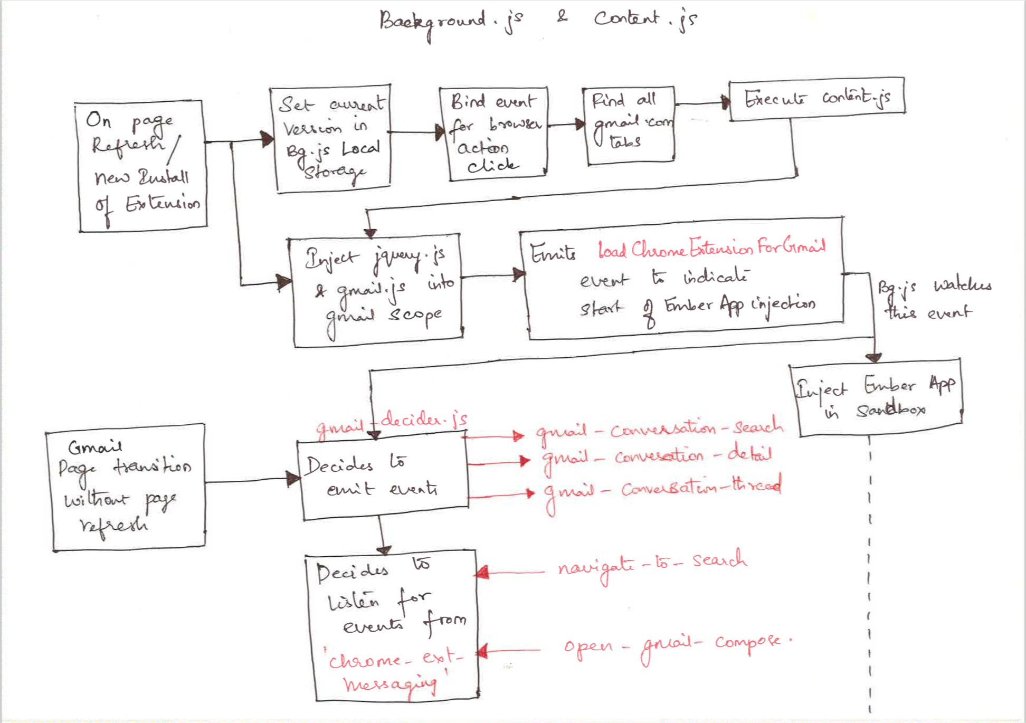

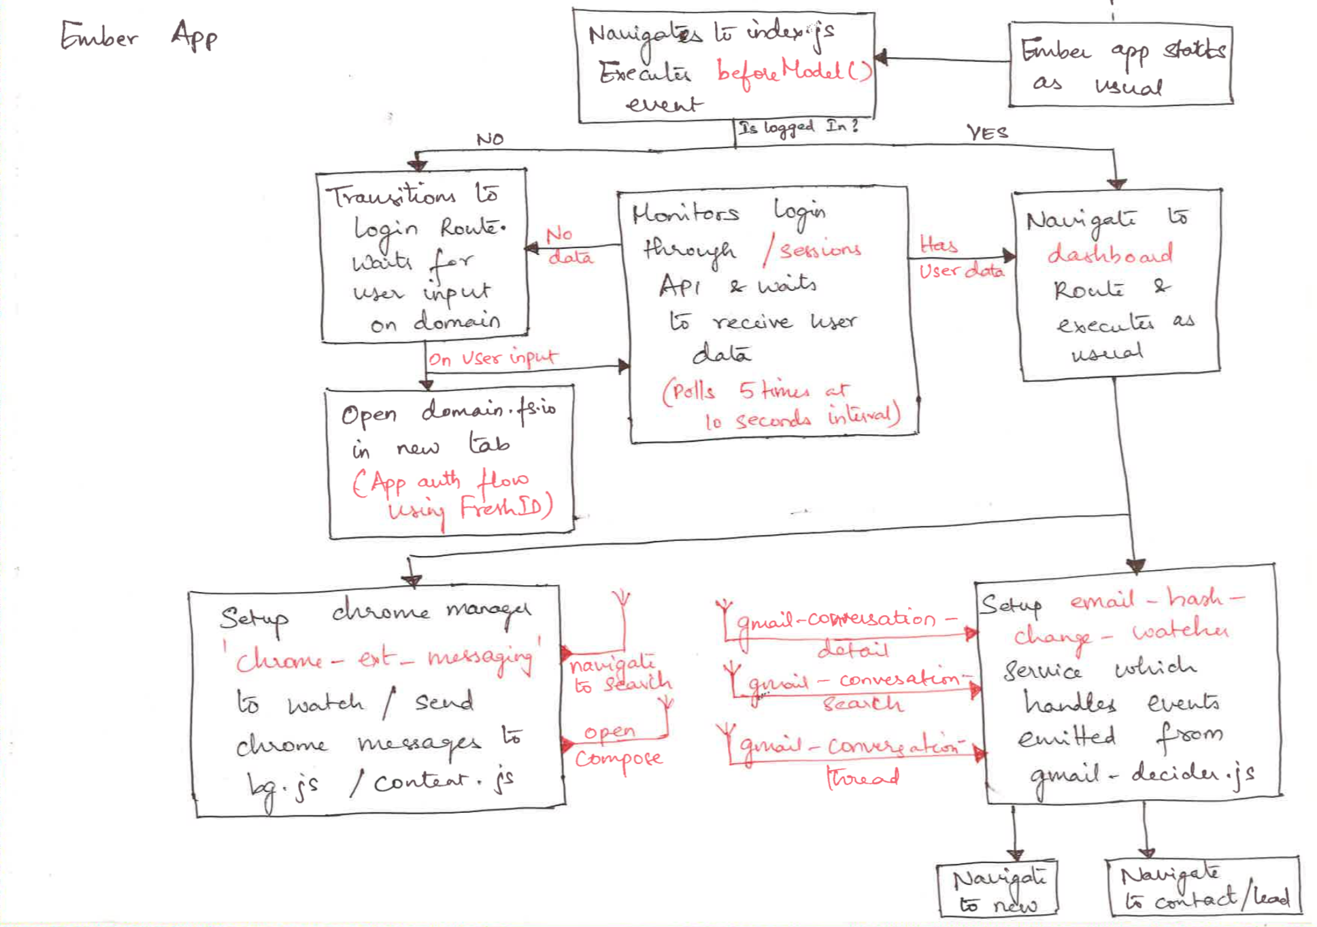

### Version 2.x:

The communication layer between the gmail interface and the ember app (extension) has been tweaked in such a way that, the ember app itself handles the changes of email thread clicks/opens and navigates to the corresponding route.

(coming soon)...