# Title: Freshsales Presales

* Org Structure
* Team Members - Contact info
* Goals
* Process (Day-in / Day-out)
* Aspirations
* New-hire Onboarding
  + Intro
  + Equipment & Tools
  + Product training Agenda (class room)
  + Exercise (To do’s in the product)
  + Mock Demo
  + Demo flow finalisation
  + Go Live - Tickets & Chat
  + Go Live - Demo & Account handling
  + Post Go-Live review (30 days from going Live)
* Collaterals
  + Demo flow (Best practices)
  + Ideal Demo notes template
  + Sample Discovery notes template
  + Sample Solution document template
  + Sample Proposal presentation template
  + Product Asks from Presales sheet (Freshrelease)
  + Best Demo recordings (Samples from different team members)
  + Knowledge Sharing session (Repository)
* Initiatives

## Org Structure

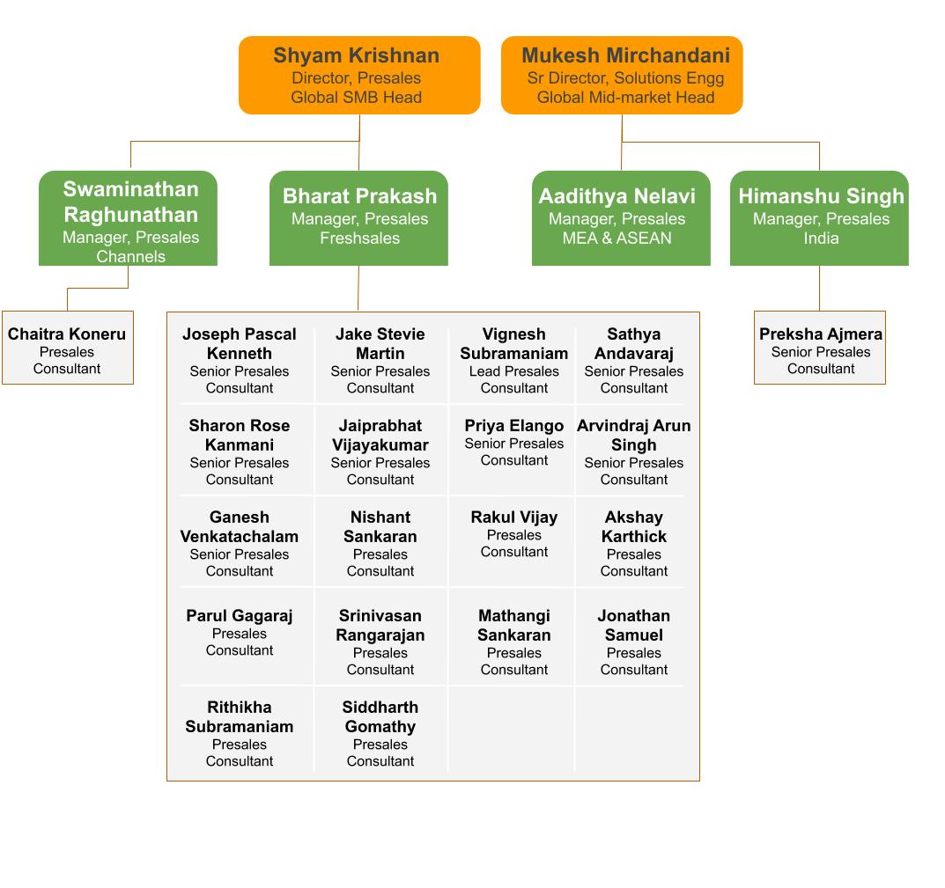

## Team Members - Contact info

|  |  |  |  |  |  |  |  |
| --- | --- | --- | --- | --- | --- | --- | --- |
| [S.NO](http://S.NO) | SEGMENT | NAME | ROLE | REGION | EMAIL | PHONE | AGE (years in Freshworks) |
| 1 | SMB | Bharat Prakash | Manager | Global | bharat.prakash@[freshworks.com](http://freshworks.com) |  | <1 |
| 2 | SMB | Vignesh Subramaniam | Lead | Global | [vignesh.subramaniam@freshworks.com](mailto:vignesh.subramaniam@freshworks.com) |  | 2+ |
| 3 | SMB | Sharon Rose Kanmani | Senior Product Consultant | RoE | [sharon.rose@freshworks.com](mailto:sharon.rose@freshworks.com) |  | 2+ |
| 4 | SMB | George Samuel | Senior Product Consultant | MEnA | [george.samuel@freshworks.com](mailto:george.samuel@freshworks.com) |  | 1+ |
| 5 | SMB | Jaiprabhat | Senior Product Consultant | ANZ | [jaiprabhat.vijayakumar@freshworks.com](mailto:jaiprabhat.vijayakumar@freshworks.com) |  | 1+ |
| 6 | SMB | Nishanth | Product Consultant | US East | [nishanth.sankaran@freshworks.com](mailto:nishanth.sankaran@freshworks.com) |  | 1+ |
| 7 | SMB | Arvindraj | Senior Product Consultant | RoE | [arvindraj.arun@freshworks.com](mailto:arvindraj.arun@freshworks.com) |  | 1+ |
| 8 | SMB | Ganesh | Senior Product Consultant | US West | [ganesh.venkatachalam@freshworks.com](mailto:ganesh.venkatachalam@freshworks.com) |  | 1+ |
| 9 | SMB | Jonathan | Product Consultant | US East | [jonathan.samuel@freshworks.com](mailto:jonathan.samuel@freshworks.com) |  | 1+ |
| 10 | SMB | Rakul | Senior Product Consultant | UK | [rakul.vijay@freshworks.com](mailto:rakul.vijay@freshworks.com) |  | 1+ |
| 11 | SMB | Mathangi | Product Consultant | India | [mathangi.sankaran@freshworks.com](mailto:mathangi.sankaran@freshworks.com) |  | 1+ |
| 12 | SMB | Parul | Product Consultant | ANZ | [parul.gajaraj@freshworks.com](mailto:parul.gajaraj@freshworks.com) |  | 1+ |
| 13 | SMB | Srini | Product Consultant | US West | [srinivasan.rangarajan@freshworks.com](mailto:srinivasan.rangarajan@freshworks.com) |  | 1+ |
| 14 | SMB | Akshay | Product Consultant | US Central | [akshay.karthik@freshworks.com](mailto:akshay.karthik@freshworks.com) |  | 1+ |
| 15 | SMB | Siddharth Gomathy | Product Consultant | US | [siddarth.gomathy@freshworks.com](mailto:siddarth.gomathy@freshworks.com) |  | 1+ |
| 16 | SMB Farming | Priya Elango | Senior Product Consultant | US Central | [priya.elango@freshworks.com](mailto:priya.elango@freshworks.com) |  | 1+ |
| 17 | Channels | Chaitra | Product Consultant | US | [chaitra.koneru@freshworks.com](mailto:chaitra.koneru@freshworks.com) |  | 1+ |
| 18 | Chat | Rithikha Subramanian | Graduate Trainee | ROW | [rithikha.subramanian@freshworks.com](mailto:rithikha.subramanian@freshworks.com) |  | 0-1 |
| 19 | Mid Market | Sathya Andavaraj | Senior Product Consultant | MEnA, UK & EU | [sathya.andavaraj@freshworks.com](mailto:sathya.andavaraj@freshworks.com) |  | 2+ |
| 20 | Mid Market | Jake Stevie Martin | Senior Product Consultant | USA | [jake.martin@freshworks.com](mailto:jake.martin@freshworks.com) |  | 2+ |
| 21 | Mid Market | Joseph Kenneth Pascal | Senior Product Consultant | USA | [joseph.kenneth@freshworks.com](mailto:joseph.kenneth@freshworks.com) |  | 2+ |
| 22 | Mid Market | Preksha Ajmera | Senior Product Consultant | India | [preksha.ajmera@freshworks.com](mailto:preksha.ajmera@freshworks.com) |  | 2+ |

## Goals

## Process (Day-in / Day-out)

## Aspirations

## New-hire Onboarding

#### Intro

#### Equipment & Tools

#### Product training Agenda (class room)

#### Exercise (To do’s in the product)

#### Mock Demo

#### Demo flow finalisation

#### Go Live - Tickets & Chat

#### Go Live - Demo & Account handling

#### Post Go-Live review (30 days from going Live)

## Collaterals

#### Demo flow (Best practices)

#### Ideal Demo notes template

#### Sample Discovery notes template

#### Sample Solution document template

#### Sample Proposal presentation template

#### Product Asks from Presales sheet (Freshrelease)

#### Best Demo recordings (Samples from different team members)

#### Knowledge Sharing session (Repository)

## Initiatives