# Title: Fuzzy de-duplication of leads and contacts

### Feature

Build scalable framework which can identify duplicates in spite of spelling mistakes, abbreviations, fields mismatch, phonetic similarity, etc.

### **Team**

|  |  |
| --- | --- |
| Team member name | Role |
| Bharathi | Freddy - Engineering |
| Srivatsa | Freddy - Data Science |
| Suvrat | Freddy - Lead |
| Ajeet | Core engineer |
| Sivalingam | Core lead |
| Madhav, Sivakumar | Devops |
| Swaminathan | Freddy |
| Sudharshan | Architect |
| Aditi, Srivatsan | Product |

**Timeline**

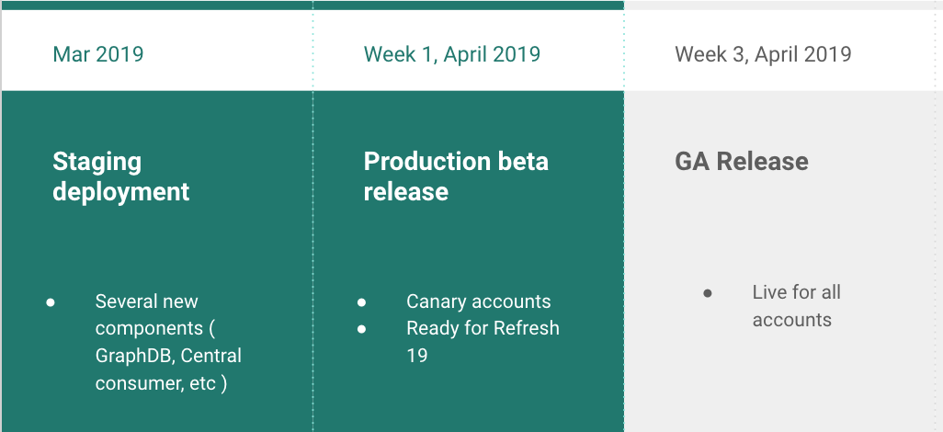

### **Success Metric to be measured**

|  |  |  |
| --- | --- | --- |
| Capability | ES based | Freddy based |
| Phonetic match | No | Yes |
| Field mismatch | No | Yes |
| Abbreviation | No | Yes |
| Spelling mistake | No | Yes |
| Domain match | No | Yes |
| Smart ranking | No | Yes |
| Pure string match on name | Yes | No |

Measure number of merges done currently vs Freddy based system

### **Demo**

### 

### **Model Metric**

|  |  |  |  |  |  |  |  |
| --- | --- | --- | --- | --- | --- | --- | --- |
| Test Accounts | AUC | Features Used | Positive | Negative | AUC | Average True Positive Rank | Average False Positive |
| Test set 1 | 0.92 | Prod features | 661 | 44,000 | 0.92 | 1.07 | NA |
| Test set 2 | 0.956 | Prod features | 752 | 503,000 | 0.96 | 1.034 | 0.25 |

### 

### **Architecture**

### 

### **Data science Model**

|  |  |  |  |
| --- | --- | --- | --- |
| Feature Name | Description | Why this feature is included ? | Priority Score |
| 1. Concat Name - Max Jaro Winkler | maximum of jaro winkler distances of (p_fn + p_ln, s_fn+s_ln) , (p_ln+p_fn, s_fn+s_ln) , (p_fn + p_ln, s_ln+s_fn) , (p_ln + p_fn, s_ln+s_fn) | Incorporates the similarity between the names of a pair of records, robust towards instances where the first name and last name are swapped |  |
| 2. Phone Match | exact match between (Last 6 digits of p_mobile_number , Last 6 digits of p_work_number) and (Last 6 digits of s_mobile_number, Last 6 digits of s_work_number) | robust towards variations in the way the phone numbers are entered - special characters, area and country codes at the beginning of the phone number | 13.82% |
| 3. Phone Given | if (p_work_number & p_mobile_number) or (s_work_number & s_mobile_number), return 1  else return 0 |  | 1.41% |
| 4. Company Name - Lname - Max Jaro Winkler | maximum of jaro winkler distances of (p_company_name, s_company_name) , (p_company_name , s_last_name) , (s_company_name, p_last_name) | captures similarity between company names or between company name and last name   * if two records are similar, then they might belong to the same company * also in some cases, the company name is entered in the last name field | 9.9% |
| 5. Number of exact token matches | intersection of no. of tokens / union of no. of tokens | captures similarity between two records based on the number of exact token matches - if this number is high, then there is a probable chance the two records are similar |  |
| 6. Number of phonetic token matches for first name and last name | intersection of no. of tokens / union of no. of tokens | captures the phonetic similarity between two names - they might differ in their spelling but might sound the same. Ex - John Smith & Jon Smyth |  |
| 7. Final Concat Name | Concat name + phonetic token match score | reinforces the concat score if the two names sound similar (Feature 6 and Feature 1 are not used explicitly - instead they are combined to form Feature 7) | 38.68% |
| 8. Final token match | Token match score with abbreviations of company names also included as tokens | reinforces the token match score if the abbreviations of the company names are similar. Ex - IBM and International Business Machines - these two have the same abbreviations and hence help increase the token match score. (Feature 5 is used along with abbreviations to form Feature 8) | 32.78% |
| 9. p_empty_fn | if the first name of the primary record is empty or not |  | 0.004% |
| 10. s_empty_fn | if the first name of the secondary record is empty or not |  | 0.66% |
| 11. p_empty_company | if the company name of the primary record is empty or not |  | 1.46% |
| 12. p_empty_company | if the company name of the secondary record is empty or not |  | 1.22% |
| 13. p_email_company | if an email address if present in the company name of the primary record or not |  | 0.002% |
| 14. s_email_company | if an email address if present in the company name of the secondary record or not |  | 0.006% |
| 15. p_email_ln | if an email address if present in the last name of the secondary record or not |  | 0.013% |
| 16. s_email_ln | if an email address if present in the last name of the secondary record or not |  | 0.012% |

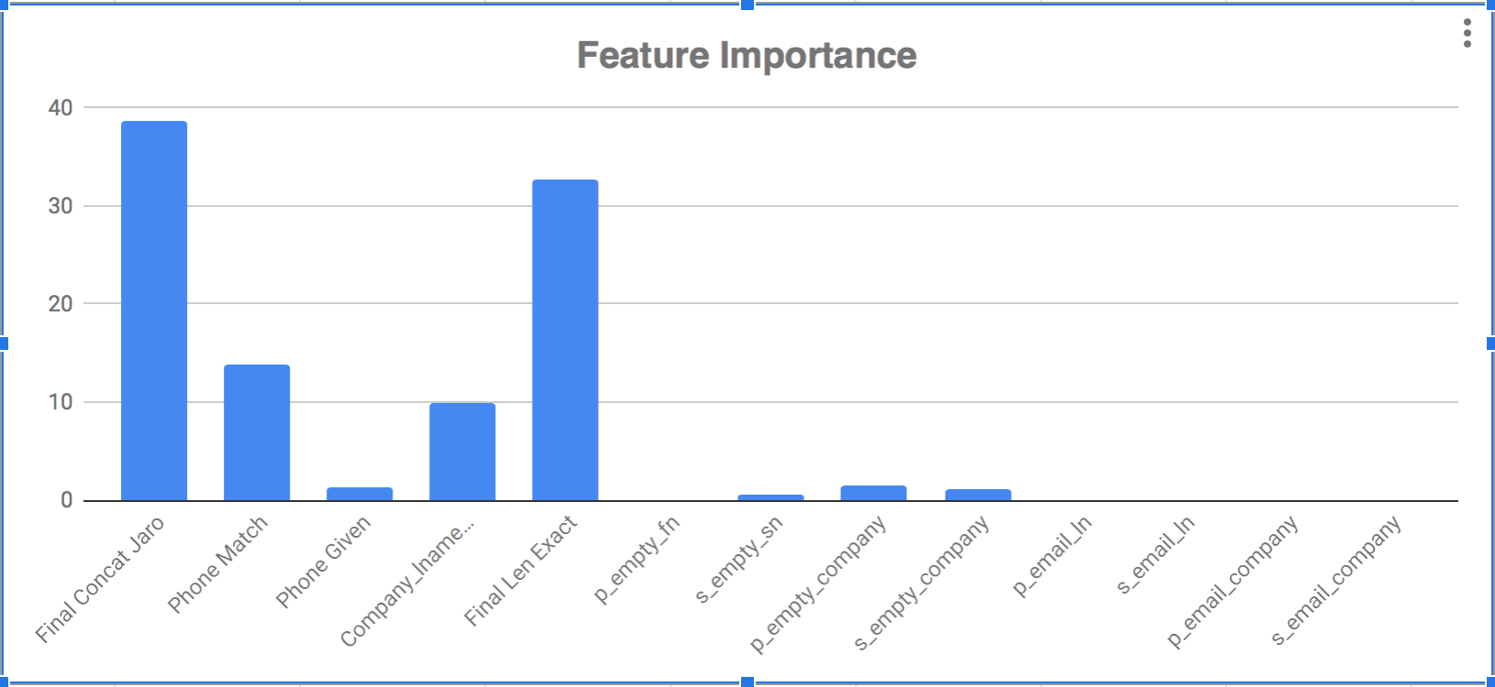

### **Q2 Plan**

1. De-dupe extensions
2. Next best action - Suggest best subsequent action for agents working on a deal (Research - DS)