# Title: Historical plots of revenue

Start date - 3/9/19

**We do not have data for revenue of subscription renewals. The data is for incoming/new deals. Hence, the problem must be defined as revenue forecasting for new deals**.

**Accounts for whom the monthly trend for all 3 years look similar**

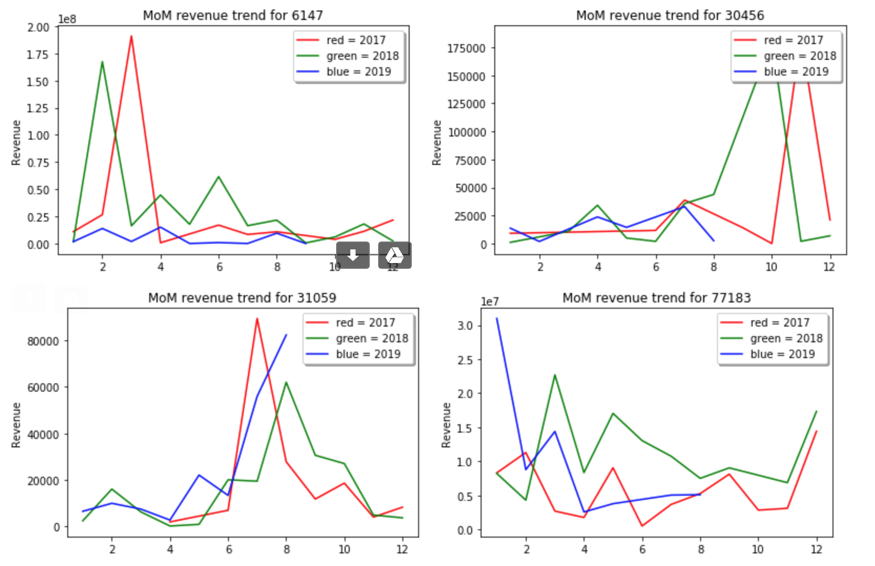

**If we can investigate what drove the peaks during the same months every year, it can be a useful seasonal signal for us.**

**Other interesting plots that can be discussed :**

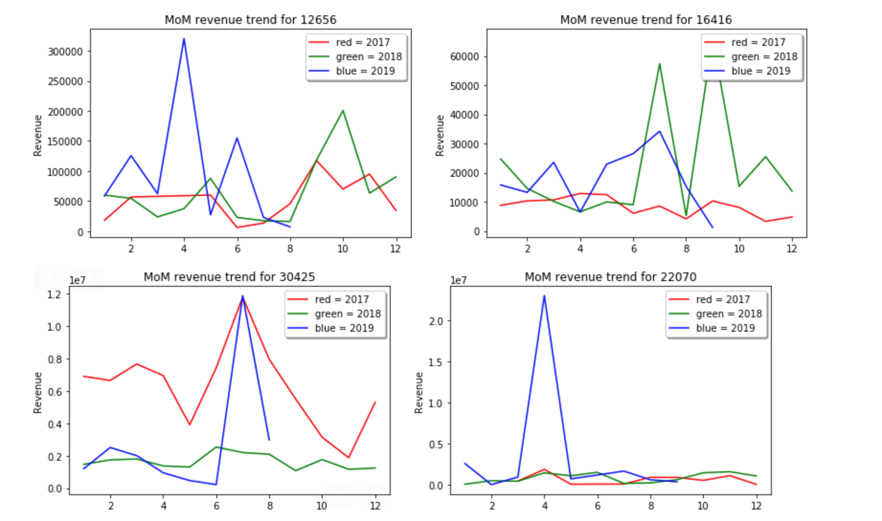

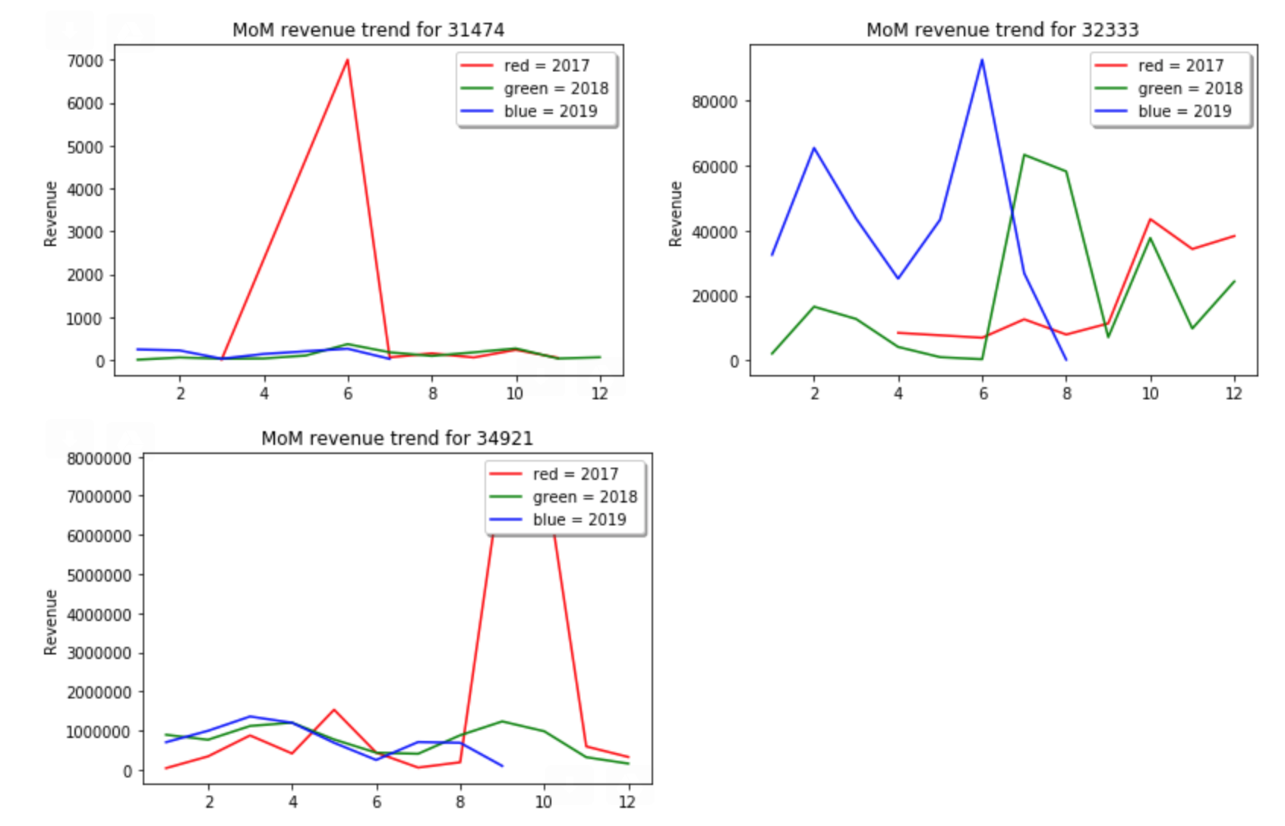

For these plots -

1. Account 30425 - there is a peak at month 7 for all 3 years - cause ??
2. Accounts 34921 , 31474 and 22070 - there is one huge peak , otherwise the trends are the same.

I have plotted revenue trends for other accounts too, but these are the ones which seem to have some decent patterns.