# Title: Learning from e-mail content - May 2019

[Adarsh Dattatri](https://confluence.freshworks.com/display/~adarsh.dattatri) [Sarthak Dev](https://confluence.freshworks.com/display/~sarthak.dev)

| **Aspirations - Q2 2019 - mid quarter update** Sales assistant , Freddy-freshsales, 21/05/2019 |
| --- |
|  |

Feature: Auto calendar scheduler

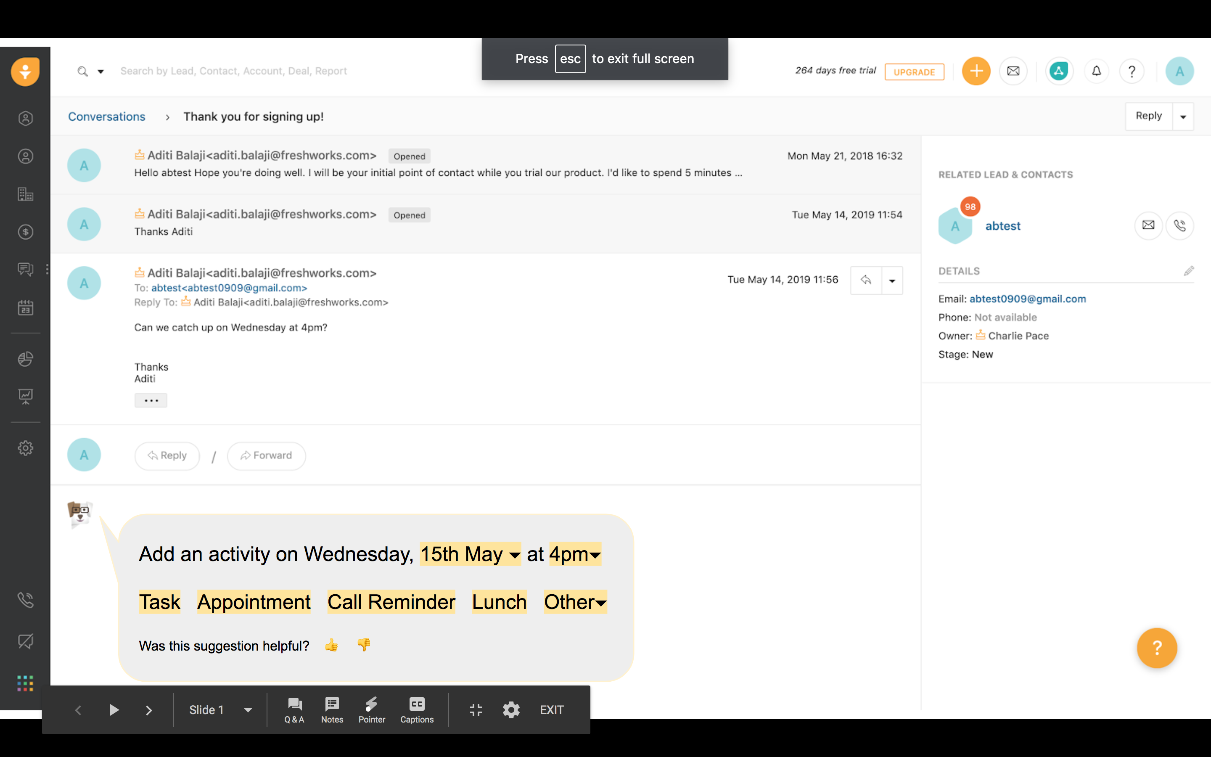

|  |  |  |  |
| --- | --- | --- | --- |
| **Squad/Team** | **Name** | **Email** | **Git home (if applicable)** |
| Freshsales - Freddy | Adarsh | [Adarsh Dattatri](https://confluence.freshworks.com/display/~adarsh.dattatri) | <https://github.com/freshdesk/freddy-freshsales-poc> |
| Swaminathan | [Swaminathan Padmanabhan](https://confluence.freshworks.com/display/~swaminathan.padmanabhan) |
| Rahul | [Rahulkumar Sharma](https://confluence.freshworks.com/display/~rahulkumar.sharma) |
| Vishal | [Vishal Gupta](https://confluence.freshworks.com/display/~vishal.gupta) |
| Freshsales - Product | Aditi | [Aditi Balaji](https://confluence.freshworks.com/display/~aditi.balaji) |
| Freshsales - Engineering | Sudharshan | [Sudharshan Jayasampath](https://confluence.freshworks.com/display/~sudharshan.jayasampath) |
| Sivalingam | [Sivalingam Selvasekaran](https://confluence.freshworks.com/display/~sivalingam.selvasekaran) |
| Freshsales - Devops | Madhav |  |

## **Success metrics - KPIs (Key Performance Indicators)**

| # | Goal area (direction/theme) | Features | Metrics |
| --- | --- | --- | --- |
| 3 | Sales assistant | * To detect calendar events in e-mail and prompt event scheduling * To detect closure intent (sentiment) from e-mail text | **Offline metrics**  **Calendar event detection:**  Precision@Recall  100%@25%, x@y    **E-mail sentiment:**  AUC=0.65 (plan to improve AUC) |

## **Timeline**

### **Calendar event detection**

|  |  |
| --- | --- |
| 21st April to 15th May | * v1 of calendar event detection Model * Nextwealth tags used to evaluate the performance |
| 15th May - ongoing | Engineering system for calendar event detection  Freshsales to send e-mail data via Kafka |

### **E-mail sentiment**

|  |  |
| --- | --- |
| 1st April to 15th May | * Models trained on historic deal outcomes with various classification and embedding techniques * NextWealth : Tagging of sales conversations to predict deal closure and mail intent |
| 15th May - ongoing | * Offline integration and comparison of mail sentiment scores with deal insights * Predicting sentiment using Customer+Agent mails for additional context * Training models on tags assigned by NextWealth * Pipeline development to predict sentiment real-time |

## **Previous Aspirations Link:**

[Learning from email content](https://confluence.freshworks.com/pages/viewpage.action?pageId=210018717)

## **Quarterly Goals & Progress:**

| Goals | Status |
| --- | --- |
| Calendar event detection:   * First version of the app to be deployed internally | In progress |
| E-mail sentiment:    * Integration with deal insights model * Making e-mail sentiment data available real-time (for sentiment widget) | In progress |

## **Innovation**

| Item | Description | Impact |
| --- | --- | --- |
| Customised vector representation of words/phrases for sales conversations | We have trained vectors for words/phrases used in sales conversations. Word vectors that are available are trained on generic text like wikipedia, news etc. | Representing text as vectors is an important step in NLP pipeline. This can now be used for other goals/tasks down the line |

## **Demo : Email Sentiment**

|  |  |  |
| --- | --- | --- |
| Scenario | Application | Samples identified with sentiment model **(conversations between 6th and 13th May)** |
| False Negative | Untagged deals (No change in deal score) with **Postive mail sentiment** | Customer : Abel, how to make the **next month's payment**? Best regards |
| Customer :  Is there any chance you can please **allow me another agent on trial for a month** as were **looking to expand the team and I want him to get used to the** **system** before we roll it out at that site? |
| False Positives | Likely to Win/Trending Up deals with **Negative mail sentiment** | Customer: The **project is currently on hold**. I’ll get back to you once it’s back on track.  Agent: I have tried reaching you out to you multiple times. Have you put this project on hold, or is it not priority for you right now? I would love to help you evaluate the tool once again and offer flexible pricing as well. :) Let me know how would you like to proceed, otherwise, I will just keep this on hold respecting your time and mine. |
| Agent : Would you like me to put you in touch with the Sydney office since you might be more comfortable evaluating in person?  Customer : Siddhi, **We’ve decided to go with another solution**, so that won’t be necessary. Thanks for the information & assistance along the way. --Bruce  Agent: No worries, thanks for the update. :) |
| Agent : How are you? Hope the start of the spring is treating you ok. Unfortunately, I was unable to reach you just now, would it be possible to reach you next week by phone? Very interested to see if we can kickstart the service desk project again and get an introduction to the IT team.  Customer : Good Morning Mr. Boven, Our CIO have finally **decided to extend our contract with supplier in place @ BESIX**. Thank you for your interest in our company. |