# Title: Marketplace Onboarding

## Scope

To onboard Freshsales in Marketplace and enable third party developers to develop apps for Freshsales.

## Proposal

1. Load the list of integrations in Freshsales through iFrame from Marketplace
   1. If number of integrations > 25, it makes sense to have a gallery view (example - <https://apps.freshdesk.com/>)
   2. Until then, we have list view, same as the one we have now.
2. Provide events and API's to enable external developers to build apps for Freshsales through Marketplace

## Basics

1. Marketplace will build iFrame that can be plugged into Freshsales. Freshsales will review and maintain this post release.  
   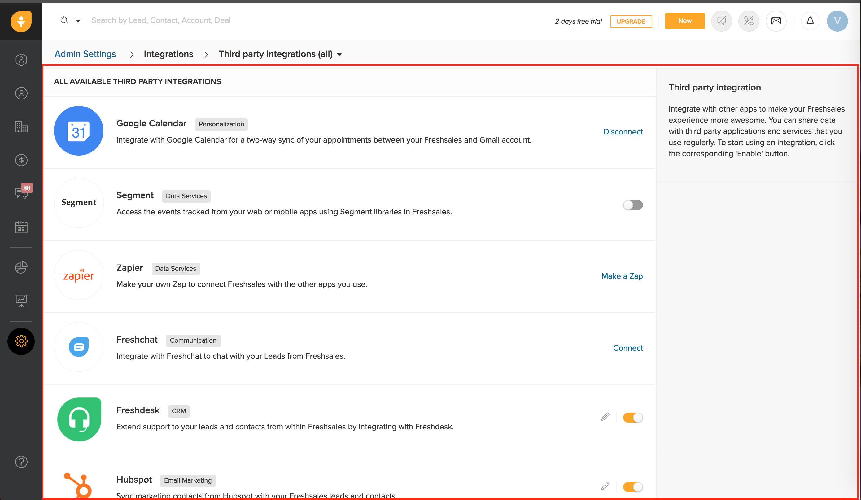
2. Freshsales will help marketplace to migrate all existing app and installations. We need to provide following list
   1. List of apps that Freshsales currently supports. This is a global list and doesn't require to be saved in specific regions.
   2. List of installed integrations per account. This is account specific list that should be saved in specific regions. Marketplace current supports US, EU, EUC and Australia. This migration is the most important work that is to be figured out.
3. Going forward, any new app that is to be listed in Freshsales should be listed through Marketplace.

## Documentation

[Marketplace onboarding](https://freshwave.atlassian.net/wiki/spaces/MAR/pages/32997684/Onboarding)

[Freshsales onboarding to Marketplace](https://freshwave.atlassian.net/wiki/spaces/MAR/pages/34079480/Freshsales+Onboarding)

[Marketplace API v2](https://developer.freshdesk.com/v2/docs/quick-start/)

[Freshsales Onboarding to Marketplace Checklist](https://docs.google.com/spreadsheets/d/1AG5MAe3t3VmGuANcWpo478hPEuDoxgT0jJvVLFtleBc/edit#gid=0)

[Marketplace support levels](https://freshwave.atlassian.net/wiki/spaces/MAR/pages/34243152/Support+Levels)

## Open Questions and Decisions

Q1: Marketplace iFrame requires authentication through FreshID. But Freshsales is not yet in FreshID and we are expecting January timeline.

D1: Marketplace agreed to look into this. In worst case, different authentication should be tried out.

Who? Marketplace

Q2: After onboarding happens, how can a developer in Freshsales add a new app and try it out in dev and staging environment?

D2: Though staging setup exists, there is no development setup. Marketplace team has agreed to provide a docker for this.

Who? Marketplace

Q3: Account ID, Product ID, Pod/region are the parameters expected to be passed to the web application when the iFrame URL is loaded

D3: If Freshsales is not in EUC during launch, then we will default to US as region for all accounts.

Who? Freshsales

Q4: Though account level integrations are supported, user level integrations are not supported in Marketplace.

D4: We need to evaluate on how to do migration of user level integrations. Also, we need to decide on how to show UI for user level integrations.

Who? Freshsales and Marketplace

Q5: We are currently sending events(create/update/delete) for Lead and Contact. Should we send events for Accounts and Deals.

D5: This is not required for Phase 1. But when we need to build apps in Marketplace, then we need to do this.

Who? Freshsales. Deferred for Phase 1.

Q6:  How does native integration continue to work?

D6: When customer clicks to enable in iFrame, Marketplace will redirect to Freshsales to render the view. From then on Freshsales will take over the flow and install the app. Once done, we need to send install event to Marketplace API. This applies for edit and uninstall too. This way, Freshsales installed integration list will continue to remain as source of truth.

Who? Freshsales.

Q7: To build serverless apps in Marketplace, Freshsales should be sending events to Central.

D7: We need to evaluate the roadmap and plan for central onboarding. Until then events that we are sending to Freshpipe through IRIS, marketplace will suffice.

Who? Freshsales. Deferred for Phase 1.

Q8: For developer portal, Freshsales needs to provide authentication support.

D8: To start with, Freshsales will use developer portal of Freshdesk. When a separate developer portal is imminent, we need to build auth.

Who? Freshsales. Deferred for Phase 1.

Q9: Marketplace can be given as a feature.

D9: We need to decide whether Marketplace is open for all plans. For engineering, it makes sense to provide it as a feature.

Who? Freshsales.

## Current list of apps in Freshsales

1. Freshdesk - Native and Pipe app - Account level
2. Hubspot, Mailchimp - Pipe app - Account level
3. Freshchat - Native app - Account level
4. Segment - Native app - Account level
5. Google calendar - Native app - User level
6. Zapier - External app - Account level
7. Quickbooks - Native app - Account level (not in prod yet)
8. Office 365 - Native app - User level (not in prod yet)

## How to onboard a new app to Marketplace?

TBD

## Migration of existing integrations per account to Marketplace

TBD

## Mocks

TBD