# Title: Rspec optimizations and refactoring

This is how we optimized and reduced execution time of documents_controller_spec.rb in local machine from 1 minute 20 seconds to just 31 seconds.

1. Made testcases atomic. Zero dependency on any other test. Here is how you can do that:
   1. Create a specific user for the spec file. Since documents controller actions have user specific use-cases, we created a new user and used it across the file.
   2. Zero traces left. Delete all data that is created during execution of testcases.
   3. Rollback every change you make. eg. in the beginning of testcase if you made a specific account or user as current user or current account, reset it to default state.
2. Skip unwanted callbacks while creating LCAD. Since most of our testcases are based on LCAD, we should put at-most care while creating those records.  
   How to skip unnecessary callbacks?   
   **Old way of creating lead** - FactoryGirl.create(:lead, owner_id: current_user_id)  
   **Optimized way of creating** :  
   include EntityCreationHelper  
   FactoryGirl.create(:lead, { owner_id: current_user_id }.merge(skip_attributes))  
     
   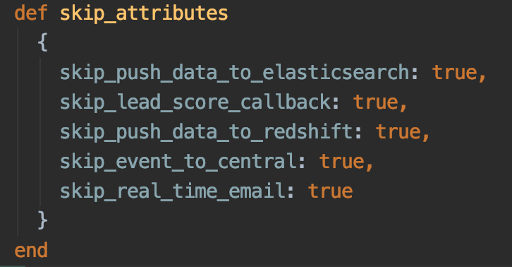

**PR -**[**https://github.com/freshdesk/freshsales/pull/2678**](https://github.com/freshdesk/freshsales/pull/2678)