# Title: Sales Goals Tech Spec [BACKEND]

## Major Engineering key Points:

1. Historical sync will be provided while creating/editing/manual-recalculate goals and separate Sidekiq process will trigger it by fetching all model for that particular goal and update it.
2. Real-time sync will be provided for updating the matched condition, For batch process overhead will be high.
3. All card view data will be computed during the run time and get from Freshsales ES cluster.
4. All Filter, view and card data will be provided from Our ES cluster, But data will be in Sync with the Search service cluster.
5. Filter be provided based on will_filters.
6. **While editing the goal past date should not be allowed to edit.**
7. **Dates cannot be changed since it is like removing and re-adding.**
8. rule_engine will be triggered for active goals only.
9. Import was provided from existing import modules
10. No Form service was used.
11. The central payload was designed and in Review(Will be pushed only after approval.

**CUD**

1. Goal creation → Model save → historical goal SideKiq → Fetch all model data (deals/call/appointments) based on condition → update in the **sales_goals** table
2. Goal updation → Recompute if necessary by separate Sidekiq → send notification based on condition(50%,80%,100%).
3. Goal deletion → model delete
4. On Deal, updation → Check if it is done a deal(previous/current state) → Match using rule_engine → update all goal model
5. For all above 4-8  upon deletion or edit based on the condition we need to **remove and readd** the respective goals on the **same thread**
6. For all sync/import/bulk deletion/bulk-edit → Match using rule_engine→ update goals at once
7. Default goal filter(along with 4 cards and 4 charts ) will be given along with **sessions** request.
8. **(V2)**Task completion →  Match(Completed date) using rule_engine → update all goal model
9. **(V2)**Appointment Creation → Match(Appointment date) using rule_engine → update all goal model
10. **(V2)**Other  custom activities creation→ Match(creation date) using rule_engine → update all goal model
11. **(V2)**Email conversation send from product→ Match(Appointment date) using rule_engine → update all goal model

PS: During creation for teams all users will be given and for backend, all user and corresponding value should be defined

**Flow of attainment calculation**

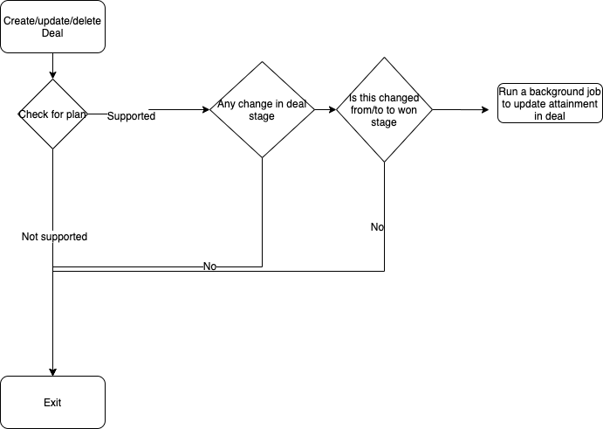

**Attainment calculation in Background jobs**

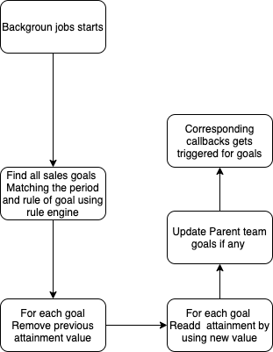

**For Manual attainment calculator**

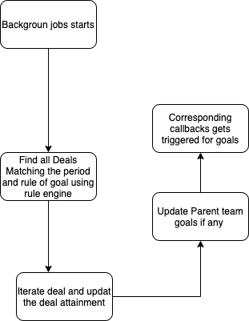

**Rendering**

Get data from **sessions** request → Get all deals list with pagination

Card view data will get from ES on real-time.

## DB Design(Optimised for high reads)

The goal can have an owner (Either User, Team)

The goal has 1 or more participant (1-n Users)

**sales_goals - Partition()**

|  |  |  |  |
| --- | --- | --- | --- |
| Column name | Type | Other | notes |
| Id | BIG INT UNSIGNED | PK auto generated |  |
| account_id | BIGINT UNSIGNEED | NOT NULL |  |
| period | TINYINT | NOT NULL | Monthly/weekly/yearly |
| owner_id | BIGINT UNSIGNED | polymorphic |  |
| owner_type | Varchar(32) | polymorphic |  |
| start_time | TIMESTAMP | NOT NULL |  |
| end_time | TIMESTAMP | NOT NULL |  |
| measure_type | TINYINT | NOT NULL | Amount/activities/ |
| va_rule_id |  | NOT NULL | Rule engine validation |
| target |  | NOT NULL |  |
| parent_id | BIGINT |  |  |
| attainment | BIGINT UNSIGNED |  |  |
| creater_id | BIGINT UNSIGNED |  |  |
| updater_id | BIGINT UNSIGNED |  |  |
| is_deleted | BOOLEAN | NOT NULL, Default → 0 |  |
| - | timestamps |  |  |
| import_csv_id | TEXT | Import |  |

**i**

**Goal Widget(V2)**

|  |  |  |  |
| --- | --- | --- | --- |
| Column Name | TYPE | OTHER | NOTE |
| account_id | BIG INT UNSIGNED |  |  |
| user_id | BIG INT UNSIGNED |  |  |
| targetable_id | BIG INT UNSIGNED | POLYMORPHIC - Between card/widget |  |
| targetable_type | BIG INT UNSIGNED | POLYMORPHIC - Between card/widget |  |

**Index:**

**account_id,goal_id**

**Stats**

Task- 22K

Appointment - 7K

sales_activites - 29K

Email conversation - 697K

For 1 month of period of  freshdesk account

## REST API Endpoints & response

Swagger Link : <https://app.swaggerhub.com/apis/freshworks/Freshsales/1.0.0>

get filter - GET - /sales_goals/filter

update widgets - PUT - /sales_goals/widgets

get card data - GET - /sales_goals/widgets/card/ID

get chart data - GET - /sales_goals/widgets/chart/ID

update widgets - PUT - /sales_goals/widgets

get goal list - GET - /sales_goals/filter/ID

create sales goals - POST /sales_goals/

update sales goals - PUT /sales_goals

delete - DELETE /sales_goals

## Plan and billing  related

All process will get executed even when the account got downgraded

## Roles related

Everything will be based on scope only. The new permission was be created and scope was be defined