# Title: Sleeper Cells Sprint 1 - Sprint Planning

* First sprint started with cleaning up the existing board

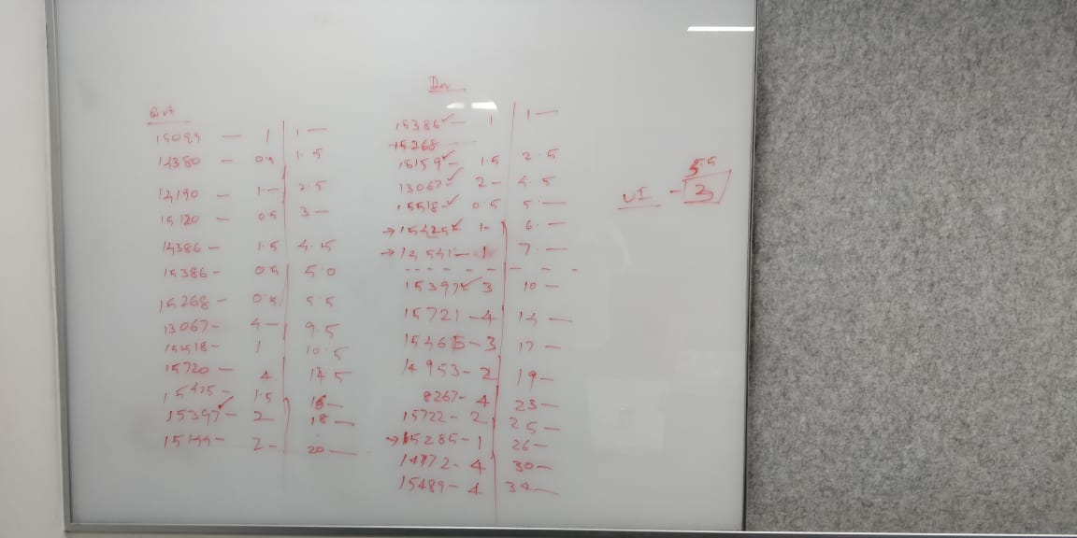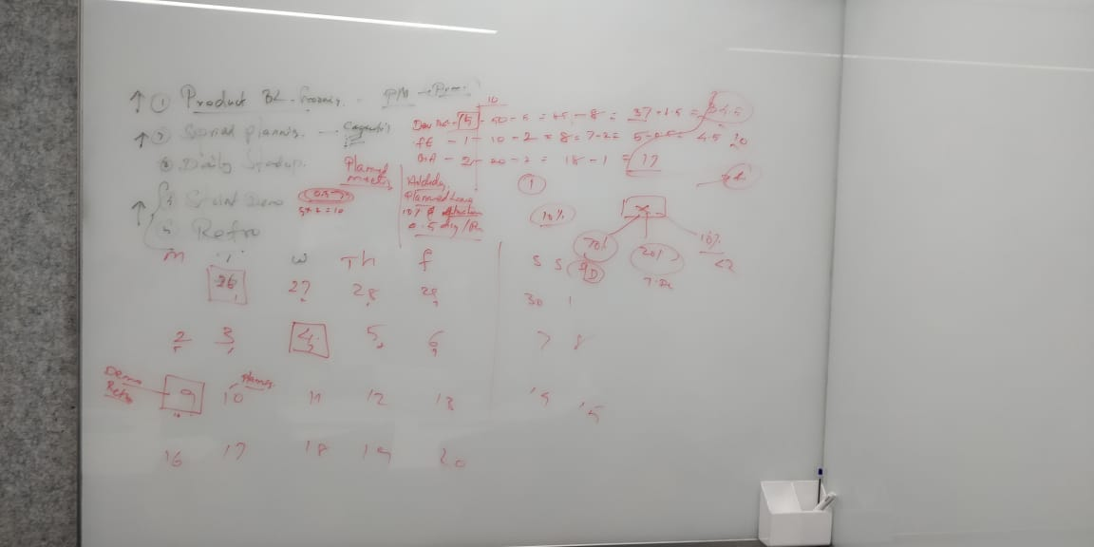

* We committed 13 items for QA and 23 items fo dev(including 13 QA items)