# Title: Sleeper Cells Sprint 2 - Sprint Planning

Sprint Started with 21 spillover items and picked 6 new items for the planning

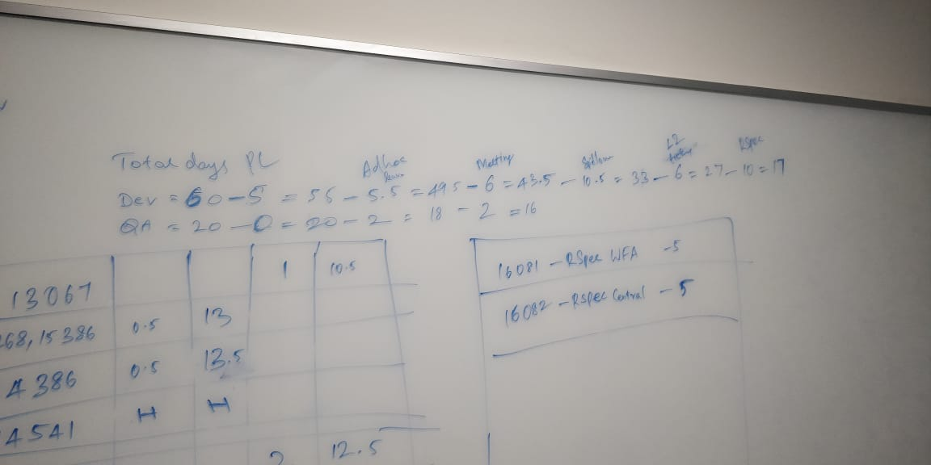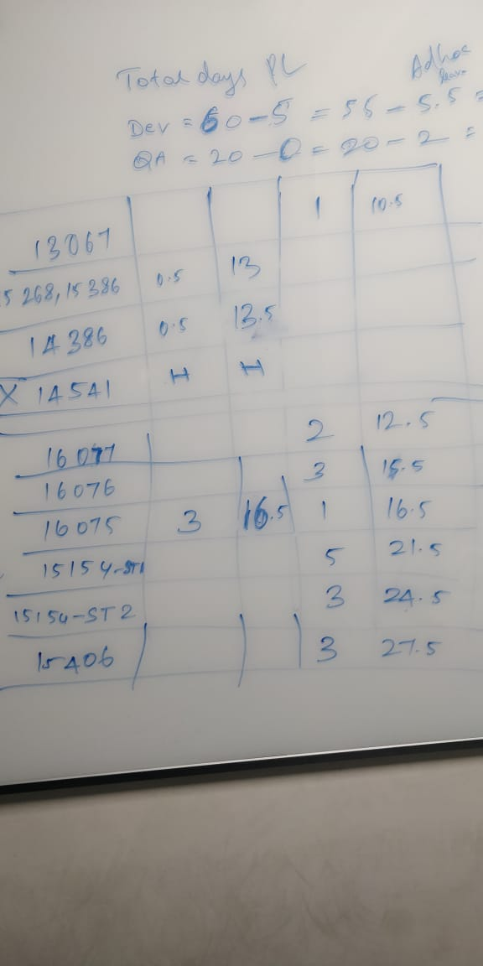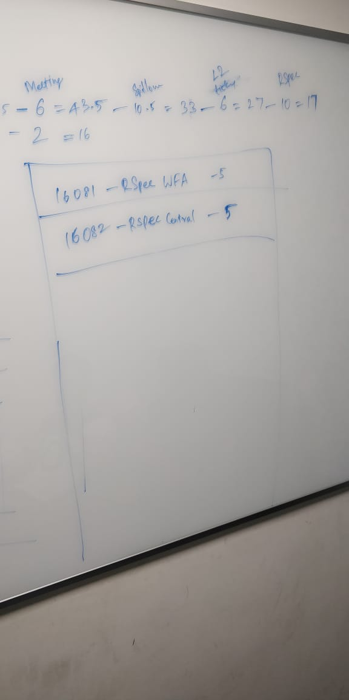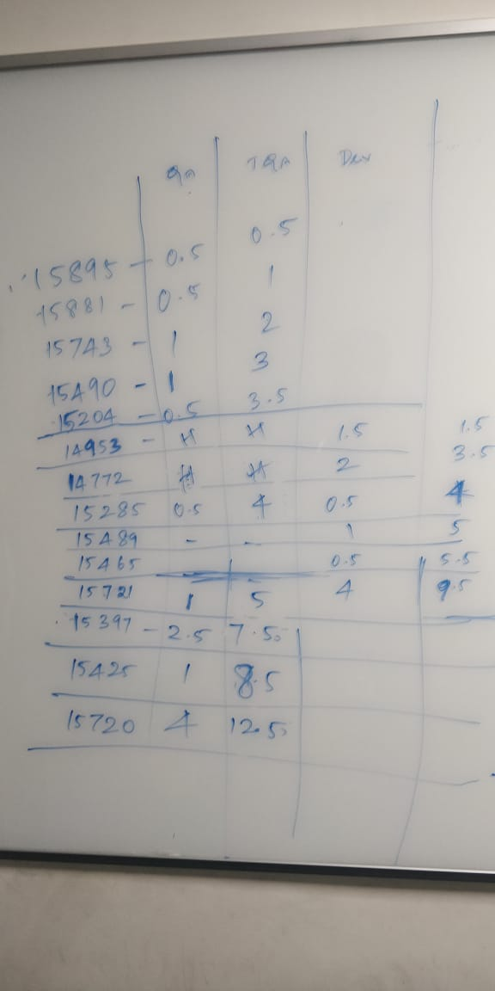

Committed 14 items for production push and 13 items till Ready to test