# Title: Sleeper Cells Sprint 3 - Sprint Planning

Started the Sprint with 18 spillovers and picked 2 new items in the planning

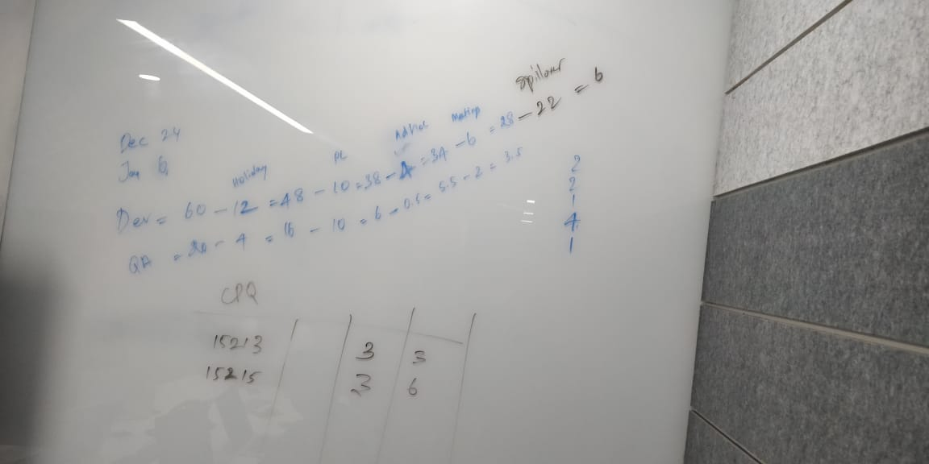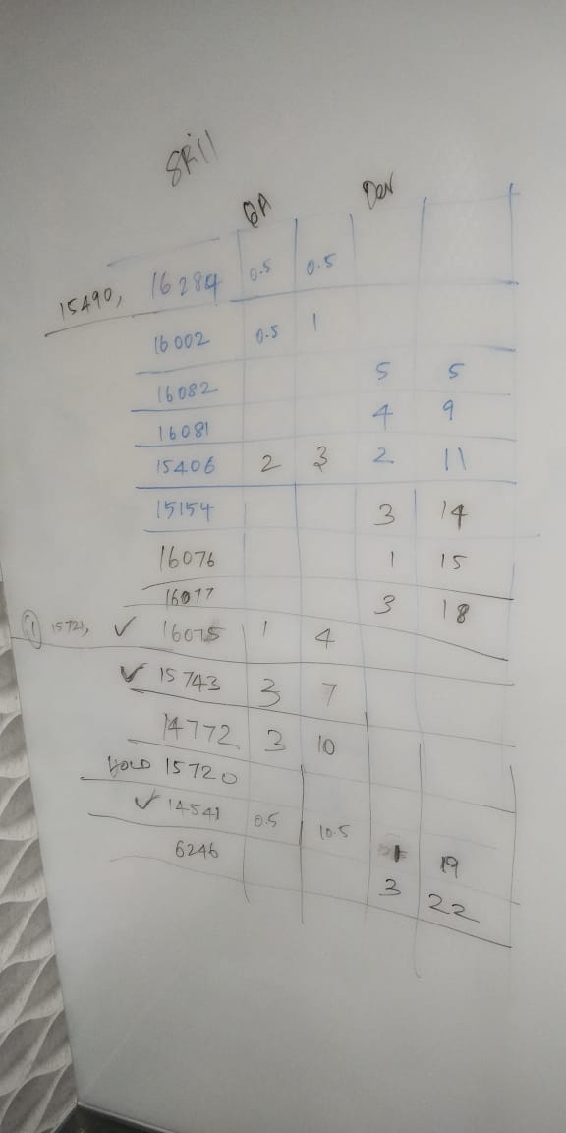

Committed 11 items to be pushed to prod and 8 items to be ready for test and 1 item to HOLD