# Title: Sleeper Cells Sprint 4 - Sprint Planning

Started the sprint with 15 spillovers and picked up 2 new items for the sprint

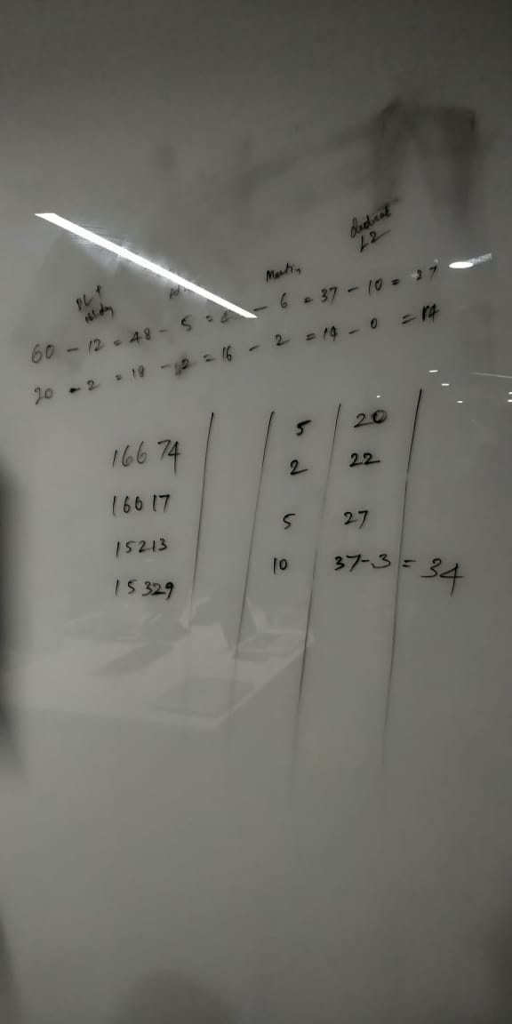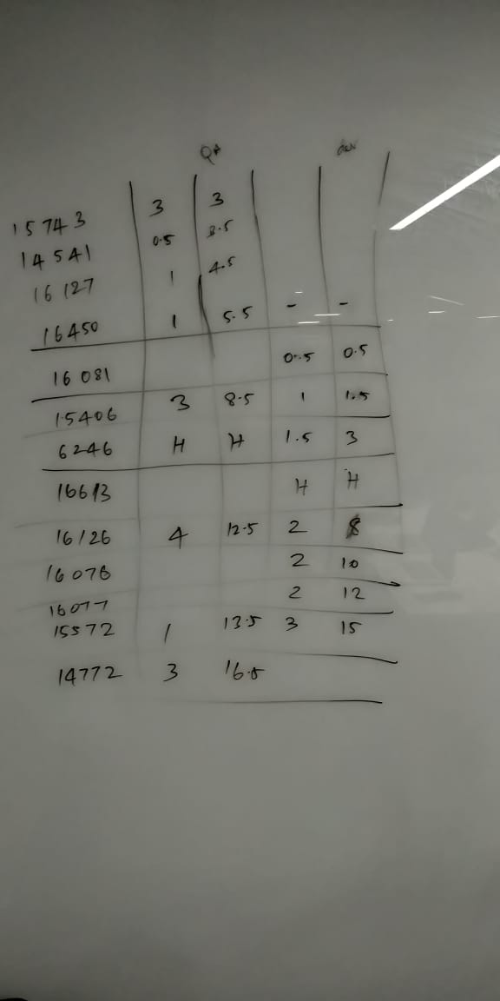

Committed 8 items for prod push and 8 items for ready for test and 2 items on HOLD(1 in dev and 1 in QA)