# Title: Sleeper Cells - Q3 2019 Aspirations



|  |
| --- |
| **Aspirations - Q3 2019** Freshsales, Sleeper Cells09 Jul 2019 |
| Mission:   * Provide better reporting in CRM space * Continue evolving integrated phone in Freshsales * Powerful automations - Workflow, Sales Campaign * Plans & Billings |

|  |  |  |  |
| --- | --- | --- | --- |
|  | **Name** | **Email** | **Git home (if applicable)** |
| **Tech Lead** | Sivalingam | [sivalingam.selvasekaran@freshworks.com](mailto:sivalingam.selvasekaran@freshworks.com) |  |
| **Squad Lead** | Manikandan | [manikandan.subramaniam@freshworks.com](mailto:manikandan.subramaniam@freshworks.com) |  |
| **Product Owner** | Swati | [swati.sharma@freshworks.com](mailto:swati.sharma@freshworks.com) |  |
|  | Aditi | [aditi.balaji@freshworks.com](mailto:aditi.balaji@freshworks.com) |  |
| **Members** | Kathirvalavan | [kathirvalavan.soundarajan@freshworks.com](mailto:kathirvalavan.soundarajan@freshworks.com) |  |
|  | Rohan | [rohan.anand@freshworks.com](mailto:rohan.anand@freshworks.com) |  |
|  | Bivil | [bivil.jacob@freshworks.com](mailto:bivil.jacob@freshworks.com) |  |
|  | Mudhabir | [mudhabir.ahmed@freshworks.com](mailto:mudhabir.ahmed@freshworks.com) |  |
|  | Prakash | [prakash.thiyagarajan@freshworks.com](mailto:prakash.thiyagarajan@freshworks.com) |  |
|  | Varshitha | [lakshmisai.varshitha@freshworks.com](mailto:lakshmisai.varshitha@freshworks.com) |  |
|  | Ajeet | [ajeet.pandey@freshworks.com](mailto:ajeet.pandey@freshworks.com) |  |
|  | Teja | [venkatasurya.tejamatcha@freshworks.com](mailto:venkatasurya.tejamatcha@freshworks.com) |  |
|  | Athish | [athishpranav.sethuram@freshworks.com](mailto:athishpranav.sethuram@freshworks.co) |  |
|  | Ramkumar | [ramkumar.ramani@freshworks.com](mailto:ramkumar.ramani@freshworks.com) |  |
|  | Logesh | [logesh.srinivasan@freshworks.com](mailto:logesh.srinivasan@freshworks.com) |  |

## **Success metrics - KPIs (Key Performance Indicators)**

|  |
| --- |
| 1. Features shipped 2. Number of tickets resolved 3. Test cases automated - RSpec coverage 4. Number of UI test cases automated |

## **Previous Aspirations Link:**

[**Sleeper Cells - Q2 Mid 2019 Aspirations**](https://confluence.freshworks.com/pages/viewpage.action?pageId=218071955)

**Results: How did we do since last Aspirations? (Planned vs Delivered - Summaries the results and provide applicable links)**

|  |  |  |
| --- | --- | --- |
| Goal (from previous Aspirations) | Results | Deliverables |
| SMS: Support replies via providers | Done | <https://freshworks.freshrelease.com/FSALES/issues/FSALES-10433> |
| Integrate with Zipwhip for SMS capabilities | Done | <https://freshworks.freshrelease.com/FSALES/issues/FSALES-10094> |
| SMS action in sales campaign | Done | <https://freshworks.freshrelease.com/FSALES/issues/FSALES-10095> |
| ML - Freddy deal insights | Done | <https://freshworks.freshrelease.com/FSALES/issues/FSALES-10105>  <https://freshworks.freshrelease.com/FSALES/issues/FSALES-8194> |
| View sharing (enabling territory, team for views) | Done | <https://freshworks.freshrelease.com/FSALES/issues/FSALES-8709> |
| Sales campaign - Step level filters to include conditions on Task and call reminder | Done | <https://freshworks.freshrelease.com/FSALES/issues/FSALES-8648> |
| Optimise filter index query | Done | <https://freshworks.freshrelease.com/FSALES/issues/FSALES-11185> |
| Filters revamp (Comma not supported in filter value) | Done | <https://freshworks.freshrelease.com/FSALES/issues/FSALES-10533> |
| Email template sharing | Done | <https://freshworks.freshrelease.com/FSALES/issues/FSALES-8712> |
| Central Payload pushing form meta data | Done | <https://freshworks.freshrelease.com/FSALES/issues/FSALES-11184> |
| FreshID org V2 migrations | Done | <https://freshworks.freshrelease.com/FSALES/issues/FSALES-10739> |
| Outlook Addon | In Testing | <https://freshworks.freshrelease.com/FSALES/issues/FSALES-10640> |
| SMS : Assign number to users | In Testing | <https://freshworks.freshrelease.com/FSALES/issues/FSALES-11267> |
| Freshreports migration | In Progress | <https://freshworks.freshrelease.com/FSALES/issues/FSALES-11006> |
| Increasing the custom field limits | In Progress |  |
| Org V2 Migrations - Iterations | In progress |  |

Optimise filter index query metrics

<https://freshworks.freshrelease.com/FSALES/issues/FSALES-11185>

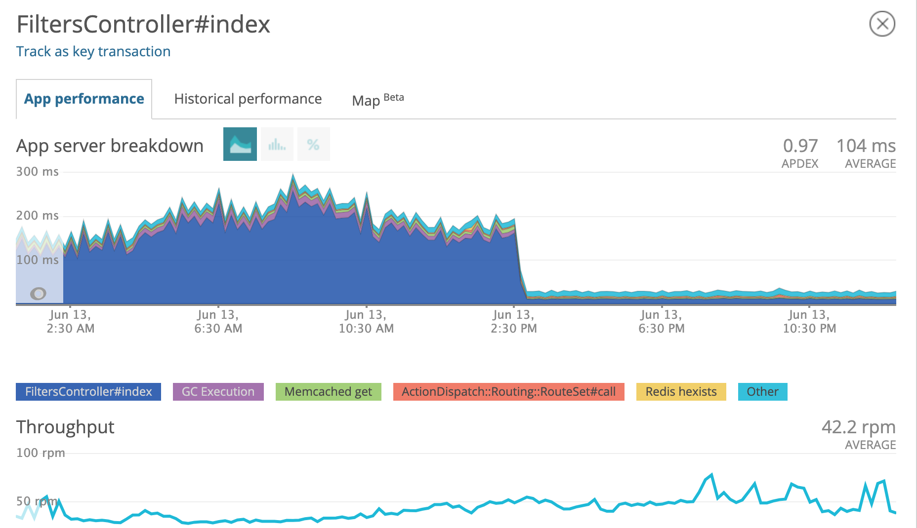

## **Success metric trend (over the past 3 months)**

|  |  |  |  |
| --- | --- | --- | --- |
| Metric | Since Last Aspirations | Mid Q2 2019 | Q2 2019 |
| Features/Enhancements shipped | 5 | 5 | 5 |
| Number of tickets resolved | 38 | 93 | 71 |
| RSpec coverage | 81.45% | 81.82% | 78.12% |

### Automation coverage:

|  |  |  |
| --- | --- | --- |
|  | Since Last Aspirations | Mid Q2 2019 |
| Test cases | Total cases: 1827  High and critical: 673 | Total cases: 1544  High and critical: 502 |
| New cases | Overall : 283  High and critical: 171 | Overall : 182  High and critical: 39 |
| Automation coverage(P0 and P1) | 43.72 % | 56.44 % |
| Cases Automated(P0 and P1) | 6 | 24 |

## **Plan for next month (or) Aspirations**

|  |  |
| --- | --- |
| Goal | Deliverables |
| Sales campaign improvements for better usability |  |
| Roles for SMS, Sales campaigns |  |
| SMS enhancements - add more SMS Providers |  |

## **Top contributors (since** **last Aspirations - please leave this section blank if data not available)**

|  |  |
| --- | --- |
| Name | Contribution |
| [Venkatasurya Tejamatcha](https://confluence.freshworks.com/display/~venkatasurya.tejamatcha) [Mudhabir Ahmed](https://confluence.freshworks.com/display/~Mudhabir.Ahmed) [Logesh Srinivasan](https://confluence.freshworks.com/display/~logesh.srinivasan) | ML - Freddy deal insights |
| [Ajeet Pandey](https://confluence.freshworks.com/display/~ajeet.pandey) [Athish Pranav Sethuram](https://confluence.freshworks.com/display/~athishpranav.sethuram) | View sharing, Template Sharing, Optimise filter query |
| [Rohan Anand](https://confluence.freshworks.com/display/~rohan.anand) [Ramkumar Ramani](https://confluence.freshworks.com/display/~ramkumar.ramani) | SMS: Support replies via providers |
| [Lakshmisai Varshitha](https://confluence.freshworks.com/display/~lakshmisai.varshitha) [Logesh Srinivasan](https://confluence.freshworks.com/display/~logesh.srinivasan) | SMS action in sales campaign |
| [Rohan Anand](https://confluence.freshworks.com/display/~rohan.anand) [Athish Pranav Sethuram](https://confluence.freshworks.com/display/~athishpranav.sethuram) | Integrate with Zipwhip for SMS capabilities |

## **Top Issues (faced since last Aspirations)**

|  |  |  |
| --- | --- | --- |
| Issue | Root cause | Recurring |
|  |  |  |

|  |  |
| --- | --- |
| Stretch goal | Deliverables |
|  |  |

## **Identified risks**

|  |  |  |
| --- | --- | --- |
| Risk | Mitigation strategy | Recurring |
|  |  |  |

## **Do you have any specific asks? (any help needed to address constraints, unblocking, ...)**

**(Please keep this list engineering related - this section is optional)**

|  |  |  |
| --- | --- | --- |
| Ask | Impact | Recurring |
|  |  |  |

## **Peer appreciation**

|  |  |  |  |
| --- | --- | --- | --- |
| Name | Appreciated by | Impact | In their own words |
|  |  |  |  |

## **Plan/Roadmap/Vision - that extends beyond one month**

* Freshreport platform migration
* Deprecate inbuilt phone
* Scenario automation

## **Demo/Deep dives/Miscellaneous items/...**