# Title: Sprint-3 ( Jan 21 - Feb 03 )

**Members Availability**

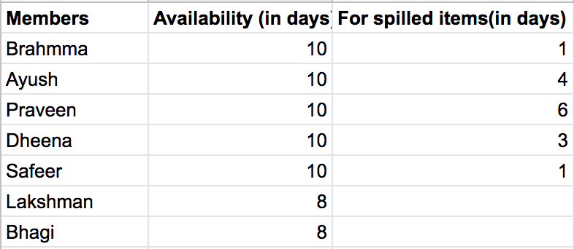

**Plan for Spilled over work items**

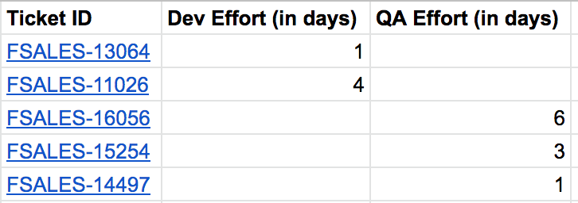

**Plan for groomed items**

After above items got completed we will have mid week planning for Sales360 items.

|  |  |
| --- | --- |
| Week 1 | Week 2 |
| Standup Day 1 | Standup Day 6 |
| Standup Day 2 | Standup Day 7  [FSALES-16513](https://freshworks.freshrelease.com/FSALES/issues/FSALES-16513) →  Start dev today  [FSALES-11026](https://freshworks.freshrelease.com/FSALES/issues/FSALES-11026) → Central team work done, Our work has to be done  [FSALES-15233](https://freshworks.freshrelease.com/FSALES/issues/FSALES-15233) →  [FSALES-16709](https://freshworks.freshrelease.com/FSALES/issues/FSALES-16709) → Its in PR for a testcase change (No work from dev side for today)  [FSALES-13064](https://freshworks.freshrelease.com/FSALES/issues/FSALES-13064) → Its in PR for a testcase change, No work from dev side for today  [FSALES-13696](https://freshworks.freshrelease.com/FSALES/issues/FSALES-13696) →  [FSALES-16056](https://freshworks.freshrelease.com/FSALES/issues/FSALES-16056) → Ready for staging merge (No work from our QA side)  [FSALES-16432](https://freshworks.freshrelease.com/FSALES/issues/FSALES-16432) → Will start dev today |
| Standup Day 3 | Standup Day 8  [FSALES-13696](https://freshworks.freshrelease.com/FSALES/issues/FSALES-13696) → Taking for testing today will wind up testing by Tomorrow EOD  [FSALES-16513](https://freshworks.freshrelease.com/FSALES/issues/FSALES-16513) → In code review, will be Ready for QA by today  [FSALES-16432](https://freshworks.freshrelease.com/FSALES/issues/FSALES-16432) → Taken for dev today no blockage  [FSALES-11026](https://freshworks.freshrelease.com/FSALES/issues/FSALES-11026) →  Completed the central producer, no blockage  [FSALES-16903](https://freshworks.freshrelease.com/FSALES/issues/FSALES-16903) → By EOD Ready for QA  [FSALES-16056](https://freshworks.freshrelease.com/FSALES/issues/FSALES-16056) → Will be going live today |
| Standup Day 4 | Standup Day 9 |
| Standup Day 5  FSALES-13064 → Review complete  FSALES-16056 → Testing will be done by today  FSALES-15254 → Will be merged to staging by today  FSALES-14497 → Work done from safeer's side  FSALES-16709 → raise PR by EOD | Standup Day 10 |

## **Retrospective :**

|  |  |
| --- | --- |
| Things went well | Things need to be improved |
| * Followed all the sprint rituals consistently * Managed to complete all the Corcoron items on time * StandUps have happened like a knowledge transfer instead of usual status update | * Allotting time for L2 support * Allot some analysis time for User story while planning * Allot buffer days for the workitems |

#### Appreciations :   Akshay, Bhagi, Dheena