# Title: Squad 1 - July 2018 Aspirations

## 

|  |
| --- |
| **Aspirations - July 2018** Freshsales, Squad 1 - 06 Jul 2018 |
| Mission:   * Build and roll out integration faster. * Build features on core objects and associated ones. * Evolve and Maintain CSV import, Migration from other CRMs |

|  |  |  |  |
| --- | --- | --- | --- |
|  | **Name** | **Email** | **Git home (if applicable)** |
| **Tech Lead** | Vijayaragavan V | vijayaragavan.venkatarathinam | <https://github.com/vijayaragavanv> |
| **Product Owner** | Venkat  Swati Sharma  Vinay K  Siddharth | venkataraman.natarajan  swati.sharma  vinay.yevatkar  siddharth.gopalasundaram |  |
| **Members** | Irfan Shaik | irfan.shaik | <https://github.com/irfu572> |
|  | Shaik Buden Saheb | buden.shaik | <https://github.com/buden1> |
|  | Aravinth Chandran | aravinth.chandran | <https://github.com/aravinth-chandran> |
|  | Arun Ignatius Infant | arun.ignatius | <https://github.com/arun-ignatius> |
|  | Ashish Muralidharan | ashish.muralidharan | <https://github.com/ashish-md> |
|  | Vaidhyanathan A | vaidhyanathan.ananthakrishnan | <https://github.com/vaidhyanathan-freshsales> |
|  | Praveen Kumar V | praveenkumar.varadan | <https://github.com/praveenv92> |
|  | Esaki Raja | esaki.raja | <https://github.com/ezaki001> |

## **Success metrics - KPIs (Key Performance Indicators)**

|  |
| --- |
| 1. Features shipped 2. Number of Jira items resolved |

## **Previous Aspirations Link:**

[Squad 1 - June 2018 Aspirations](https://confluence.freshworks.com/display/freshsales/Squad+1+-+June+2018+Aspirations)

## **Results: How did we do since last Aspirations? (Planned vs Delivered)**

|  |  |  |
| --- | --- | --- |
| Goal (from previous Aspirations) | Results | Deliverables |
| Integration - Marketplace Onboarding  [Shaik Buden Saheb](https://confluence.freshworks.com/display/~shaikb) [Ezaki](https://confluence.freshworks.com/display/~esaki) | Done * | Unable to render Jira issues macro, execution error. |
| Core - Task Performance Improvement  [Shaik Buden Saheb](https://confluence.freshworks.com/display/~shaikb) [Irfan Shaik](https://confluence.freshworks.com/display/~irfan.shaik) [Praveenkumar Varadan](https://confluence.freshworks.com/display/~praveenkumar.varadan) | Done * | Unable to render Jira issues macro, execution error. |
| Integration - Freshpipe issues  [Irfan Shaik](https://confluence.freshworks.com/display/~irfan.shaik) [Shaik Buden Saheb](https://confluence.freshworks.com/display/~shaikb) | In Progress * | |  |  |  |  |  |  |  |  |  |  |  | | --- | --- | --- | --- | --- | --- | --- | --- | --- | --- | --- | |  |  |  |  |  |  |  |  |  |  |  | | type | key | summary | assignee | reporter | priority | status | resolution | created | updated | due | | JQL and issue key arguments for this macro require at least one Jira application link to be configured | | | | | | | | | | | |
| Notification - IRIS ember add on + JWT  [Shaik Buden Saheb](https://confluence.freshworks.com/display/~shaikb) | In Staging * | Unable to render Jira issues macro, execution error. |
| Integration - Freshchat EU support  [Ashish Muralidharan](https://confluence.freshworks.com/display/~ashish.muralidharan) [Praveenkumar Varadan](https://confluence.freshworks.com/display/~praveenkumar.varadan) | Done | Unable to render Jira issues macro, execution error. |
| Integration - Convert email as ticket  [Aravinth Chandran](https://confluence.freshworks.com/display/~aravinthchandran) [Praveenkumar Varadan](https://confluence.freshworks.com/display/~praveenkumar.varadan) | Done | Unable to render Jira issues macro, execution error. |
| Core - Territory for Contacts  [Aravinth Chandran](https://confluence.freshworks.com/display/~aravinthchandran) | In Dev | Unable to render Jira issues macro, execution error. |
| Core - Transfer owner  [Aravinth Chandran](https://confluence.freshworks.com/display/~aravinthchandran) | In Dev | Unable to render Jira issues macro, execution error. |
| Core - Move away from Using segment to collect product metrics for internal teams  @mudhabhir | In Staging | Unable to render Jira issues macro, execution error. |
| Enabling Frontend app development through Marketplace  [Arun Infant Ignatius](https://confluence.freshworks.com/display/~arun.ignatius) [Vaidhyanathan Ananthakrishnan](https://confluence.freshworks.com/display/~vaidhyanathan.ananthakrishnan) | In Dev |  |
| Revamp the pre-requisites for the current automation suite - to remove the dependency on existing accounts | In Progress |  |
| Automated pending cases for the squad [Senthil vel](https://confluence.freshworks.com/display/~senthilvelp) | Done |  |

|  |  |  |  |  |  |  |
| --- | --- | --- | --- | --- | --- | --- |
| Freshpipe L2 issues [Irfan Shaik](https://confluence.freshworks.com/display/~irfan.shaik) | **June 2018 aspiration** | **May 2018 aspiration** | **April 2018 aspiration** | **March 2018 aspiration** | **Feb 2018 aspiration** | **Jan 2018 aspiration** |
| **Total tickets** | 39 | 37 | 31 | 46 | 48 | 29 |
| **Resolved** | 26 | 31 | 26 | 35 | 35 | 22 |
| **Pending** | 13 | 6 | 5 | 11 | 13 | 7 |

**Task Performance changes**

For the past few months, We have had complaints from customers and internal team, that My tasks and appointments page is either too slow or not loading at all. This was because the way it was designed back in 2016.

When you land in My tasks and appointments page, we load tasks that you are owner or that you are collaborator. But this query was doing a left join on tasks and task users with OR condition in where. Also it was not picking the indexes as well. This was a bad approach.

So we started questioning the approach and completely rethought it. We decided that owner of a task is collaborator by default. This simplified things wherein we can do away from OR condition. We shipped this today morning around 6.30AM and was happy to see the improvement in newrelic.

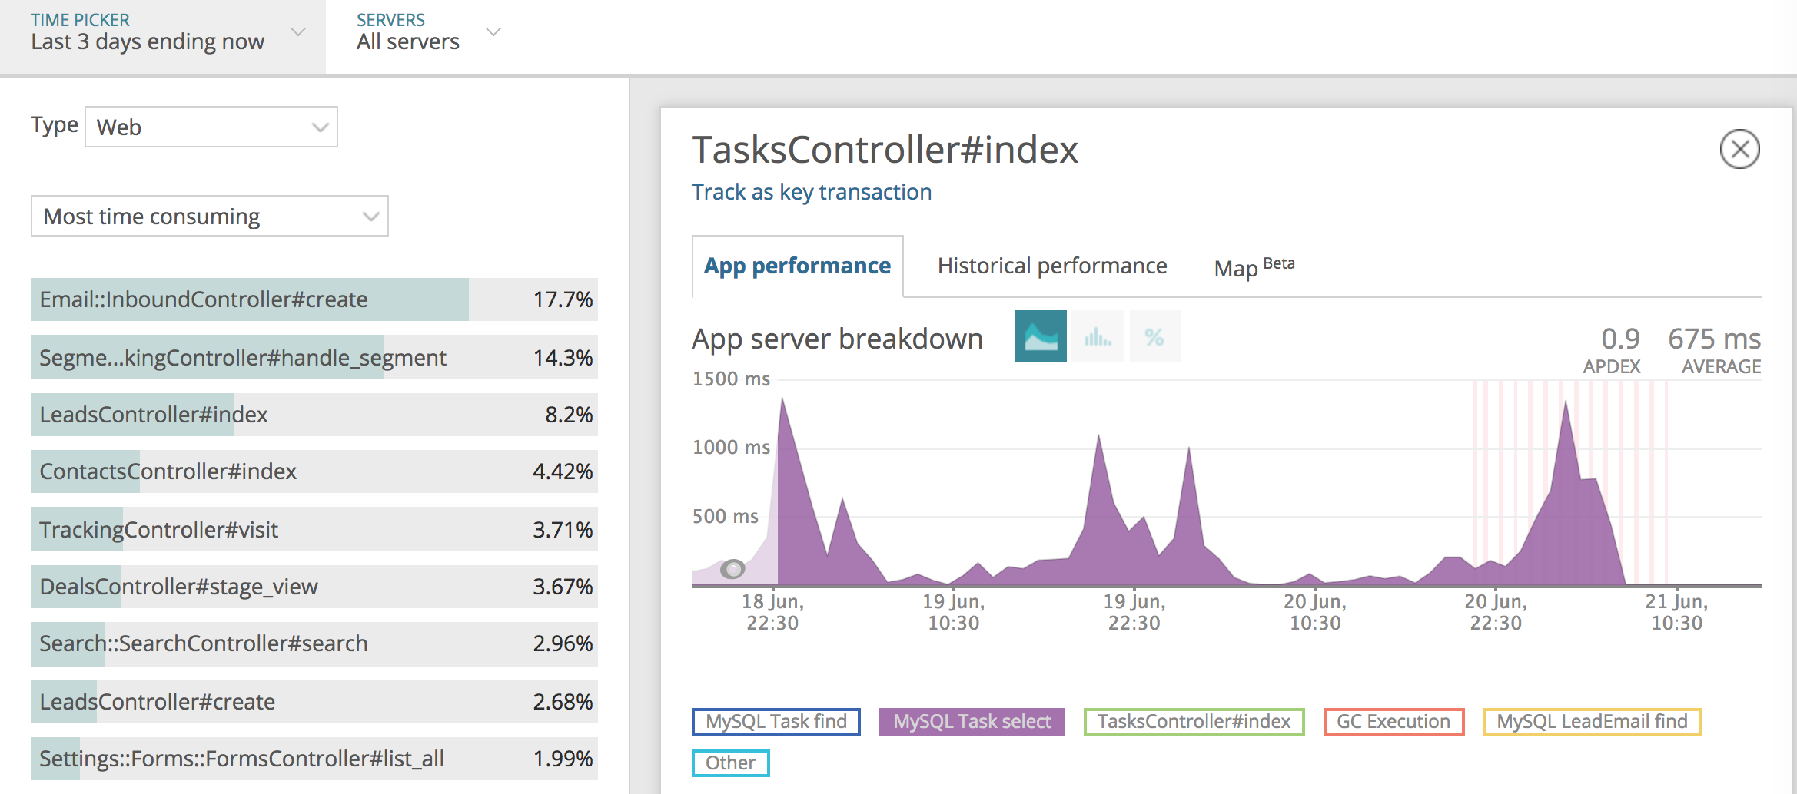

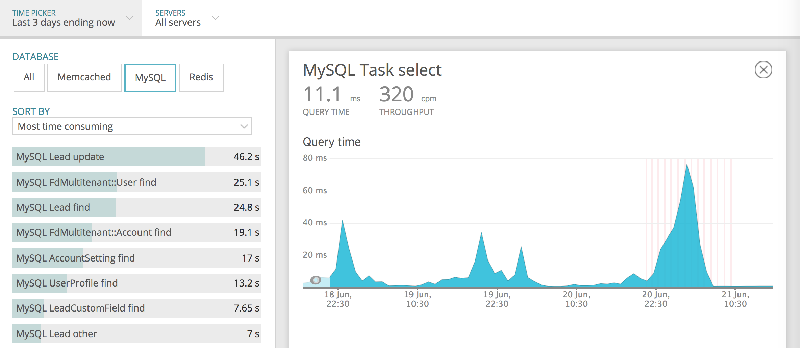

At one point, we have had 280ms for task select query. Now it is executing around 0.6ms.

Before 6.30AM, average response time was 776ms. Now it's at 92ms.

Good work Buden, Irfan and Praveen!

## **Success metric trend (over the past 3 months)**

|  |  |  |  |  |  |  |  |
| --- | --- | --- | --- | --- | --- | --- | --- |
| Metric | June 2018 | May 2018 | April 2018 | March 2018 | Feb 2018 | Jan 2018 | Dec 2017 |
| Features shipped | 2 | 1 | 2 | 3 | 4 | 3 | 1 |
| Number of JIRA items resolved | 15 | 20 | 28 | 33 | 28 | 34 | 10 |
| Number of Testcases automated | 24 | 18 | 4 | 4 | 71 |  |  |

## **Plan for next month (or) Aspirations**

|  |  |
| --- | --- |
| Goal | Deliverables |
| Integration - Enabling Frontend app development through Marketplace  [Vaidhyanathan Ananthakrishnan](https://confluence.freshworks.com/display/~vaidhyanathan.ananthakrishnan) [Arun Infant Ignatius](https://confluence.freshworks.com/display/~arun.ignatius) | Unable to render Jira issues macro, execution error. |
| Integration - Marketplace backend app development  [Vaidhyanathan Ananthakrishnan](https://confluence.freshworks.com/display/~vaidhyanathan.ananthakrishnan) [Arun Infant Ignatius](https://confluence.freshworks.com/display/~arun.ignatius) | Unable to render Jira issues macro, execution error. |
| Integration - Freshpipe issues  [Irfan Shaik](https://confluence.freshworks.com/display/~irfan.shaik) [Shaik Buden Saheb](https://confluence.freshworks.com/display/~shaikb) | |  |  |  |  |  |  |  |  |  |  |  | | --- | --- | --- | --- | --- | --- | --- | --- | --- | --- | --- | |  |  |  |  |  |  |  |  |  |  |  | | type | key | summary | assignee | reporter | priority | status | resolution | created | updated | due | | JQL and issue key arguments for this macro require at least one Jira application link to be configured | | | | | | | | | | | |
| Integration - Understanding custom traits implicitly in Segment  [Ashish Muralidharan](https://confluence.freshworks.com/display/~ashish.muralidharan) | Unable to render Jira issues macro, execution error. |
| Automate p1 & p2 cases for 'Transfer-records', 'Territories for Contacts' and 'User deletion'  [Ezaki](https://confluence.freshworks.com/display/~esaki) [Praveenkumar Varadan](https://confluence.freshworks.com/display/~praveenkumar.varadan) |  |

|  |  |
| --- | --- |
| Stretch goal | Deliverables |
| Automation - Complete automation for all the Integrations available in Freshsales (as Applicable) |  |

## **Identified risks**

|  |  |  |
| --- | --- | --- |
| Risk | Ask | Recurring |
| Freshpipe | 1. Stability in current syncs(Freshdesk/Mailchimp/Hubspot) that are already supported. (<5 support tickets per month) 2. Ability to build new syncs where product should own 95% of the work. Expected ownership: 95% Current ownership: 50% 3. Building new enhancements or fixing issues should take less time. Expected: Few hours to few days Current: 3+ weeks |  |

## **Do you have any specific asks? (any help needed to address constraints, unblocking, ...)**

|  |  |  |
| --- | --- | --- |
| Ask | Impact | Recurring |
|  |  |  |

## **Peer appreciation**

|  |  |  |
| --- | --- | --- |
| Name | Appreciated by | Impact |
|  |  |  |

## **Plan/Roadmap/Vision - that extends beyond one month**

* Marketplace - Trello, Magento, Shopify, Knowlarity, Exotel
* Integration - E Signature & Document