# Title: Stage analysis

Start date : 5/9

Observation:

1. There can be multiple stages which map to "Closed Won"/"Closed Lost"

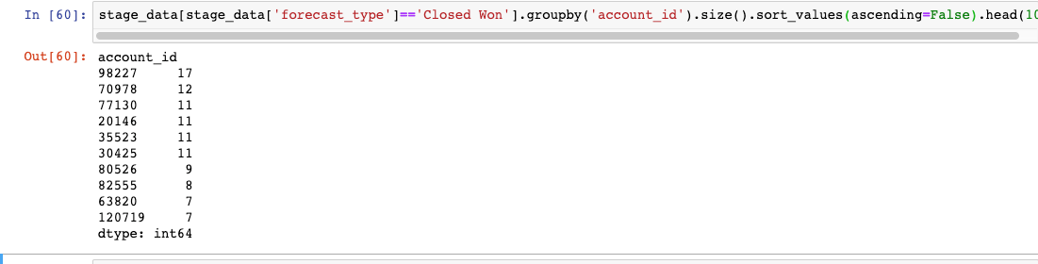

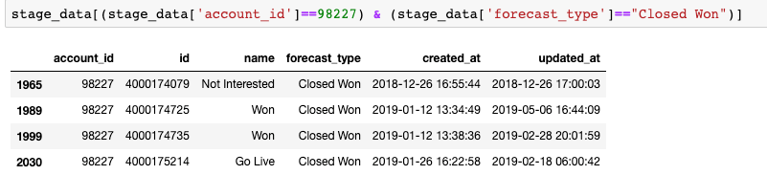

Number of pipelines (

select account_id, count(*) as cnt from deal_pipelines  where account_id in (66489,20146,34921,16416,92267,31059,63820,110916,12656,35523,54473,82538,59002,93262,75689,70978,80406,62354,51151,45578,89865,98227,32333,114112,82555,30456,80526,94260,50388,114645,22070,92637,35959,52241,77130,94752,118761,38707,98701,37592,101126,88700,31474,34305,120719,51867,105028,107799,108582,115462,119421,41585,64848,96468,47,21) group by account_id; )

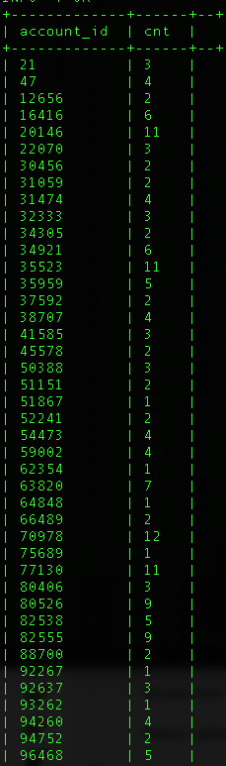

Notes:

One product can have different pipeline. According to Aditi, a field agent selling a product will follow a pipeline and call agent may follow different pipeline. They both might still sell same product. Following are restrictions though

1. One deal can only be in one pipeline
2. One deal can only have one product
3. One product can be part of different pipelines
4. One pipeline can only have one stage each marked as "Closed Won" "Closed Lost"`