# Title: Summary

Initial objective -

Revenue forecasting for accounts based on leads/deals in the system

Experiments/Observations

1. Exploratory analysis on leads, contacts, deals and activities
   1. Critical data points for revenue forecasting
      1. Deal create date/Lead create date
      2. Deal close date
      3. Activities create date ( phone calls, emails, tasks, appointments, etc from timeline_feeds table )
      4. Deal amount value
      5. Sales account related data ( annual revenue, number of employees, industry id, business id )
      6. Deal product id
   2. Sales cycle -
      1. 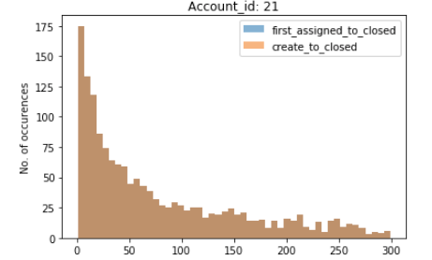
      2. Large number of deals with sales cycle < 1 week
      3. Deals with very large sales cycle > 1 year
      4. Many deals create dates are very old with no activities for long duration.
   3. Deal data
      1. Closed dates not marked properly. (Some places after 2020 year)
      2. Deal amount is missing/negative
      3. Deals closing without any activity
2. Experimentation
   1. Revenue forecast
      1. Predict number of active deals that would close in next 4 weeks.  ( Does not include deals which might start and close in prediction weeks )
      2. Activities (phone call, email, etc) based model. ( Regression model and state machine model)
      3. Predict revenue based on expected number of closed deals
      4. 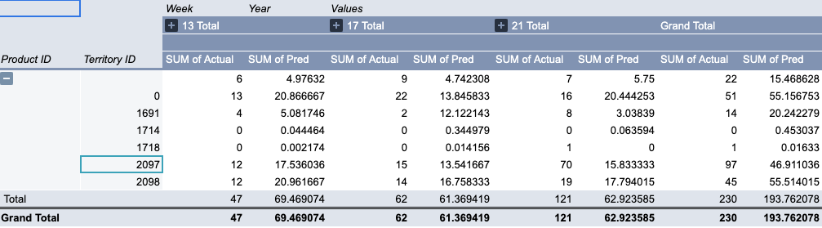
      5. Gaps/sub problems
         1. New leads added are not taken into account
         2. Contacts can have multiple deals ( because of renewals? )
         3. Expected size of deals for new leads
         4. Activity data in closed deals  in some cases is very less
         5. Sudden spikes in closed deals during a month
         6. Incorrect data of deals
   2. Expected size of deals from new leads
      1. Based on lead company/sales accounts data give estimate of deal amount
      2. 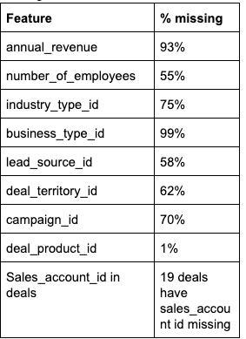
      3. 1st experiment MAPE - 60%