# Title: UI Automation - April 2018 Aspirations

## 

|  |
| --- |
| **Aspirations - Apr 2018**Freshsales/ UI Automation |
| Mission: Consistently maintain a stable regression suite with >95% coverage that assists in Continuous Integration |

## **Success metrics - KPIs (Key Performance Indicators)**

|  |
| --- |
| 1. No. of bugs identified via Automation 2. % of test cases automated (P1&P2) - Including Backlog and New features |

## **Results: How did we do since last Aspirations? (Planned vs Delivered - Summarise the results and provide applicable links)**

|  |  |  |
| --- | --- | --- |
| Goal (from previous Aspirations) | Results | Deliverables |
| Complete automation for P1/P2 test cases (except Integrations and Phone module) | Partially completed | 120 cases Pending |
| API Automation | Initiated | Completed only for Leads module |
| Parallel Automation for New features/ Enhancements | Partially completed | * Filtering by Events (*Automated fully before Staging*) * Clone Reports (*Automated fully before Staging*) * Inactive User labels (*Automated fully before Staging*) * Remember last selected view (*Automated fully before Staging*) * Transfer ownership and assign related activities (*Automation completed the week after feature*) * Sales Activities in Reports (*Feature deployed;* *Automation In Progress*) * Google Chrome plugin (*Automation In Progress*) |

## **Success metric trend (over the past 3 months)**

|  |  |  |
| --- | --- | --- |
| Metric | Apr | Mar |
| **No. of valid bugs identified via Automation** | 11 | 8 |
| **% of test cases automated (P1&P2)** |  | |
| **Parallel Automation for new features** | * User Story - 4 | |

**Bugs Identified via Automation:**

|  |  |
| --- | --- |
| Priority | Count |
| Urgent | 1 |
| High | 9 |
| Medium | 1 |
| **Total** | **11** |

* 9 issues were regression issues (breakage) in existing functionality - Identified in Staging due to the corresponding commits
* 2 issues were existing Sidekiq issues

**Squad-wise Automation coverage:**

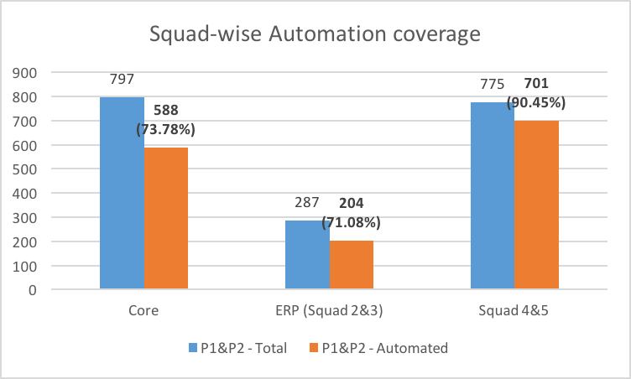

## **Top Issues (faced since last Aspirations)**

|  |  |  |
| --- | --- | --- |
| Issue | Root cause | Recurring |
| Running 27 accounts in parallel caused multiple false failures consistently | Load issues in stack | Yes |

## **Plan for next month (or) Aspirations**

|  |  |
| --- | --- |
| Goal | Deliverables |
| Complete 100% P1 and P2 automation for Reports module |  |
| Complete the pending % of P1/P2 (spill-over backlog cases) |  |
| Deliver/ Sign-off more features with parallel automation |  |

|  |  |
| --- | --- |
| Stretch goal | Deliverables |
| Automation suite revamp to create pre-requisites on the go | Remove dependency on Account-specific automation |
| Optimise the runtime for each of the Squad specs (currently ~ 1hr) |  |