# Title: WhatsNew - Auto sync wordpress blog

To introduce a mechanism to fetch blogs automatically from the Freshsales Blog as and when it got published.

**Wordpress**

Introduced a plugin Feed-JSON(PHP) in Wordpress Blog, which will provide json feed by adding "/feed/json"

to existing path. We fetch data based on category as in the following url: <https://blog.freshsales.io/category/feature-updates/feed/json>.

CORS headers added and json template has been modified to support Ember model.

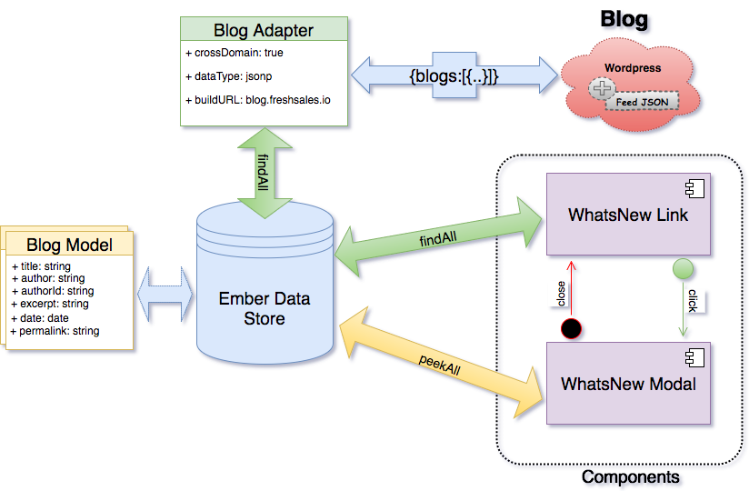

**Frontend**

We have removed the Backend dependency with the new architecture. This way we just fetch blogs straight away

from Freshsales Blogs in the browser. Frontend part involves 2 components(whatsnew-link & modal-whatsnew),

a model & adapter for Blog. Blog adapter has been introduced since there is a change in buildURL(crossDomain request) and dataType.

Last viewed blog info has been stored in localStore in order to ignore highlighting whatsnew link once the user

visited the latest blog.