# Title: (Old-Freshsales Support L2 process)

For new process please refer - [Freshsales L2 Process](https://confluence.freshworks.com/pages/viewpage.action?pageId=237157701)

### **Freshsales Support Agent :**

Will gather all the details regarding the reported issue and adds a detailed private note.

* Mark the Category and Sub-Category according to the issue.
* Status : Awaiting L2 response
* Internal Group : Based on the category of the issue
* Type   : L2- Analysis / Troubleshooting
* Priority : Urgent/ High/Medium/Low

#### Private Note Template to be followed by Freshsales Support Agent:

* Account Id:
* Issue Description:
* Locally Reproducible: Yes / No
* Steps to Reproduce:
* Supporting Logs: Code / Timestamp of when it happened with Time Zone.

#### Custom View Setup - (Freshsales Support Agent):

1. Set the “**Group**” Field as “Freshsales Support”.
2. Set the “**Agents**” Field as “**Me**”. This will show the tickets assigned to the concerned agent
3. Set the **Status** field as “Open”, “Pending”, “Customer Responded”, “L2 Responded”.

### [**Freshsales L2 Team**](https://confluence.freshworks.com/pages/viewpage.action?pageId=218073692)**:**

* Freshsales Engineering team will keep monitoring the L2 tickets from the support portal:
  + The QAs from the corresponding Internal group will be doing the first level of analysis, and will come up with their observations. (Can assign themselves as an "**Internal Agent**" for the corresponding ticket)
  + If any Dev assistance is required, the QA will get support from the corresponding Dev POC
* L2 agent (mostly QA) will add a private note to the *support agent* with their initial observations. The ticket will automatically be moved to **“L2 Responded”** status by an observer rule configured.
* If the initial observation is already communicated to the *support agent* over Freshconnect/ Chat, the L2 agent will still go ahead and add a private note about the corresponding discussion to the support ticket. The ticket will automatically be moved to **“L2 Responded”** status by an observer rule configured.
* The Initial response to be provided **within 24 hours** of assigning to the group.

#### Private Note Template to be followed by L2 Agent:

* Initial Observation:
* Next steps:
* Root cause:
* ETA: (This alone can be given by TL/EM/PM)
* Fix:

#### Custom View Setup - (L2 Agent):

1. Set the “**Group**” Field as “Freshsales Support”.
2. Set the "**Status"** field as “Awaiting L2 Response".
3. Set the "**Internal Group**" field to your appropriate group

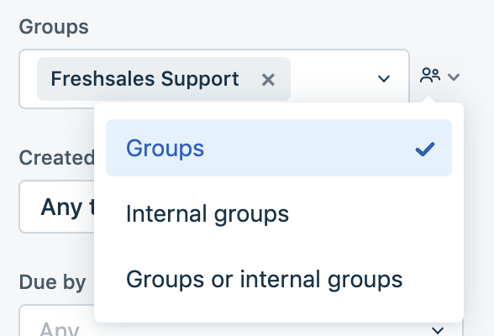 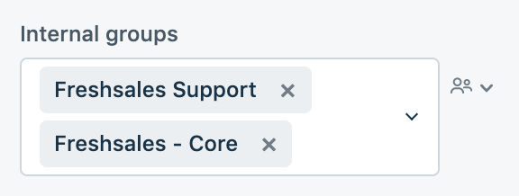

### **L4 Workflow (Bugs):**

* After the initial observation, the L2 team will add a detailed private note on what has been fixed / acknowledge it as a bug.
* The Support agent would
  + Update the type as L4
  + From the Freshdesk ticket, use the Freshrelease integration to “Link a new work item”.
  + Select the project as “Freshsales”.
  + Give the appropriate title. Kindly look for already existing Freshrelease items before creating a new one to avoid duplicates.
  + Select the appropriate reporter.
  + Select type as “**L4 Bug**”.
  + Inform the customer and update the status of the ticket as ‘**Awaiting developer fix**’.
* For all the issues identified over the discussion in "Freshsales - Queries" or "Freshsales - Production 24x7" chat rooms, the Support agent would
  + Create a bug in Freshrelease with the "**Freshdesk Tickets**" field updated with the link to the support ticket (if any) OR the source of the issue
  + Select type as “**L4 Bug**” in Freshrelease
* The PMs/ EMs will assign the appropriate module, prioritise the Freshrelease bugs and plan them for upcoming releases

#### Further Transitions

* If the issue is NOT a bug, the Support agent will update the customer and will await customer’s response. (Set status to “**Awaiting Customer Response**”).
* If the Customer acknowledge that the issue is fixed, Support agent will move the ticket to “**Resolved**” status.
* If the issue is not fixed, The Support agent will get the required information from the customer and will assign it back to the Dev (Set status as “**Awaiting L2 response**”).

|  |  |  |
| --- | --- | --- |
| **Internal Groups** | **L2 Team** | **Point of Contact** |
| Freshsales - Core | Guru, Praveen, Anushia, Gowthaman, Meenaloshani, Dheena  Vaidhyanathan, Vijay, Bhagirath, Buden, Irfan, Ashish, Ayush, Bhuvanesh, Nivedita, Robin, Sakrishna, Prabhu, Umashankar  Swathi, Vinay | Swati,  Guru, Vaidhyanathan |
| Freshsales - Email | Uma  Sivakumar, Mani, Dwarak, Kalai, Hariharasuthan  Aditi, Sujitha | Aditi, Uma, Sivakumar |
| Freshsales - Phone | Athish  Kathir, Mani  Aditi | Aditi, Athish, Kathir |
| Freshsales - Reports | Ram, Balasubramanian  Sivalingam, Mani, Prakash, Varshitha  Aditi | Aditi, Ramkumar, Sivalingam |
| Freshsales - Integrations and Marketplace(Except FD-FS, Hubspot and Mailchimp) | Gowthaman  Vaidhyanathan, Vijay, Vipul, Bhuvanesh  Venkat | Venkat, Gowthaman, Vaidhyanathan |
| Freshsales - Workflow & Sales Campaigns | Ram, Athish  Sivalingam, Mani, Bivil, Varshitha  Swati | Swati, Ramkumar, Sivalingam |
| Freshsales - Migration, Import & Export | Praveen  Vaidhyanathan, Vijay, Irfan  Vinay | Vinay, Praveen, Vaidhyanathan |
| Freshsales - Plans and Billing | Athish,  Kathir, Mani, Mudhabir, Ajeet  Vinay | Vinay, Athish, Kathir |
| Freshsales - Mobile | Senthil, Sathish  Saravanan, Rinoy, Mani, Ramanathan, Satya, Saranya  Swathi Y | Swathi, Senthil, Saravanan, Rinoy |
| Freshsales - iPass(FD-FS, Hubspot and Mailchimp) | Venkat, Vijay | Venkat, Vijay |
| Freshsales - General | Vijay, Mani, Nivedhana | Vijay, Mani, Nivedhana |
| Freshsales - Freddy | Logesh  Swaminathan, Mani  Aditi | Aditi, Logesh, Swaminathan |
| Freshsales - Search and Filters | Uma  Sivakumar, Mani, Dwarak  Vinay | Vinay, Uma, Sivakumar |
| Freshsales - Onboarding | Prem, Ishwaryaa | Prem, Ishwaryaa |