**Name : محمد أحمد محمد أنور**

**B.N: 654**

**Date : 5/6/2020**

**Topic:** **Operating Systems**

**GitHub link:**

**GitHub page:**

**Application brief:** this topic discusses operating systems. It is a very important field. Operating systems are very useful in our daily life today. We manage to run every computing machine with operating systems today. The research presented a good introduction to operating systems. We made a comparison of most common and popular operating systems. We talked about a very important point in operating system and it is operating system development as a hobby. In present time, we see a lot of developers in programing and deal with the matter as a hobby. The project presented a brief look about operating systems.

Also we inserted a picture which expresses on the top operating systems in the whole world at the current time. We talked briefly about history of operating systems.

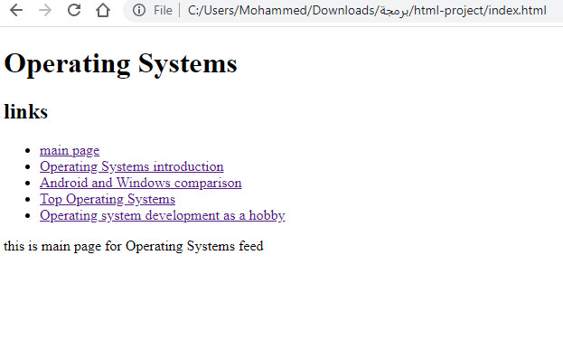**Screenshots:**

