MENOFIA UNIVERSITY
SYSTEM ANALYSIS & DESIGN PROJECT – SECOND YEAR 2026-2027
Analysis Phase
Requirements Elicitation: Interview, Web Questionnaire and Report
Project 47: Learning Management System (LMS) – Course Administration

Part 1: Interview Questions
Target Audience: Course Administrators and Instructors.

A. Open-Ended Questions
Q1. How do you add a new course?
Sample Answer: We enter the course name and its information into the system.
Q2. What problems do you have when making course schedules?
Sample Answer: Sometimes two courses may have the same time.
Q3. How do you tell students about changes in the course schedule?
Sample Answer: We usually inform them by email or messages.
Q4. What problems happen when students register for courses?
Sample Answer: Sometimes student information needs to be updated manually.
Q5. What would you like to change about the current system?
Sample Answer: I would like it to be easier to use and save time.

B. Closed-Ended Questions
Q6. Do you use a computer to manage courses?
Sample Answer: Yes.
Q7. Do you use Excel to save course information?
Sample Answer: Yes.
Q8. Should students and instructors have different permissions?
Sample Answer: Yes.
Q9. Do you want the system to send notifications about schedule changes?
Sample Answer: Yes.
Q10. Is the current way of managing courses easy to use?
Sample Answer: No.
Note: These are example answers. Actual answers should be recorded if an interview is conducted.

Part 2: Web Questionnaire
Form Title: LMS Course Administration Questionnaire
Description: This form asks users about course management and what they need from the new system.
Form Link:
https://docs.google.com/forms/d/e/1FAIpQLSd90tCQLyvczGiC90tfTUbBcrSEByWZvXb5EFyZ2zcz6iiwWg/viewform
We made this form using Google Forms. It has 10 questions (Q1 to Q10): 7 multiple choice, 1 checkboxes, 1 short answer and 1 paragraph.

Screenshot of the Form
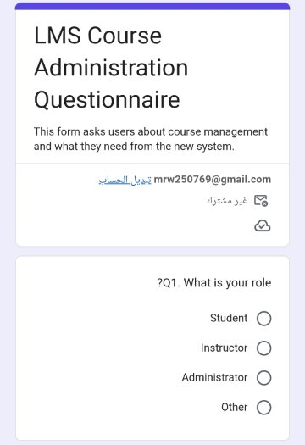 | 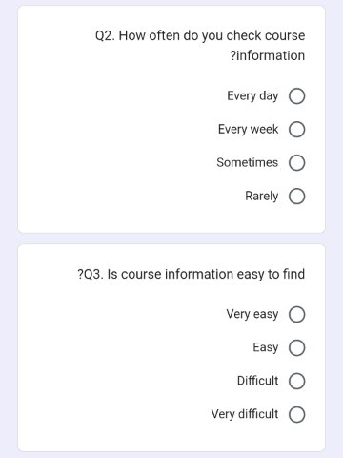 | 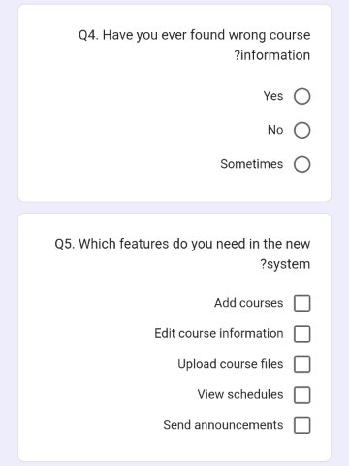
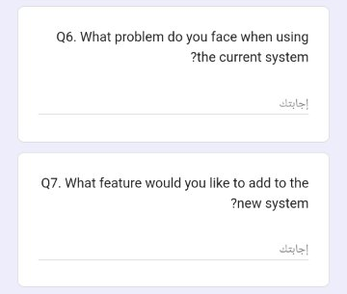 | 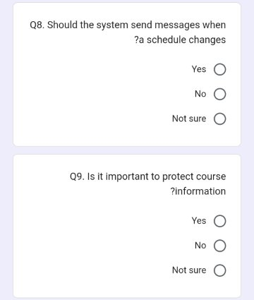 | 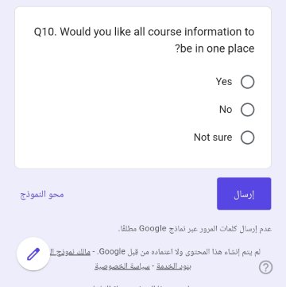
Figure: The LMS Course Administration Questionnaire as shown on Google Forms.

The 10 Questions in the Form

A. Closed-Ended Questions
Q1. What is your role?
- Student
- Instructor
- Administrator
- Other
Question Type: Multiple Choice.
Q2. How often do you check course information?
- Every day
- Every week
- Sometimes
- Rarely
Question Type: Multiple Choice.
Q3. Is course information easy to find?
- Very easy
- Easy
- Difficult
- Very difficult
Question Type: Multiple Choice.
Q4. Have you ever found wrong course information?
- Yes
- No
- Sometimes
Question Type: Multiple Choice.
Q5. Which features do you need in the new system?
- Add courses
- Edit course information
- Upload course files
- View schedules
- Send announcements
Question Type: Checkboxes.

B. Open-Ended Questions
Q6. What problem do you face when using the current system?
Question Type: Short Answer.
Q7. What feature would you like to add to the new system?
Question Type: Paragraph.

C. Additional Closed-Ended Questions
Q8. Should the system send messages when a schedule changes?
- Yes
- No
- Not sure
Question Type: Multiple Choice.
Q9. Is it important to protect course information?
- Yes
- No
- Not sure
Question Type: Multiple Choice.
Q10. Would you like all course information to be in one place?
- Yes
- No
- Not sure
Question Type: Multiple Choice.

Part 3: Report

1. Interview Opinion
In my opinion, the interview is a good way to know how the courses are managed now and what problems the administrators and instructors face. From the questions, I think the users need a system that is easy to use and keeps all the course information in one place.
The answers of the interview will help us understand what the users really need in the new LMS.

2. Interview Feelings
During the interview we should also notice how the users feel. Some of them may feel tired or annoyed because they do the same work again and again, or because they cannot find the course information fast.
On the other hand, they will probably feel more comfortable with a simple system that saves their time. We need to check these feelings when we do the real interview.

3. Current State of the System
At the moment, the courses are managed using a computer, Excel files, and emails or messages. This way has some problems, for example:
- It is hard to find course information.
- Schedule updates are late.
- The same information is entered more than one time.
- Users do not know about course changes on time.
Also, in the sample answers, two courses can have the same time, and student information is updated manually. The interview will show us which of these problems really happen.

4. System Goals
The new LMS Course Administration system should:
- Make adding new courses easier.
- Let the administrators edit course information.
- Let users check the course schedules.
- Make student registration easier to manage.
- Let instructors share course files.
- Send notifications when a course changes.
- Protect the course information.
- Keep all course information in one place.
- Save time and reduce mistakes.

Part 4: Types of Questions
Open-Ended Questions:
The user answers in his own words.
Example: What problems do you have when making course schedules?
Closed-Ended Questions:
These questions have a specific answer like Yes or No.
Example: Do you use Excel to save course information?
Multiple-Choice Questions:
The user chooses one answer from a list.
Example: What is your role?
Checkbox Questions:
The user can choose more than one answer.
Example: Which features do you need in the new system?

Conclusion
In this project we wanted to understand how courses are managed and what the users need. The interview helps us know the problems of the administrators and instructors, and the questionnaire collects answers from more people.
The information we collect will help us decide which features to put in the new LMS Course Administration system.

