# Real-time Hand Tracking using OpenCv and MediaPipe

##### **Submitted by:**

**Submitted to:**

**Abstract-** We present a real-time on-device hand tracking solution that predicts a hand skeleton of a human from a single RGB camera for AR/VR applications. Our pipeline consists of two models: 1) a palm detector, that is providing a bounding box of a hand to, 2) a hand landmark model, that is predicting the hand skeleton. It is implemented via MediaPipe[12], a framework for building cross-platform ML solutions. The proposed model and pipeline architecture demonstrate real-time inference speed on mobile GPUs with high prediction quality. MediaPipe Hands is open sourced at https://mediapipe.dev.

# Introduction

Hand tracking is a vital component to provide a natural way for interaction and communication in AR/VR, and has been an active research topic in the industry [2] [15]. Vision-based hand pose estimation has been studied for many years. A large portion of previous work requires specialized hardware, e.g. depth sensors [13][16][17][3][4]. Other solutions are not lightweight enough to run real-time on commodity mobile devices[5] and thus are limited to platforms equipped with powerful processors. In this paper, we propose a novel solution that does not require any additional hardware and performs in real-time on mobile devices. Our main contributions are:

• An efficient two-stage hand tracking pipeline that can track multiple hands in real-time on mobile devices.

• A hand pose estimation model that is capable of predicting 2.5D hand pose with only RGB input.

• And open source hand tracking pipeline as a ready-to go solution on a variety of platforms, including Android, iOS, Web (Tensorflow.js[7]) and desktop PCs.

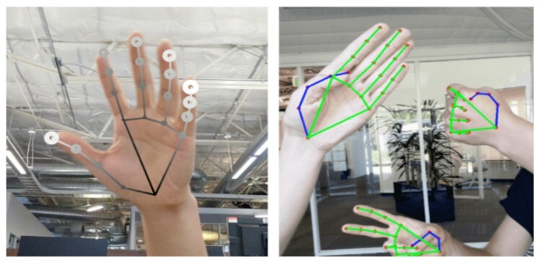

Figure : Rendered hand tracking result

(Left): Hand landmarks with relative depth presented in different shades. The lighter and larger the circle, the closer the landmark is towards the camera.

(Right): Real-time multi-hand tracking on Pixel 3.

**2. Architecture**

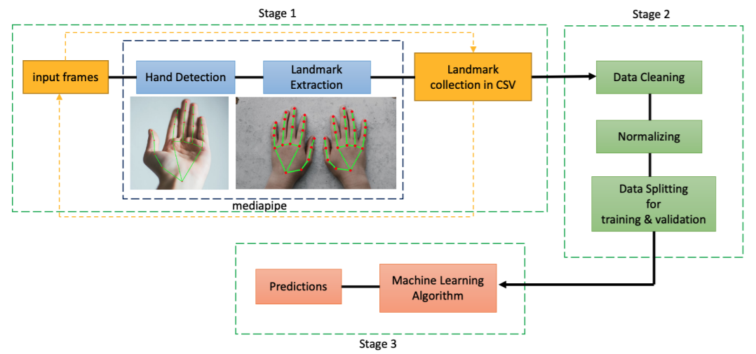

Figure : Proposed architecture to detect hand gestures and predict sign language finger-spellings

Our hand tracking solution utilizes an ML pipeline consisting of two models working together:

• A palm detector that operates on a full input image and locates palms via an oriented hand bounding box.

• A hand landmark model that operates on the cropped hand bounding box provided by the palm detector and returns high-fidelity 2.5D landmarks. Providing the accurately cropped palm image to the hand landmark model drastically reduces the need for data augmentation (e.g. rotations, translation and scale) and allows the network to dedicate most of its capacity towards landmark localization accuracy. In a real-time tracking scenario, we derive a bounding box from the landmark prediction of the previous frame as input for the current frame, thus avoiding applying the detector on every frame. Instead, the detector is only applied on the first frame or when the hand prediction indicates that the hand is lost.

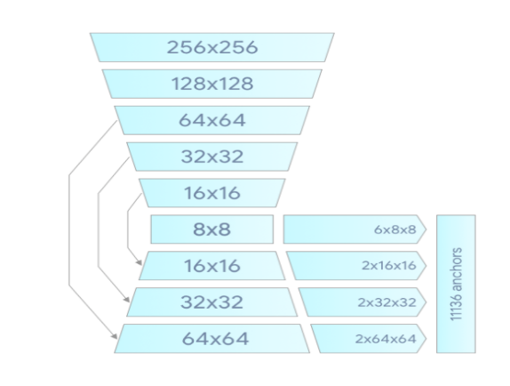

Figure :Palm detector model architecture.

**2.1. BlazePalm Detector**

To detect initial hand locations, we employ a single shot detector model optimized for mobile real-time application similar to BlazeFace[1], which is also available in MediaPipe[12]. Detecting hands is a decidedly complex task: our model has to work across a variety of hand sizes with a large scale span (∼20x) and be able to detect occluded and self-occluded hands. Whereas faces have high contrast patterns, e.g., around the eye and mouth region, the lack of such features in hands makes it comparatively difficult to detect them reliably from their visual features alone. Our solution addresses the above challenges using different strategies. First, we train a palm detector instead of a hand detector, since estimating bounding boxes of rigid objects like palms and fists is significantly simpler than detecting hands with articulated fingers. In addition, as palms are smaller objects, the non-maximum suppression algorithm works well even for the two-hand self-occlusion cases, like handshakes. Moreover, palms can be modelled using only square bounding boxes [11], ignoring other aspect ratios, and therefore reducing the number of anchors by a factor of 3∼5. Second, we use an encoder-decoder feature extractor similar to FPN[9] for a larger scene-context awareness even for small objects. Lastly, we minimize the focal loss[10] during training to support a large amount of anchors resulting from the high scale variance. High-level palm detector architecture is shown in Figure 2. We present an ablation study of our design elements in Table 1.

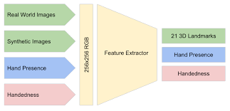

Figure :Architecture of our hand landmark model

. The model has three outputs sharing a feature extractor. Each head is trained by correspondent datasets marked in the same color. See Section 2.2 for more detail.

**2.2. Hand Landmark Model**

After running palm detection over the whole image, our subsequent hand landmark model performs precise landmark localization of 21 2.5D coordinates inside the detected hand regions via regression. The model learns a consistent internal hand pose representation and is robust even to partially visible hands and self-occlusions. The model has three outputs (see Figure 3): 1. 21 hand landmarks consisting of x, y, and relative depth. 2. A hand flag indicating the probability of hand presence in the input image. 3. A binary classification of handedness, e.g. left or right hand. We use the same topology as [14] for the 21 landmarks. The 2D coordinates are learned from both real-world images as well as synthetic datasets as discussed below, with the relative depth w.r.t. the wrist point being learned only from synthetic images. To recover from tracking failure, we developed another output of the model similar to [8] for producing the probability of the event that a reasonably aligned hand is indeed present in the provided crop. If the score is lower than a threshold then the detector is triggered to reset tracking. Handedness is another important attribute for effective interaction using hands in AR/VR. This is especially

useful for some applications where each hand is associated with a unique functionality. Thus we developed a binary classification head to predict whether the input hand is the left or right hand. Our setup targets real-time mobile GPU inference, but we have also designed lighter and heavier versions of the model to address CPU inference on the mobile devices lacking proper GPU support and higher accuracy requirements of accuracy to run on desktop, respectively.

**3. Pre-Processing of Images to get Multi-hand Landmarks using MediaPipe**

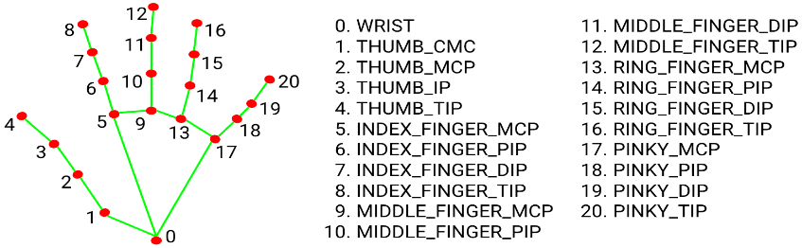

Figure : 21 Hand Landmarks

After the palm detection is skimmed over the whole image frame, subsequent Hand Landmark models comes into the picture. This model precisely localize 21 3D hand-knuckle coordinates (i.e., x, y, z-axis) inside the detected hand regions. The model is so well trained and robust in hand detection that it even maps coordinates to partially visible hand. Figure 2 shows the 21 landmark points detection by the Hand Landmark model. Now that we have a functional Palm and Hand detection model running, this model is passed over our dataset of various language. Considering the American Sign Language dataset, we have a to z alphabets. So, we pass our detection model over every alphabet folder containing images and perform Hand detection which yields us the 21 landmark points as shown in Figure 2. The obtained landmark points are then stored in a file of CSV format. A simultaneous, elimination task is performed while extracting the landmark points. Here, only the x and y coordinates detected by the Hand Landmark model is considered for training the ML model. Depending upon the size of the dataset around 10-15 minutes is required for Landmark extraction.

**4. Implementation in MediaPipe**

With MediaPipe[12], our hand tracking pipeline can be built as a directed graph of modular components, called Calculators. Mediapipe comes with an extensible set of Calculators to solve tasks like model inference, media processing, and data transformations across a wide variety of devices and platforms. Individual Calculators like cropping, rendering and neural network computations are further optimized to utilize GPU acceleration. For example, we employ TFLite GPU inference on most modern phones. Our MediaPipe graph for hand tracking is shown in Figure 5. The graph consists of two subgraphs one for hand detection and another for landmarks computation. One key optimization MediaPipe provides is that the palm detector only runs as needed (fairly infrequently), saving significant computation. We achieve this by deriving the hand location in the current video frames from the computed hand landmarks in the previous frame, eliminating the need to apply the palm detector on every frame. For robustness, the hand tracker model also outputs an additional scalar capturing the confidence that a hand is present and reasonably aligned in the input crop. Only when the confidence falls below a certain threshold is the hand detection model reapplied to the next frame.

**5. Application examples**

Our hand tracking solution can readily be used in many applications such as gesture recognition and AR effects. On top of the predicted hand skeleton, we employ a simple algorithm to compute gestures, see Figure 6. First, the state of each finger, e.g. bent or straight, is determined via the accumulated angles of joints. Then, we map the set of finger states to a set of predefined gestures. This straightforward, yet effective technique allows us to estimate basic static gestures with reasonable quality. Beyond static gesture recognition, it is also possible to use a sequence of landmarks to predict dynamic gestures. Another application is to apply AR effects on top of the skeleton. Hand based AR effects currently enjoy high popularity. In Figure 7, we show an example AR rendering of the hand skeleton in neon light style.

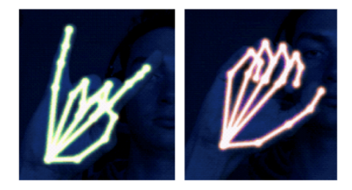

Figure :Example of real-time AR effects based on our

**6.Conclusion**

In this paper, we proposed MediaPipe Hands, an end-to end hand tracking solution that achieves real-time performance on multiple platforms. Our pipeline predicts 2.5D landmarks without any specialized hardware and thus, can be easily deployed to commodity devices. We open sourced the pipeline to encourage researchers and engineers to build gesture control and creative AR/VR applications with our pipeline.

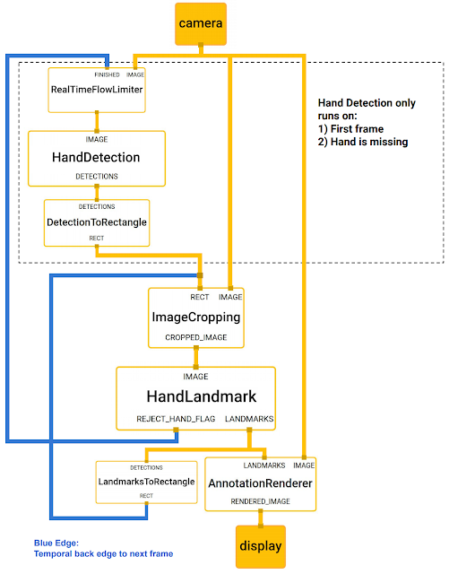

Figure :Flowchart of MediaPipe

The hand landmark models output controls when the hand detection model is triggered. This behavior is achieved by MediaPipes powerful synchronization building blocks, resulting in high performance and optimal throughput of the ML pipeline.

**7. References**

[1] Valentin Bazarevsky, Yury Kartynnik, Andrey Vakunov, Karthik Raveendran, and Matthias Grundmann. Blazeface: Sub-millisecond neural face detection on mobile gpus.

[2] Liuhao Ge, Hui Liang, Junsong Yuan, and Daniel Thalmann. Robust 3d hand pose estimation in single depth images: from single-view cnn to multi-view cnns. In Proceedings of the IEEE conference on computer vision and pattern recognition, pages 3593–3601, 2016

[3] Liuhao Ge, Hui Liang, Junsong Yuan, and Daniel Thalmann. Robust 3d hand pose estimation from single depth images using multi-view cnns. IEEE Transactions on Image Processing, 27(9):4422–4436, 2018.

[4] cessing, 27(9):4422–4436, 2018. 1 [5] Liuhao Ge, Zhou Ren, Yuncheng Li, Zehao Xue, Yingying Wang, Jianfei Cai, and Junsong Yuan. 3d hand shape and pose estimation from a single rgb image. In Proceedings of the IEEE conference on computer vision and pattern recognition, pages 10833–10842, 2019.

[5] Google. Tensorflow lite on GPU. https://www.tensorflow.org/lite/ performance/gpu advanced. 3

[6] Google. Tensorflow.js Handpose. https://blog.tensorflow.org/2020/03/ face-and-hand-tracking-in-browser-withmediapipe-and-tensorflowjs.html. 1

[7] Yury Kartynnik, Artsiom Ablavatski, Ivan Grishchenko, and Matthias Grundmann. Real-time facial surface geometry from monocular video on mobile gpus. CoRR, abs/1907.06724, 2019. 2 [8] Tsung-Yi Lin, Piotr Dollar, Ross B. Girshick, Kaiming He, ´ Bharath Hariharan, and Serge J. Belongie. Feature pyramid networks for object detection. CoRR, abs/1612.03144, 2016. 2

[9] Tsung-Yi Lin, Priya Goyal, Ross B. Girshick, Kaiming He, and Piotr Dollar. Focal loss for dense object detection. ´ CoRR, abs/1708.02002, 2017

[10] Wei Liu, Dragomir Anguelov, Dumitru Erhan, Christian Szegedy, Scott E. Reed, Cheng-Yang Fu, and Alexander C. Berg. SSD: single shot multibox detector. CoRR, abs/1512.02325, 2015.

[11] Camillo Lugaresi, Jiuqiang Tang, Hadon Nash, Chris McClanahan, Esha Uboweja, Michael Hays, Fan Zhang, ChuoLing Chang, Ming Guang Yong, Juhyun Lee, Wan-Teh Chang, Wei Hua, Manfred Georg, and Matthias Grundmann. Mediapipe: A framework for building perception pipelines. volume abs/1906.08172, 2019. 1, 2, 4

[12] Iason Oikonomidis, Nikolaos Kyriazis, and Antonis A Argyros. Efficient model-based 3d tracking of hand articulations using kinect. 1

[13] Tomas Simon, Hanbyul Joo, Iain A. Matthews, and Yaser Sheikh. Hand keypoint detection in single images using multiview bootstrapping. CoRR, abs/1704.07809, 2017. 2

[14] Snapchat. Lens Studio by Snap Inc. https://lensstudio.snapchat.com/ templates/object/hand/. 1

[15] Andrea Tagliasacchi, Matthias Schroder, Anastasia Tkach, ¨ Sofien Bouaziz, Mario Botsch, and Mark Pauly. Robust articulated-icp for real-time hand tracking. In Computer Graphics Forum, volume 34, pages 101–114. Wiley Online Library, 2015. 1

[16] Chengde Wan, Thomas Probst, Luc Van Gool, and Angela Yao. Self-supervised 3d hand pose estimation through training by fitting. In Proceedings of the IEEE Conference on Computer Vision and Pattern Recognition, pages 10853– 10862, 2019