In the name of God

Univrsity of Tehran

Faculty of engineering

Electrical and computer faculty

**Linear control systems lab**

**Exp3**

--

Group numb:5

Aban 1398

**Contents**

|  |  |
| --- | --- |
| **Title** | **Page number** |
| Abstract | 3 |
| Part 1 | 4 |
| Part 2 | 12 |
| Ps | 13 |

Abstract

As we see in previous experiments, Matlab is a great tool for simulating our sample before building it, with various stability tests in matlab and changing inputs to get our desired outputs we can evaluate our system. In this experiment we see one of matlab’s property a classical simulation for mechanical systems. With simMechanics we can have our desired outputs due to classical Newton’s Laws. In pendulum part we can easily change pendulum’s angle to see it’s stability. Also we can see stable and transient response of our system and with changing the time we can reach to our desired graph. Finally, the simscape part in matlab has real physical blocks so we can easily compare our result with real experiments results.

# Part 1

## sim Mechanics

### Question One

theoretical results:

$l_{0}=10 cm$

$$mg-f_{B}-f_{k}=ma$$

$$mg=0.1*10=1$$

$$f_{B}=B\dot{y}=0.3\dot{y}$$

$$f_{k}=k∆y=5(y-10.5)$$

$$1-0.3\dot{y}-5\left(y-10.5*{10}^{-2}\right)=0.1\ddot{y}$$

$$1-0.3\dot{y}-5y+0.525=0.1\ddot{y}$$

$\begin{matrix}y=x_{1} \\ \dot{y}=x_{2}\end{matrix}$ = X

$\begin{matrix}\dot{x_{1}}=x_{2} \\ \dot{x_{2}}=10-3x_{2}-50x_{1}+5.25\end{matrix}$ = $\dot{X}$

$$10-3\dot{y}-50y+5.25=\ddot{y}$$

$$x_{2E}=0$$

$$10-3x_{2E}-50x_{1E}+5.25=0$$

$$x_{1E}=0.305m$$

$l_{0}=5 cm$

$$mg-f_{B}-f_{k}=ma$$

$$mg=0.1*10=1$$

$$f_{B}=B\dot{y}=0.3\dot{y}$$

$$f_{k}=k∆y=5(y-5.5)$$

$$1-0.3\dot{y}-5\left(y-5.5*{10}^{-2}\right)=0.1\ddot{y}$$

$$1-0.3\dot{y}-5y+27.5*{10}^{-2}=0.1\ddot{y}$$

$\begin{matrix}y=x_{1} \\ \dot{y}=x_{2}\end{matrix}$ = X

$\begin{matrix}\dot{x_{1}}=x_{2} \\ \dot{x_{2}}=10-3x_{2}-50x_{1}+2.75\end{matrix}$ = $\dot{X}$

$$10-3\dot{y}-50y+2.75=\ddot{y}$$

$$x_{2E}=0$$

$$10-3x_{2E}-50x_{1E}+2.75=0$$

$$x_{1E}=0.255m$$

Matlab simulation:

A)

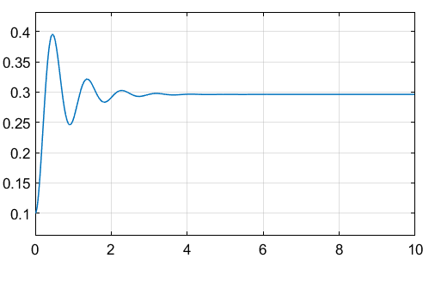

Graph I

Graph I: the result of matlab simulation in simMechanics with free length = 10cm

B)

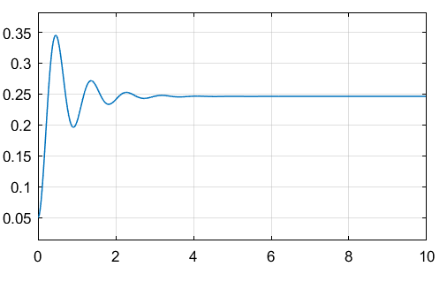

Graph II

Graph II: the result of matlab simulation in simMechanics with free length = 5cm

### 1-3.Question Two

theoretical results:

$mg=N$

$$F-f_{B}-f_{k}=ma$$

$$mg=0.1*10=1=N$$

$$f_{B}=B\dot{x}=0.3\dot{x}$$

$$f_{k}=k∆x=5(x-0.13)$$

$$1-0.3\dot{x}-5\left(x-0.13\right)=0.1\ddot{x}$$

$$10-3\dot{x}-50(x-0.13)=\ddot{x}$$

$\begin{matrix}x=x_{1} \\ \dot{x}=x_{2}\end{matrix}$ = X

$\begin{matrix}\dot{x_{1}}=x_{2} \\ \dot{x_{2}}=10-50x_{1}-3x_{2}+6.5\end{matrix}$ = $\dot{X}$

$$x_{2E}=0$$

$$10-50x_{1E}-3x_{2E}+6.5=0$$

$$x_{1E}=0.33m$$

Matlab simulation:

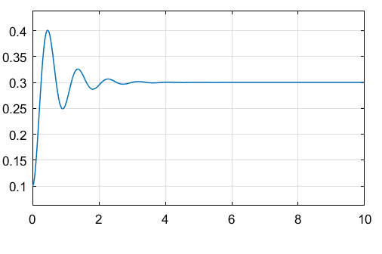

Graph III

Graph III: the result of matlab simulation in simMechanics with free length = 10cm

### 1-4.Question Three

theoretical results:

$mg cosθ=N=\frac{\sqrt{3}}{2}$

$$mgsinθ-f_{B}-f_{k}=ma$$

$$mg\sin{θ=} 0.1*10*\frac{1}{2}=0.5$$

$$f_{B}=B\dot{x}=0.3\dot{x}$$

$$f_{k}=k∆x=5(x-0.18)$$

$$0.5-0.3\dot{x}-5\left(x-0.18\right)=0.1\ddot{x}$$

$$5-3\dot{x}-50(x-0.18)=\ddot{x}$$

$\begin{matrix}x=x_{1} \\ \dot{x}=x_{2}\end{matrix}$ = X

$\begin{matrix}\dot{x_{1}}=x_{2} \\ \dot{x_{2}}=5-50x_{1}-3x_{2}+9\end{matrix}$ = $\dot{X}$

$$x_{2E}=0$$

$5-50x_{1E}+9=0$

$$x_{1E}=0.28m$$

Matlab simulation:

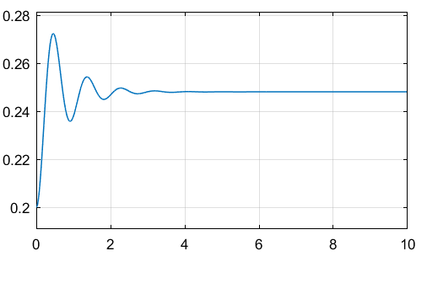

Graph IV

Graph IV: the result of matlab simulation in simMechanics with free length = 15cm

### 1-4.Question Four

### 1-4-1.theoretical

$$mgsinθ=\left(\frac{1}{3}M_{1}l^{2}+ M_{2}l^{2}\right)\ddot{θ}$$

$$\left(M_{1}+M_{2}\right)*10*\sin\left(70\right)=\left(\frac{1}{3}M_{1}l^{2}+ M_{2}l^{2}\right)\ddot{θ}$$

$$1cm*1cm*24cm*π*2700=2.03*{10}^{-1}kg$$

$$\frac{4}{3}*π*{\left(6cm\right)}^{3}*7800=7.05kg$$

### 1-4-2.Simulink

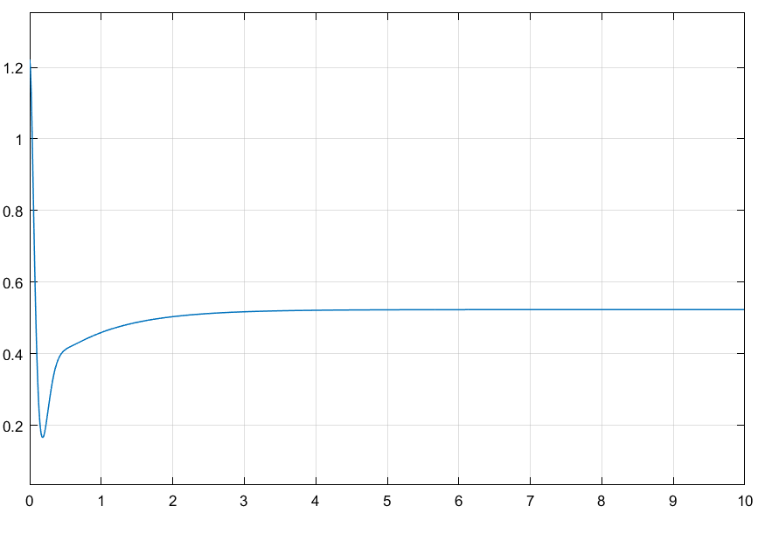

Graph V

Graph V is our feedback system with 30 degree input

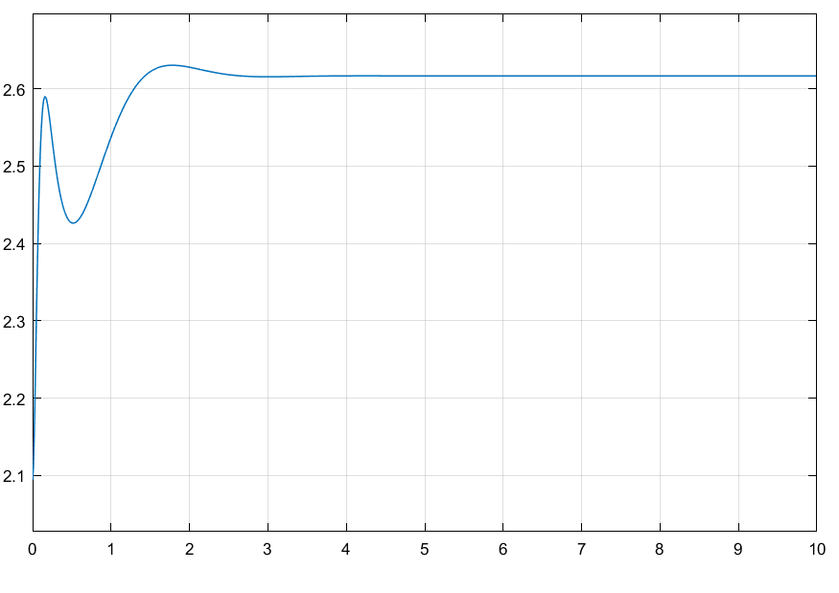

Graph VI

Graph VI is our inverted pendulum feedback system with 150 degree input

### 1-4-3.SimMechanics



Graph VII

This graph shows the output of our subsystem in semmechanics without PID

If we compare these two graphs together we can see that due to lack of PID our position is not stable and our pundulum continue its swing.

# Part 2

## Modelling of DC motor with simscape / matlab



Graph VIII

As our motor provide a DC voltage for our armature, the armature will provide a constant speed for rotation so as we can see in the graph VIII our speed is constant along the time and our speed is rising with respect to a constant speed. If we ignore delta function in current graph due to our inductance and preventing to a change in current, we can say that our current will remain constant too with respect to a constant voltage.

# Ps: process of program

P1-1. Is a. slm file that contains Simulink blocks for the question 1 and as our output is mechanical so we need a converter to see our output in scope and there is a solver that we can change our various solver like we discussed in previous experiment.

P1-2. Contains the same simulation for question 2 and so p1-3.

P1-4. Contains our simulation blocks with different inputs (different angle) that one of them (150) is an inverted pendulum.

Part 2 is for part two like its name and contains our DC motor and we will add its parameters and see armature current and its speed and position with respect to time.