**Apple Inc. – An Analysis of Stock Performance**

**Authors:** Fatima Zahra El Alami, Maha Alsaleh, Mohammed Gaghman  
**Affiliation:** Faculty FABIZ – IMBA program, 2nd year

**Keywords:** Apple, stock, closing price, opening price, volatility, beta negative, sustainability

**Abstract**

This research paper presents a comprehensive analysis of the stock performance of Apple Inc., a leading multinational technology company. We have used Yahoo Finance as our primary source for historical data, which spans from January 1, 2000, to January 20, 2024. The data is divided into two categories: one that includes all stock-related data and another that focuses solely on yearly stock volume information.

**Introduction**

Apple Inc., headquartered in Cupertino, California, is a global leader in the technology sector. The company is renowned for its innovative consumer electronics, computer software, and online services. Some of its most popular products include the iPhone, iPad, and Mac computers.

As a significant player in the global technology landscape, Apple’s trajectory is closely tied to the innovations that have revolutionized the way individuals interact with and perceive technology. Beyond its groundbreaking products, Apple’s stock performance has been a key area of interest for investors navigating the dynamic and often unpredictable financial markets.

This research paper provides a detailed analysis of Apple’s stock performance from 2020 to 2024. This period was marked by a series of unprecedented challenges and transformative opportunities, including the onset of the COVID-19 pandemic, which significantly disrupted global markets, and Apple’s continued product innovations.

Understanding the complexities of Apple’s stock dynamics during this period requires a multifaceted approach that combines quantitative and qualitative research methods. By examining financial statements, market trends, key events, and sentiment indicators, we aim to unravel the factors that have shaped Apple’s stock trajectory.

As technology continues to evolve and permeate various aspects of our lives, the stock performance of tech giants like Apple not only reflects the company’s internal dynamics but also broader shifts in the technological landscape. Apple’s strategic decisions, product launches, and responses to external factors all contribute to the intricate interplay of supply and demand in the stock market.

Through this research, we aim to provide stakeholders, analysts, and investors with a nuanced understanding of the forces driving Apple’s stock performance. This will ultimately enable more informed decision-making in the dynamic world of financial markets.

**Methods and Results**

For our performance analysis, we used Yahoo Finance to gather historical data spanning from January 1, 2000, to January 20, 2024. This data was then organized into two separate CSV files: one encompassing all stock-related data, and the other solely containing yearly stock volume information.

**Data Analysis**

To conduct this analysis, we used several Python libraries as follows:

**

**AAPL Stock Prices (2000-2024)**

The graph of AAPL stock prices from 2000 to 2024 shows that the stock was relatively stable for a period before it began to increase significantly. This indicates a positive performance of the stock over the observed period.

**AAPL Volume (2000-2024)**

The graph of AAPL volume from 2000 to 2024 shows that there was initially a high volume of the metric, which then significantly decreased and stabilized at a lower level. This could indicate a decrease in sales, stock trading volume, or any other measurable factor over time.

**Market Capitalization**

The market capitalization has significantly increased from around 2000 to 2022, indicating the company’s substantial growth over these years.

# Here volume visualized from 2000 – 2024

# This volume-by-year summing the volume by year shows that the stock volume increased during 2006 -2009.

#### Market Capitalization

The market capitalization has significantly increased from around 2000 to 2022, indicating the company’s substantial growth over these years.

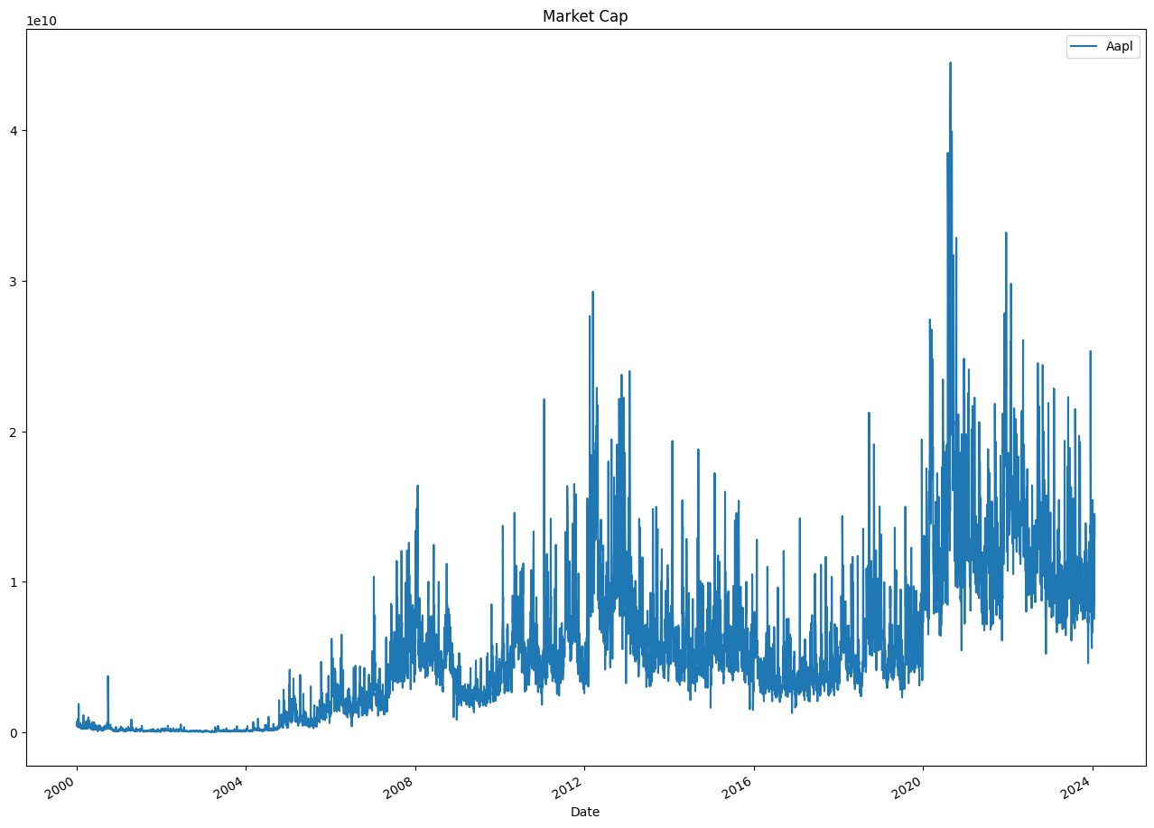

# Both the 50-day and 200-day moving averages follow the trend of the opening prices closely, smoothing out short-term fluctuations and highlighting the underlying trend. The moving averages provide insights into potential trends and reversals, offering a clearer picture of long-term and short-term movements.

## Discussion

The analysis of Apple’s stock performance from 2000 to 2024 reveals several key insights. The significant increase in stock prices over the observed period indicates a positive performance of the stock, reflecting the company’s growth and success in the market. This growth can be attributed to Apple’s continuous innovation and its ability to stay at the forefront of the technology sector.

The initial high volume of the metric, followed by a significant decrease and stabilization at a lower level, could be indicative of various factors. It could suggest a decrease in sales or stock trading volume over time. However, it’s also important to consider other factors such as market conditions, investor sentiment, and company-specific events that could influence trading volume.

The substantial increase in market capitalization from 2000 to 2022 further underscores Apple’s growth over these years. Market capitalization, which is the total market value of a company’s outstanding shares of stock, is often used as a measure of a company’s success. The increase in Apple’s market capitalization suggests that the company has been successful in increasing shareholder value.

In conclusion, the analysis provides a comprehensive overview of Apple’s stock performance, shedding light on the various factors that have influenced its trajectory. While the analysis is based on historical data, the insights derived could be valuable for future investment decisions. However, it’s important to note that stock performance is influenced by a multitude of factors, and past performance is not indicative of future results. Therefore, investors should consider a wide range of information and conduct thorough research before making investment decisions.

GitHub:   
  
<https://github.com/mohagag/Apple-Stocks-Performance>