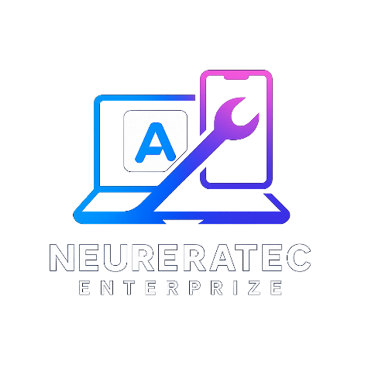
From: Calton Dick, Neuereatec Enterprise
Address: 1001 Glasgow Housing Scheme, East Berbice-Corentyne, Guyana
To: Linden Utility Services Co-op Society Ltd.
Date: 15 NOV 2025
Invoice #: INV-LUS-140325

1. Your Website Package (Core Cost)
This is the main cost to design and build your website.
Item | Total Cost (GYD)
Website Design & Development | $170,000
Mobile-Friendly Layout & Styling | $75,000
Adding Your Content (Text, PDFs, Images) | $25,000
CORE PACKAGE TOTAL | $270,000

2. Choose Your Hosting Plan (Optional)
Your website needs a domain name (e.g., .com) and hosting (a place to live online).
Option A: Self-Managed (We Recommend for Savings)
- What it is: You pay the hosting company directly. We help you set it up.
- Your Cost: $0 on this invoice.
- Your Ongoing Yearly Cost: ~$9,000 GYD paid to Digital Ocean.
Option B: Fully Managed by Us (For Hassle-Free Service)
- What it is: We handle everything for 1 year (domain, hosting, security).
- Your One-Time Cost: +$60,000 GYD

3. Staff Training (Optional)
Stop paying for future small updates.
Item | One-Time Fee | Long-Term Benefit
Train your staff to update the website themselves. Includes 30-day support. | +$40,000 | Save $10,000+ per update.

Summary: Your Final Total
Your Choices | Total Amount to Pay (GYD)
Core Package Only (Self-Managed Hosting) | $270,000
Core Package + Fully Managed Hosting | $330,000
Add Staff Training to either option above | *+ $40,000*

Payment Details:
- Due Date: Upon website launch.
- Method: Cash, MMG, or Bank Transfer (Guyana).
To Proceed:
Please sign below to approve and indicate your choice:
Chosen Package: ___________________________________________________
Authorized Signature: ___________________________
Print Name & Title: ___________________________
Date: ___________________________

Calton Dick
Neuereatec Enterprise
[Your Street Address], Georgetown, Guyana
6933542 / 6871917 | neuereatec@gmail.com

