Fronend :

To create a frontend website using HTML, CSS, and JavaScript, you may follow these steps:

•HTML

Hyper-Text Markup Language is the standard markup language for pages that are designed to be viewed on a web browser. Technologies such as Cascading Style Sheets (CSS) and programming languages like JavaScript can improve it to make a full website.

•CSS

Cascading Style Sheets is a style sheet language for describing the style of a document written in a markup language like HTML. CSS, along with HTML and JavaScript, is a key component of the World Wide Web.

•Bootstrap

Is a free and open-source web development framework. It’s designed to ease the web development process of responsive, mobile-first websites

by providing a collection of syntax for template designs. In other words, Bootstrap helps web developers build websites faster as they don’t need to worry about basic commands and functions. It consists of HTML, CSS, and JS-based scripts for various web design-related functions and components.

•JavaScript

Is a dynamic programming language that's used for web development, in web applications, for game development, and lots more. It allows you to implement dynamic features on web pages that cannot be done with only HTML and CSS.

Backend:

To convert the project to dynamic we using (php , mysql(phpMyAdmin)).

•PHP is a server-side scripting language designed for web development. It is used to create dynamic web pages and can be embedded into HTML code. PHP code is executed on the server, generating HTML output that is sent to the client's web browser. PHP stands for "Hypertext Preprocessor," which reflects its primary purpose of processing web content.

PHP syntax is similar to C and Java, which makes it easy for programmers to learn. It supports a wide variety of databases such as MySQL, PostgreSQL, Oracle, and others. PHP also has a rich set of built-in functions that allow developers to perform various tasks, from processing form data to manipulating images.

•MySQL is an open-source relational database management system (RDBMS) that uses SQL (Structured Query Language) as its querying language. It is widely used for web development and other applications that require database functionality. MySQL is known for its scalability, reliability, and ease of use.

**Design**

**Umls**

**Use case Diagram**

Here the admin has cases which are:

• register

• login

•check result

• knoeledge

And the user has cases which are:

•register

•login

•upload image

•show results

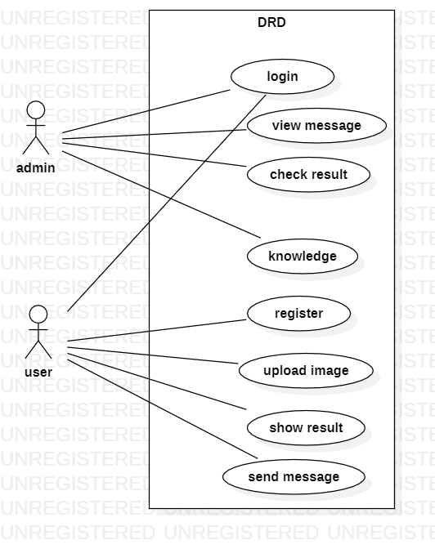

**Activity Diagram of users:**

**The activity diagram of this project is as following:**

•first, user must be create an account to access the website.

•the user can benefit from the services

1. Detection of diabetes.
2. Send message
3. Show result
4. Show Knowledge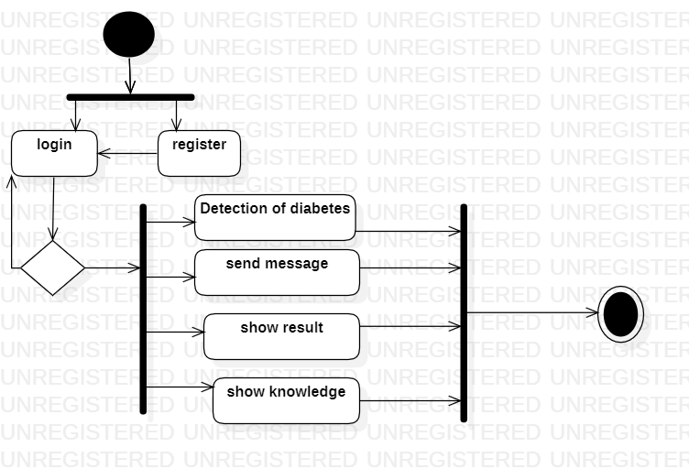

Activity Diagram of users:

The activity diagram of this project is as following:

* After admin login.
* Admin can detection of diabetes , check result , show message , control of knowledge

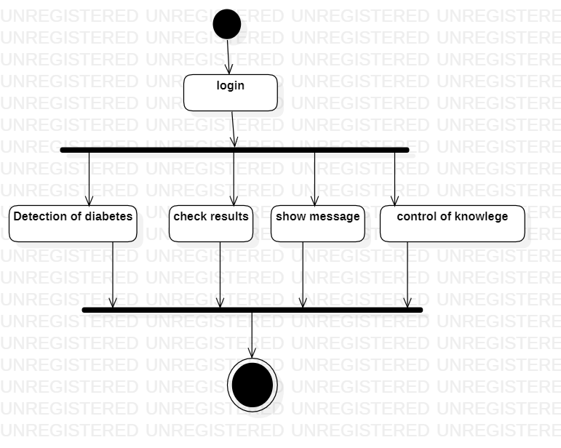

**_Sequance Diagram To User:**

(1)Clicking On Module: When user open Website Will go the Default Main Page

(Login & Registration Page)

(2)Input Registration Info: to Make user Any Action Must Have A Account For User ,To Make User Account The User Give The information to Login & Registration Page

(Database)

(3)Save Data: The information to User Must Save In Database To Give It when needed Anther Time

(Login & Registration Page)

(4)Account Registered: The Date Base Give Responce To Login & Registration Page (Account Created)

(Service Page)

(5)Upload Photo: Thes Step Can User Upload Photo To Service Page

(6)Protect Level Of Photo: Will Protected The Photo To fixing Wich Level of 4 Level This Photo & Responce to Database

(Database)

(7)Save Data: The information to User Must Save In Database To Give It when needed Anther Time

(Massage Box)

(8)Show to User: After Protected The Photo Show To User The Output Of Protected

(9)Send Massage To Admin: When User Need To Send To Admin Massage & Can Resive Massage From Admin

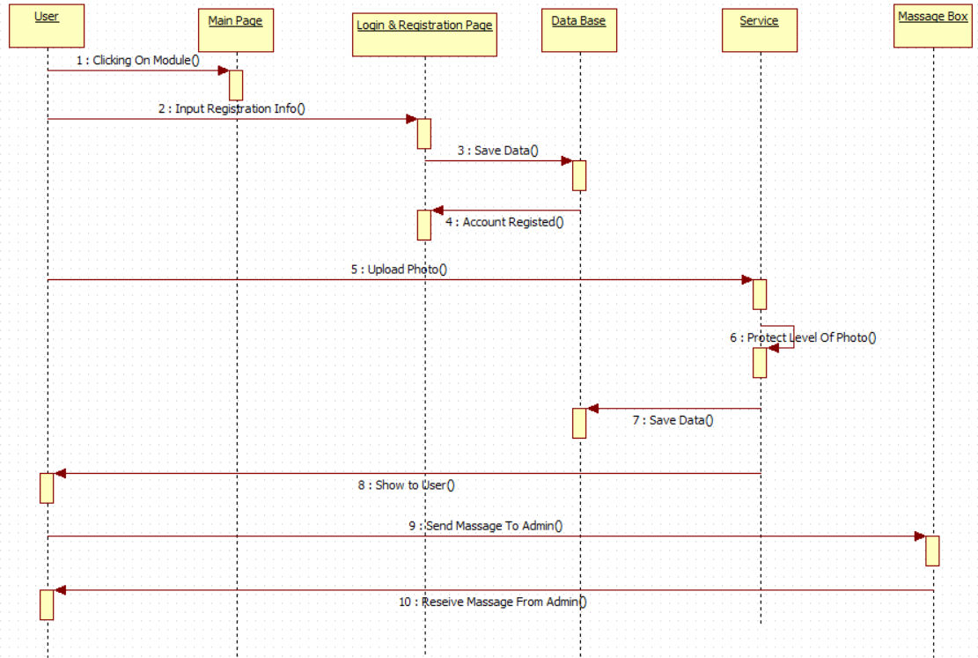

_Sequance Diagram To Admin

(1)Clicking On Module: When Admin open Website Will go the Default Main Page

(Login & Registration Page)

(2)Input Registration Info: to Make Admin Any Action Must Have A Account For Admin ,To Make Admin Account The User Give The information to Login & Registration Page ,And Control To User Account

(Database)

(3)Save Data: The information to Admin Must Save In Database To Give It when needed Anther Time

(Login & Registration Page)

(4)Account Registered: The Date Base Give Responce To Login & Registration Page (Account Created)

(Service Page)

(5)Upload Photo: Thes Step Can Admin Upload Photo To Service Page ,Can Show Another Photos Of User Uploaded In Website

(6)Protect Level Of Photo: Will Protected The Photo To fixing Wich Level of 4 Level This Photo & Responce to Database

(Database)

(7)Save Data: The information to User Must Save In Database To Give It when needed Anther Time

(Massage Box)

(8)Show to Admin: After Protected The Photo Show To Admin The Output Of Protected

(9)show Massage of User.

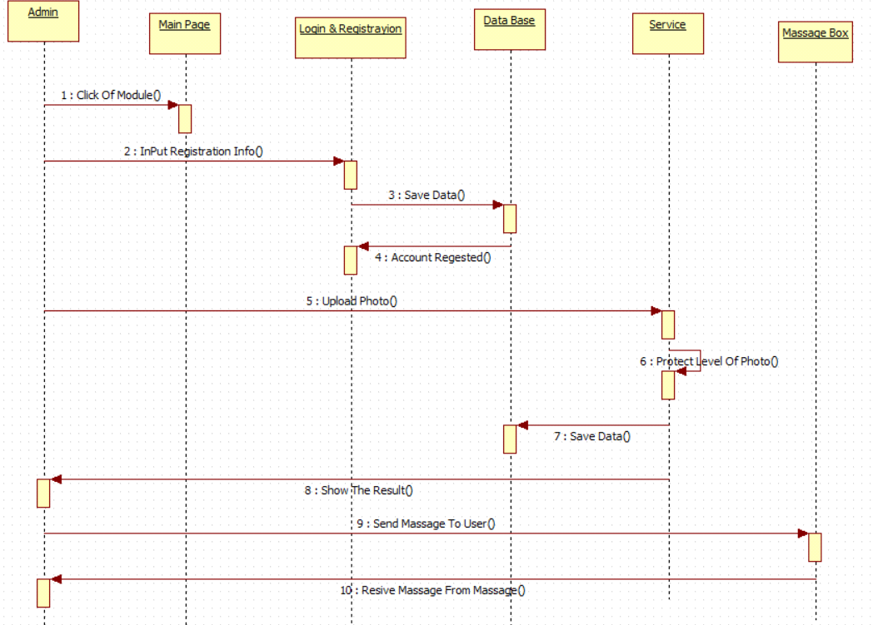

**ERD diagram:**

Admin : manage website, check result , upload photo.

User :show website, use the some service , send message , detecting of diabetes.

