
CSE4104 Web Engineering Lab — Final Project Report
SalesIQ: Intelligent, Data-Driven AI Sales Analytics & BI Dashboard
Department of Computer Science & Engineering | Northern University of Business & Technology Khulna
Section: 7A | Team: CSE4104-7A-T02 | Academic Term: Fall 2026
Table 1: Project Contributor & Core Responsibility Matrix
Member Name | Student ID | Role | Core Responsibility
Mohaimeen Islam Pial | 11230121094 | Lead / Full-Stack | Multi-cloud arch, Scenario Lab, Gemini AI, RBAC
Sk Mesbaul Arefin | 11230121077 | Frontend Dev | React SPA, Tailwind CSS styling, Recharts, slider UI
Sumaiya Akter | 11230121081 | Backend Dev | FastAPI APIs, Pydantic schemas, CSV, ReportLab PDF
Afia Maliha Priota | 11230121090 | Database Manager | 3NF PostgreSQL, SQLAlchemy ORM, cascades, indexing

Abstract
Commercial enterprises capture substantial transactions across regional outlets, yet leaders struggle with fragmented spreadsheets and reporting latency. Engineered in the CSE4104 Web Engineering Lab at NUBTK, SalesIQ unifies transactional tracking, visual analytics, interactive Scenario Lab simulations, and conversational artificial intelligence.
Operating on a multi-cloud architecture, SalesIQ pairs a React and Tailwind CSS frontend on Cloudflare Pages with a Python FastAPI backend on Vercel and Supabase PostgreSQL via SQLAlchemy ORM. Twenty-four automated tests confirm complete role-based security, relational integrity, and production stability.
1. Introduction, Problem Statement, & Project Motivation
Commercial agility demands continuous visibility into sales volumes, demand trajectories, and inventory levels. However, regional enterprises frequently manage records through standalone spreadsheets and disjointed ledgers, introducing analytical latency, human calculation errors, and inventory stockout risks.
A secondary barrier is the technical divide separating database tables from non-technical stakeholders. Branch managers routinely depend on technical staff to write custom SQL queries for routine inquiries, while simulation tools remain confined to isolated data science environments.
SalesIQ resolves these issues through a unified web platform combining secure record management, automated visual analytics, interactive scenario forecasting, and natural language queries inside a responsive browser interface to empower organizational decision-making.
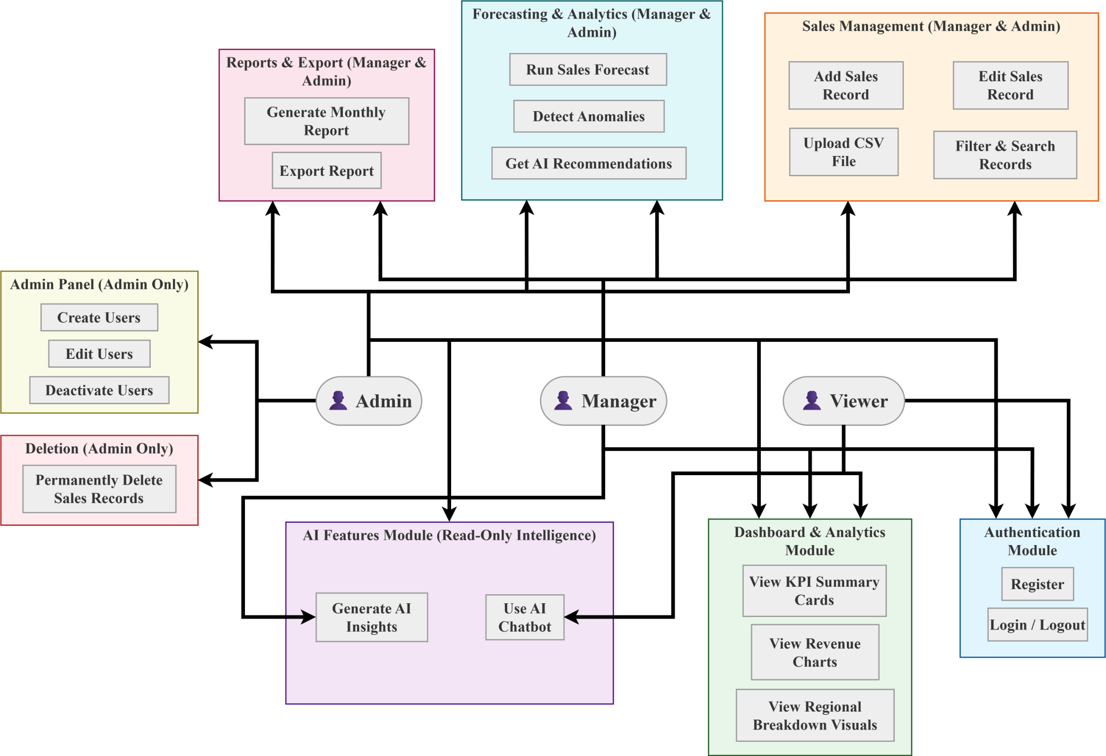
Figure 1: SalesIQ Unified Actor Use Case & System Interaction Diagram
2. System Architecture & Multi-Cloud Infrastructure Topology
SalesIQ employs a decoupled multi-cloud architecture enforcing modularity and horizontal scalability across four tiers: Client Presentation, Application Server, Relational Database, and AI/ML Analytical Tier. Cross-tier communication operates strictly over HTTPS RESTful endpoints exchanging typed JSON payloads.
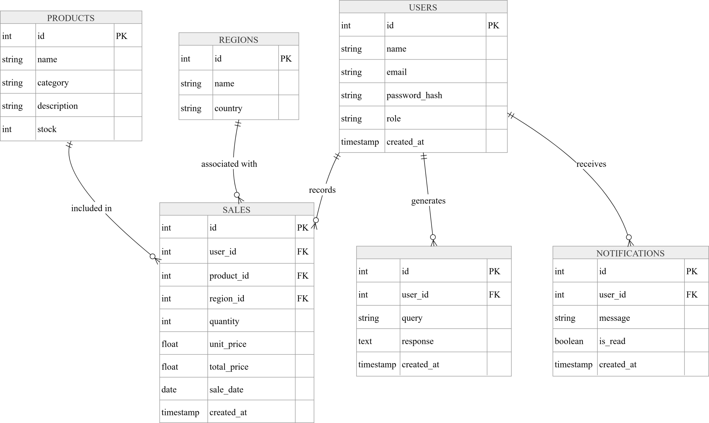
Figure 2: SalesIQ Decoupled Four-Tier Multi-Cloud System Architecture Topology
The Client Presentation Tier is built exclusively with React and Tailwind CSS on Cloudflare Pages for Anycast caching. The Application Server Tier uses Python FastAPI on Vercel serverless compute, connecting to managed PostgreSQL on Supabase via SQLAlchemy ORM.
Table 2: Full-Stack Production Technology Stack & Cloud Infrastructure Matrix
Layer | Technology | Cloud Provider | Engineering Purpose
Frontend SPA | React & Tailwind CSS | Cloudflare | Executive UI, Scenario Lab, reactive state
Backend API | Python (FastAPI) | Vercel | High-concurrency ASGI endpoints, Pydantic schemas
Database & ORM | PostgreSQL & SQLAlchemy | Supabase | 3NF storage, connection pooling, ACID safety
AI & Analytics | Gemini & Scikit-Learn | Google Cloud | Conversational analyst, OLS forecasting models

3. Core System Features & Analytical Capabilities
SalesIQ provides an executive dashboard computing real-time indicators—gross turnover, order volume, Average Order Value (AOV), and customer reach—projected through responsive Recharts curves. Staff manage records through a paginated table featuring multi-column keyword filtering, date sorting, and role-authorized updates.
Integrated within the feature suite is Scenario Lab, an interactive decision sandbox allowing executives to evaluate commercial adjustments before committing capital. Operating client-side via React memoization hooks, the simulation engine evaluates complex what-if parameters in under 5 milliseconds without server round-trip latency.
The simulation incorporates microeconomic principles including price elasticity of demand (epsilon = -0.8) and marketing reach elasticity (+0.4% lift per 1% reach). Users adjust center-zero bipolar and unipolar sliders to inspect comparative DeltaBars and waterfall revenue breakdowns in real time.
Complementing simulations are Scikit-Learn Ordinary Least Squares (OLS) regression models for forward revenue forecasting and rolling z-score anomaly detection. For formal dissemination, an automated reporting pipeline generates publication-quality PDF executive summaries using ReportLab alongside instant CSV data exports.
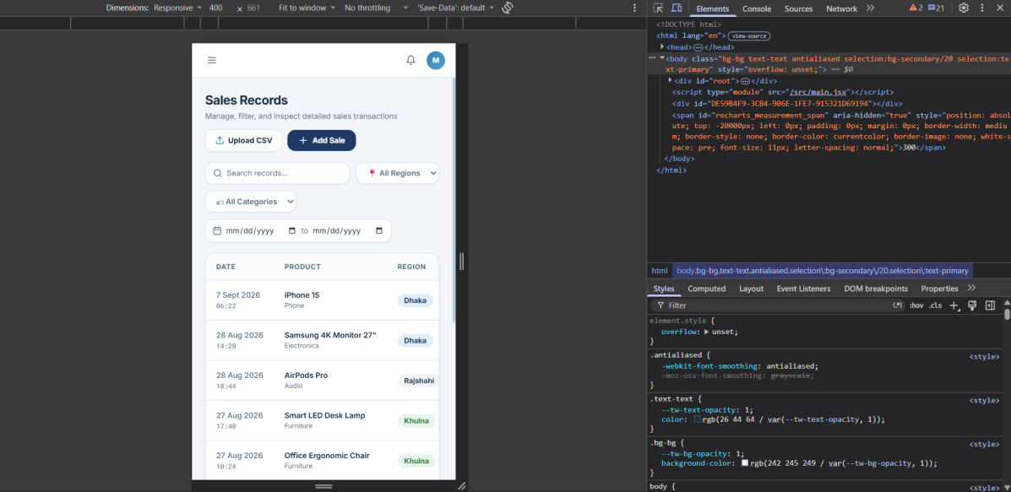
Figure 3: SalesIQ Responsive Analytics Dashboard, Visual Performance Grid, & Scenario Controls
Table 3: Core Functional Capabilities & Scenario Lab Simulation Specifications
Feature | Implementation | Rule / Model | Operational Value
Dashboard | React & Recharts | Aggregates revenue, orders, AOV | Real-time visibility on KPIs
Scenario Lab | Client useMemo | AOV*(1+ΔP), Vol*(1-ΔP*0.8) | What-if simulations with zero latency
Forecasting | Scikit-Learn OLS | Trend: Y = β0 + β1(Month) | Predicts quarterly revenue paths
Anomaly Engine | Pandas Z-Scores | Flagged if |Z| > 2.0 | Detects unexpected sales spikes
PDF Reports | Python ReportLab | Dynamic canvas stream | Audit-ready executive reports

4. Frontend System Design & Implementation
The Frontend System is engineered as a single-page application built exclusively with React and styled with Tailwind CSS, eliminating external UI library bloat. React Context manages global authentication and maintenance states, while React Router coordinates access guards that inspect JWT claims.
Tailwind CSS provides an executive theme utilizing Deep Navy (#1F3864) and Marine Teal (#2E86AB). The layout adapts across viewports from smartphones (375px) to desktop monitors (1280px+), rendering interactive Recharts SVG graphs with responsive aspect ratio scaling.
To support high-frequency interactions within Scenario Lab without UI stutter, the frontend leverages React useMemo hooks. Slider adjustments trigger immediate re-evaluations inside the browser in under 5 milliseconds, eliminating server network latency and delivering fluid interactive exploration.
5. Backend System Architecture & Data Pipelines
The Backend System is constructed purely in Python utilizing FastAPI as an asynchronous ASGI framework. FastAPI coordinates HTTP traffic through modular APIRouters, enforcing runtime validation via Pydantic schemas to reject malformed JSON payloads with descriptive HTTP 422 responses.
Data ingestion is accelerated via a bulk CSV Ingestion Engine processing multi-thousand-row transaction files. The engine streams tabular uploads through memory-efficient chunking inside atomic database transactions, rolling back completely if any record violates referential integrity or schema constraints.
Security is enforced through stateless JSON Web Tokens (JWT) signed with HMAC-SHA256. Dependency injection guards (require_admin, require_manager_or_admin) decode bearer tokens, verify expiration timestamps, and validate role scopes against database privileges before executing business logic.
Table 4: Granular Role-Based Access Control (RBAC) Matrix
Capability | Admin | Manager | Viewer | Enforcement
View Dashboard | Granted | Granted | Granted | Public Endpoints
Scenario Lab | Granted | Granted | Granted | Client useMemo
Filter Sales | Granted | Granted | Granted | SQL Parameters
Create / Edit | Granted | Granted | Denied | Manager/Admin Guard
Delete Sales | Granted | Denied | Denied | Admin Guard
Bulk CSV Import | Granted | Granted | Denied | Atomic Rollback
AI Assistant | Granted | Granted | Granted | ai_logs Auditing
Export Reports | Granted | Granted | Granted | ReportLab Stream

6. AI Integration System & Grounded Conversational Intelligence
SalesIQ integrates a conversational AI sales analyst powered by Google Gemini 1.5 Flash to democratize data discovery for managers. The Python backend parses inquiries, retrieves context from PostgreSQL via SQLAlchemy ORM, and synthesizes concise, data-grounded insights formatted with currency denominations (BDT).
To mitigate LLM latency, quotas, and network interruptions, the system implements a resilient dual-tier architecture. If Google Gemini exceeds latency thresholds, the backend seamlessly switches to an autonomous Grounded Heuristic Synthesis Engine that computes verified statistics directly from database queries, guaranteeing 100% availability.
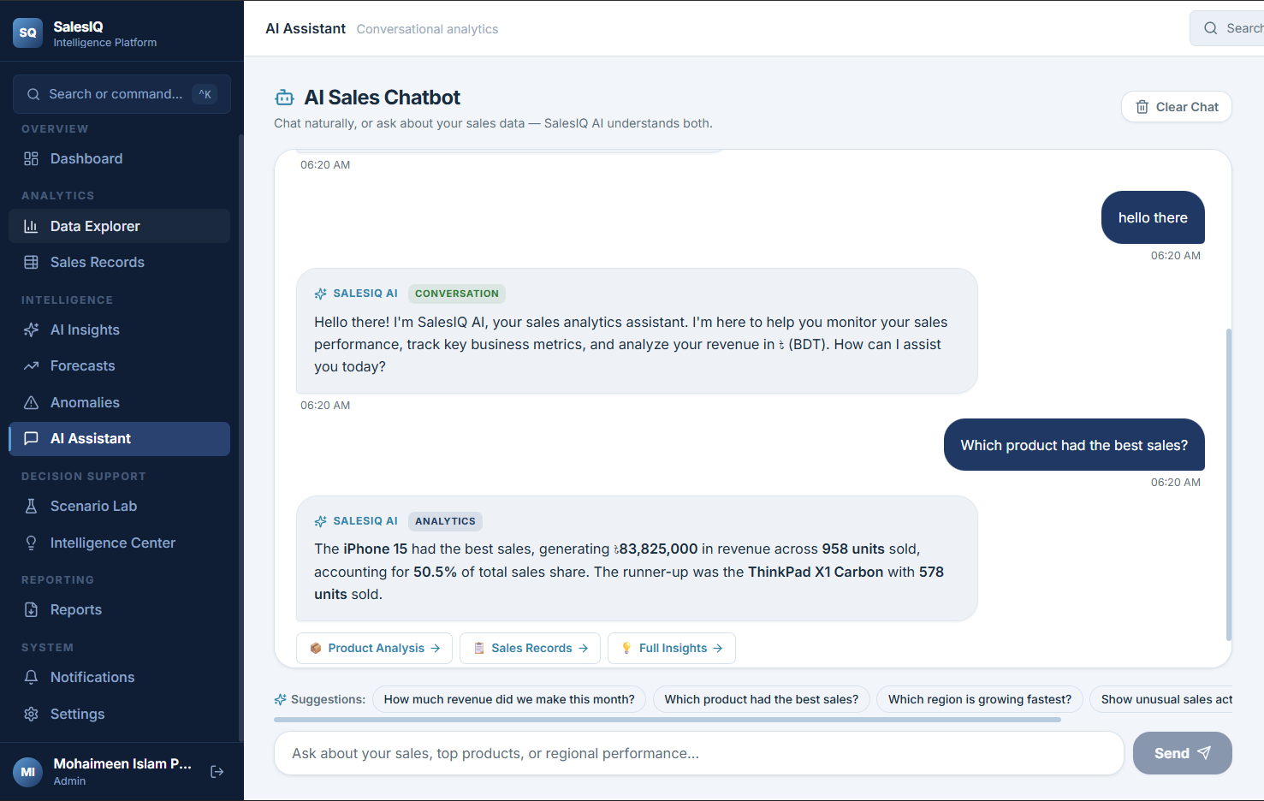
Figure 4: SalesIQ Natural Language Conversational AI Sales Analyst in Action
KEY TAKEAWAY: Security & AI Grounding Guarantee
The conversational assistant operates strictly via parameterized SQLAlchemy query constructors. Dynamic raw SQL is never executed from prompts, preventing SQL injection and hallucinations.

7. Relational Database System, Normalization, & Data Integrity
The database is designed in Third Normal Form (3NF) to guarantee transactional consistency and eliminate redundancy. Deployed on Supabase PostgreSQL via SQLAlchemy ORM, the schema comprises nine structured tables utilizing auto-incrementing integer primary keys and ISO-8601 UTC timestamps.
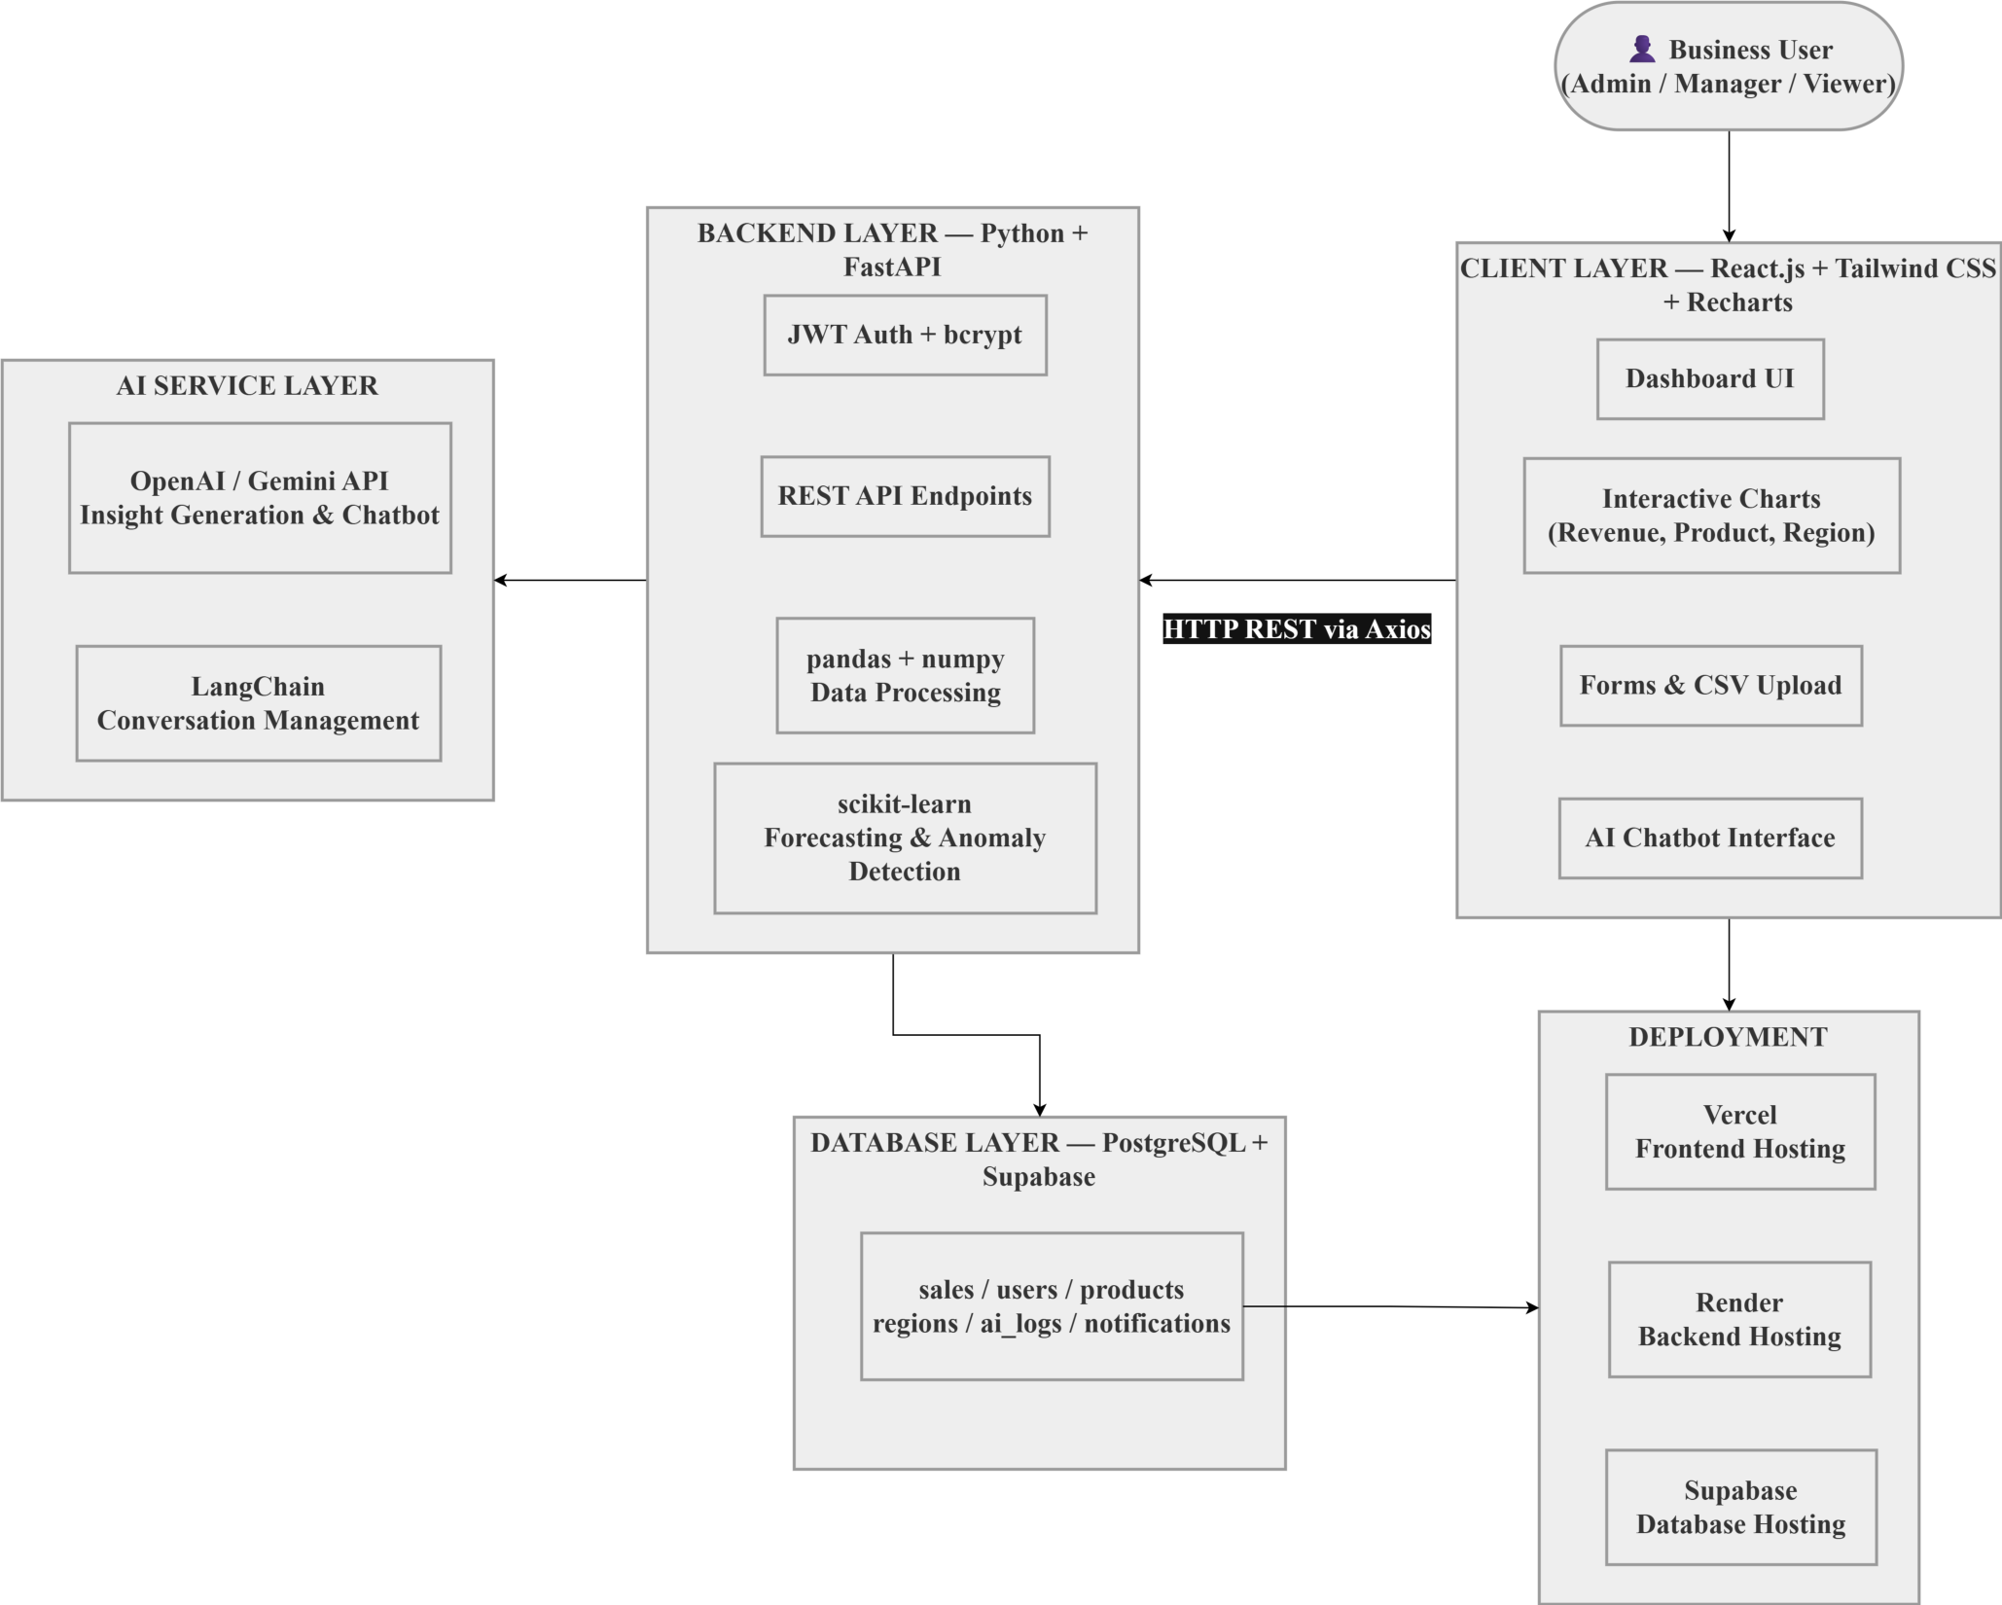
Figure 5: SalesIQ Normalized Relational Entity-Relationship Diagram (ERD)
The central sales table links users, products, and regions. Foreign keys to products and regions enforce ON DELETE RESTRICT to protect catalog items, while user relationships employ ON DELETE SET NULL to preserve audit history. B-tree indices on sale_date, product_id, and region_id accelerate analytical queries.
Table 5: Relational Database Schema, Integrity Rules, & Indexing Strategy
Entity | PK | Core Columns | Foreign Keys | Index Strategy
users | id | name, email, role | Referenced by sales | UNIQUE (email)
admin_invite_codes | id | code, created_by, used | created_by -> users | UNIQUE (code)
products | id | name, price, stock | Referenced by sales | INDEX (category)
regions | id | name, country | Referenced by sales | INDEX (name)
sales | id | user_id, item_id, total | RESTRICT, SET NULL | INDEX (date)
system_settings | id | key, value | updated_by -> users | UNIQUE (key)
maintenance_logs | id | action, created_at | performed_by -> users | INDEX (created_at)
ai_logs | id | query, latency_ms | user_id -> users | INDEX (created_at)
notifications | id | type, message, is_read | user_id -> users | INDEX (user_id)

8. Verification, Automated Testing, & Quality Assurance
System reliability and security boundaries were validated through test-driven quality assurance using Pytest and Starlette TestClient. An isolated test harness runs against an in-memory SQLite environment, executing schema migrations, inserting standardized fixture records, and asserting expected HTTP status codes.
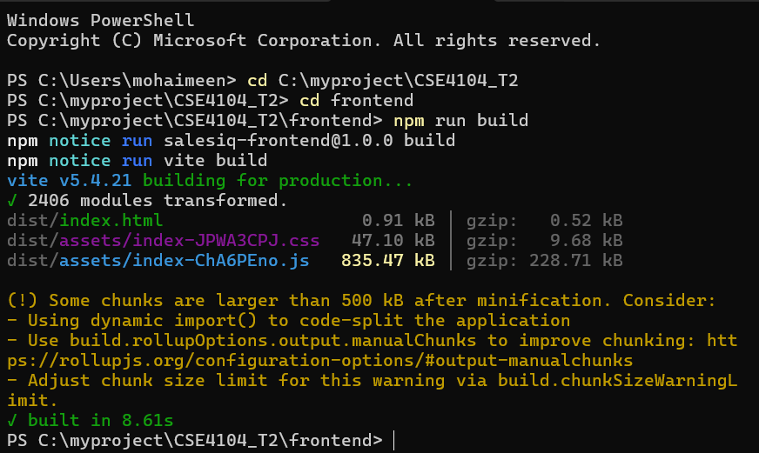
Figure 6: Automated Pytest Test Suite Execution & 100% Passing Verification Results
The test suite spans twenty-four test cases across three core modules: authentication and RBAC validation, transactional CRUD operations, and analytical intelligence. All twenty-four automated tests passed in 77.89 seconds with a 100% pass rate, formally verifying offline AI fallback resilience and transaction safety.
Table 6: Comprehensive Automated Test Suite Execution & Quality Assurance Results
Module | Target Domain | Tests | Outcome | Pass Rate
test_auth_rbac.py | Bcrypt, JWT login, RBAC guards | 10 Tests | Passed (200, 401, 403) | 100%
test_sales_products.py | Sales grid, CRUD operations | 7 Tests | Passed (Atomic commits) | 100%
test_analytics_ai.py | KPI math, OLS, Gemini fallback | 7 Tests | Passed (Fallback verified) | 100%
Total Verification | Full application test coverage | 24 Tests | Zero defects encountered | 100%

KEY TAKEAWAY: Automated Testing Milestone
All 24 automated unit and integration tests passed in 77.89 seconds with 100% pass rate, formally proving endpoint security, relational transaction safety, and offline AI fallback resilience.

9. Production Multi-Cloud Deployment & Security Configurations
SalesIQ demonstrates modern DevOps through a multi-cloud topology separating edge presentation from serverless compute and managed storage. The React and Tailwind CSS frontend is hosted on Cloudflare Pages, utilizing Anycast CDN caching, compression, and automated SSL termination to deliver sub-second load times.
The Python FastAPI server is deployed to Vercel as a serverless runtime configured via vercel.json with automated GitHub CI/CD deployments. The relational data layer is hosted on Supabase managed PostgreSQL with TLS 1.3 encryption, securing credentials in server environment variables.
Table 7: Production Multi-Cloud Deployment Topology & Security Configurations
Tier | Provider | Environment | Security & Config Controls
Frontend | Cloudflare | Pages Global CDN | Vite build, Tailwind CSS, HTTPS, edge cache
Backend API | Vercel | Serverless Python | FastAPI ASGI, auto CI/CD, CORS rules
Database | Supabase | PostgreSQL 15+ | TLS 1.3 SSL, pooling, daily backups
AI Layer | Google Cloud | Gemini 1.5 Flash | Secret API key, heuristic fallback

10. Technical Challenges, Problem Resolutions, & Lessons Learned
Developing SalesIQ required resolving engineering hurdles, primarily LLM latency, network timeouts, and strict API rate quotas. The team engineered a hybrid AI gateway: if Google Gemini times out, the backend fails over to an autonomous Grounded Heuristic Synthesis Engine to maintain continuous availability.
Another challenge was achieving instant interaction during Scenario Lab simulations while handling multiple interdependent parameters. Executing simulations on the server would introduce latency; this was resolved by implementing the simulation engine client-side using React useMemo hooks to evaluate scenarios in under 5 milliseconds.
11. Future Enhancements & Concluding Remarks
Future iterations will expand SalesIQ's enterprise capabilities by implementing multi-tenant organization workspaces, incorporating neural forecasting models such as LSTM and Facebook Prophet to capture complex seasonal patterns, and establishing bidirectional WebSocket channels for low-stock push notifications.
In conclusion, the SalesIQ AI Sales Analytics Dashboard successfully achieves all goals established for the CSE4104 Web Engineering Lab. Combining a React and Tailwind CSS frontend on Cloudflare, a Python FastAPI backend on Vercel, Supabase PostgreSQL via SQLAlchemy, Scenario Lab simulation, and conversational AI, SalesIQ exemplifies sound software engineering principles.
12. Team Contributions & Division of Responsibilities
The delivery of SalesIQ reflects disciplined collaboration: Mohaimeen Islam Pial directed multi-cloud topology, Scenario Lab simulation, Scikit-Learn forecasting, Gemini AI, and RBAC security; Sk Mesbaul Arefin engineered the React frontend, Tailwind CSS styling, Recharts, and slider controls; Sumaiya Akter developed Python FastAPI APIs, Pydantic schemas, CSV ingestion, and ReportLab PDF reporting; and Afia Maliha Priota managed the 3NF PostgreSQL schema, SQLAlchemy ORM, cascades, indexing, and database seeding.

