|  |  |  |
| --- | --- | --- |
| |  | | --- | | **MARKS:** | |  |

**AMERICAN INTERNATIONAL UNIVERSITY BANGLADESH (AIUB)**

**Electronic Devices Laboratory**

**LAB REPORT**

**Title: Verification of Kirchhoff’s Voltage Law (KVL) and Kirchhoff’s Current Law (KCL).**

**Experiment No: 2**

**Section: R**

**Semester: Fall 2019-20**

**Submitted To: SUSMITA GHOSH**

**Group No: 4**

|  |  |  |
| --- | --- | --- |
| **Serial No** | **Name** | **ID** |
| **1** | **SULTANA,ZAFRIN** | **19-39345-1** |
| **2** | **MOHAIMENUR RAHMAN** | **19-40338-1** |
| **3** | **AURNOB, MD. JISUN ABEDIN** | **19-40318-1** |
| **4** | **SUNNY,KHONNDOKAR AHAMED ALFA** | **19-40251-1** |
| **5** | **SAMI, MD ABDUS** | **19-40140-1** |
| **6** | **SARWAR,SUMAIYA** | **19-40319-1** |
| **7** | **SHARNA,TANZINA AZMARIN** | **19-40322-1** |
| **8** | **SHAHRIAR, B.M.MAHIR** | **19-40538-1** |

***Date of Performance:***

***Date of Submission:***

**Title:** Verification of Kirchhoff’s Voltage Law (KVL) and Kirchhoff’s Current Law (KCL).

**Abstract:** In this experiment the basic equipment like resistors, trainer board, multi meter etc. was observed and their operation were studied. Also some basic laws like Ohm’s law, the definition of voltage and current were studied and their operation was verified with the basic equipment.

**Background body:**

**i) Kirchhoff’s Voltage Law (KVL):** Kirchhoff’s Voltage Law (KVL) in a DC circuit states that, “the algebraic sum of the potential rises and drops around a closed loop (or path) is zero”. In other words, “the sum of the rises around a closed loop must equal the sum of the drops in potential”. A plus (+) sign is assigned for the potential rises (- to +) and minus sign (-) is assigned to a potential drop (+ to -). In symbolic form, KVL can be expressed as

*cV*=0, Where *c* is used for closed loop and *V* is used for the potential rises and drops.

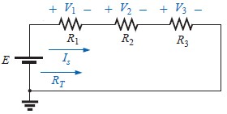**KVL a circuit**

**Analysis of KVL circuit:** For doing a complete analysis of KVL, with the given values of circuit parameters follow the following steps:

Calculate the equivalent resistance of circuit:

*RT = R1 + R2 + R3*

Calculate the supply current *IS*:

*IS = E / RT*

Calculate the voltage across different resistors:

*V1 = ISR1 V2 = ISR2 V3 = ISR3*

Use KVL to verify:

*∑cV* = 0 or *E –V1 –V2 –V3 =* 0or  *E = V1 –V2 –V3*

**ii) Kirchhoff’s Current Law (KCL):** Kirchhoff’s Current Law (KCL) in a DC circuit states that, “the algebraic sum of the currents entering and leaving an area, system or junction is zero”. In other word, “the sum of the currents entering an area, system or junction must equal the sum of the currents leaving the area, system or junction”. In equation form, KCL can be expressed as

*∑****I***entering **=** *∑* ***I***leaving

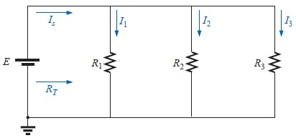

**KCL in circuit**

**Analysis of KCL circuit:** For doing a complete analysis of KCL, with the given values of circuit parameters follow the following steps:

Calculate the equivalent resistance of circuit:

*RT = [(1/R1) + (1/R2) + (1/R3)]-1*

Calculate supply current *IS*:

*IS = E / RT*

Calculate the current through different branches:

*I1 = E / R1 I2 = E / R2 I3 = E /R3* Use KCL to verify:

***I***entering = ***I***leaving or *IS = I1 + I2 + I3*

**Apparatus List:**

1. Trainer Board,
2. Voltmeter,
3. Ammeter,
4. AVO meter or Multi meter,
5. DC source,

6. Resistors.

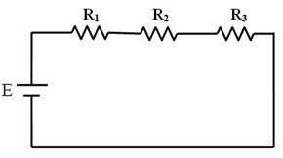**Circuit Diagram:**

**KVL circuit:**

Circuit diagram for series(KVL)

**KCL Circuit :**

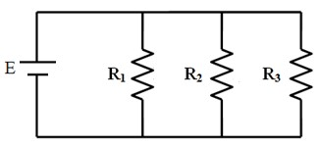

Circuit diagram for parallal(KCL)

**Experimental Procedure:**

Connect the circuit as shown in the diagram of series. Measure the voltage across each elements of the circuit. Fill the following table with necessary calculations.

Connect the circuit as shown in the diagram of parallal. Measure the current through each branch of the circuit. Fill the following table with necessary calculations.

**Result:**

1. **KVL Circuit**

KVL circuit in series circuit

**THEORETICAL RESULT:**

R1=6.62 kΩ, R1=0.998 kΩ, R1=2.205kΩ

V1 = (R1*E) / (R1+R2+R3) = 6.739V

V2 = (R2*E) / (R1+R2+R3) = 1.0V

V3 = (R3*E) / (R1+R2+R3) = 2.244V

V= V1+V2+V3=10.01V

**EXPERIMENTAL RESULT:**

|  |  |  |  |  |
| --- | --- | --- | --- | --- |
| E | V1 | V2 | V3 | V=V1+V2+V3 |
| 1O(v) | 6.80(v) | 1.025(v) | 2.26(v) | 10.085(v) |

**SIMULATION:**

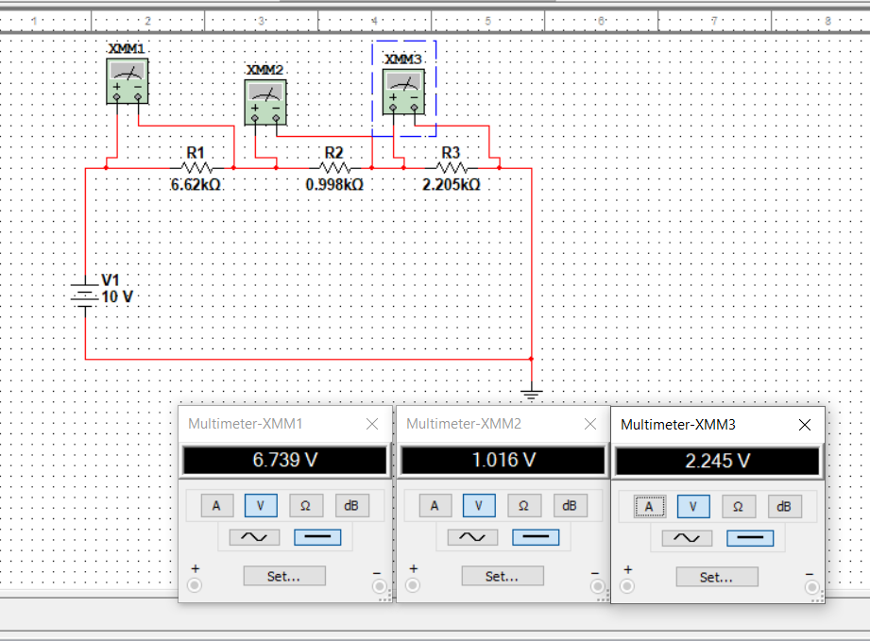

**KCL Circuit :**

KCL in parallal circuit

**THEORETICAL RESULT:**

R1=6.62 kΩ, R1=0.998 kΩ, R1=2.205kΩ

I1=E/R1=10/6.62=1.51mA

I2=E/R1=10/0.99=10.10mA

I3=E/R1=10/2.205=4.535mA

I1 + I2 + I3 = 16.145

1/RT=1 R1+1/R2+1/R3=1.6146

RT=0.619 kΩ

Is =E/RT=10/0.619=16.155mA

|  |  |  |  |  |
| --- | --- | --- | --- | --- |
| I | I1 | I2 | I3 | I1+I2+I3 |
| 16.06 mA | 1.51 mA | 11.531 mA | 4.535 mA | 16.066mA |

**EXPERIMENTAL RESULT:**

R1=6.62 kΩ, R1=0.998 kΩ, R1=2.205kΩ

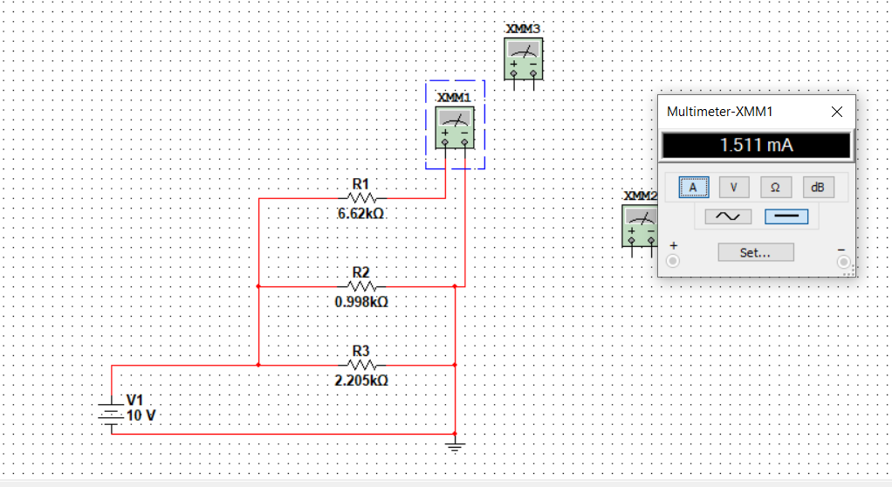

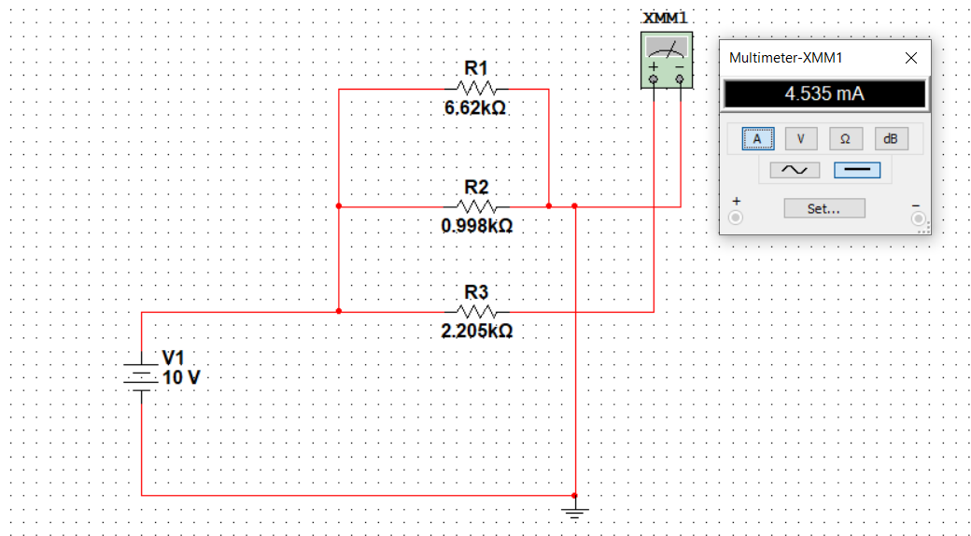

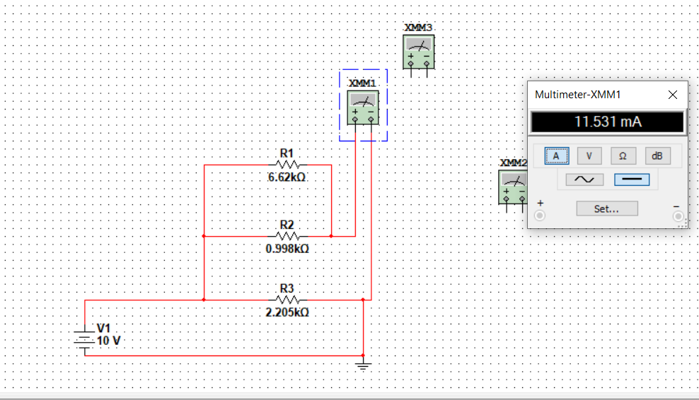

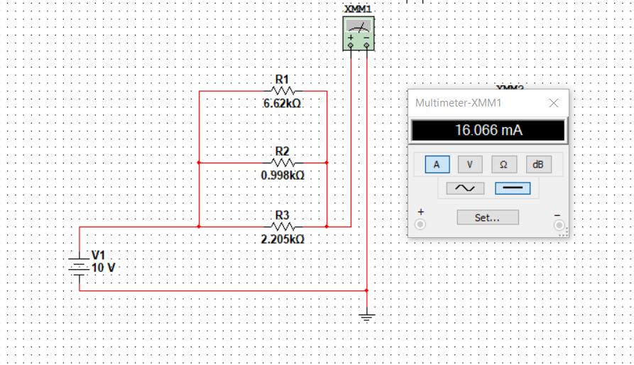

**Question & Answer:**

**1.**Show the difference between your theorical value and experimental value.

**Ans:**

**KVL circuit:**

Theorical value: Experimental value:

V=10.01 v V=10.085 v

Difference=( VExperimental- VTheorical ) = 0.075 v

**KCL circuit:**

Theorical value: Experimental value:

I=16.155mA I=16.066mA

Difference=( ITheorical -IExperimental ) =0.089mA

**2.**What is the % of error for KVL and KCL circuit in theorical value?

**Ans:**

**KVL circuit:**

%Error=((VTheorical -VExperimental) /VTheorical)*100%

= 0.749%

**KCL circuit:**

%Error=(( ITheorical -IExperimental) /ITheorical)*100%

=0.55%

**3.** In which cuircuit do we use for KVL and KCL?

**Ans.** KVL is for series circuit and KCL is for parallal circuit.

**Discussion of Conclusion:** Interpret the data/findings and determine the extent to which the experiment was successful in complying with the goal that was initially set. Discuss any mistake you might have made while conducting the investigation and describe ways the study could have been improved.

**Reference:**

Robert L. Boylestad, “Introductory Circuit Analysis”, 10th Edition, Prentice Hall, New York, 2005-2006, pp. 133-134, 180.