**Quiz 1**

**Name: MOHAIMENUR RAHMAN ID: 19-40338-1 Sec:K**

1. **Create the table using following requirements & insert the given values-[10]**

Table-**“Your** **Name_Your Id” example=tasnim_124292**

|  |  |  |
| --- | --- | --- |
| **Column** | **Datatype** | **Constraints** |
| PID | Number(5) | Primary Key |
| P_Name | Varchar2(20) |  |
| P_Country | Varchar2(15) |  |
| P_Dob | Date(7) |  |
| GID | Number(10) |  |
|  |  |  |

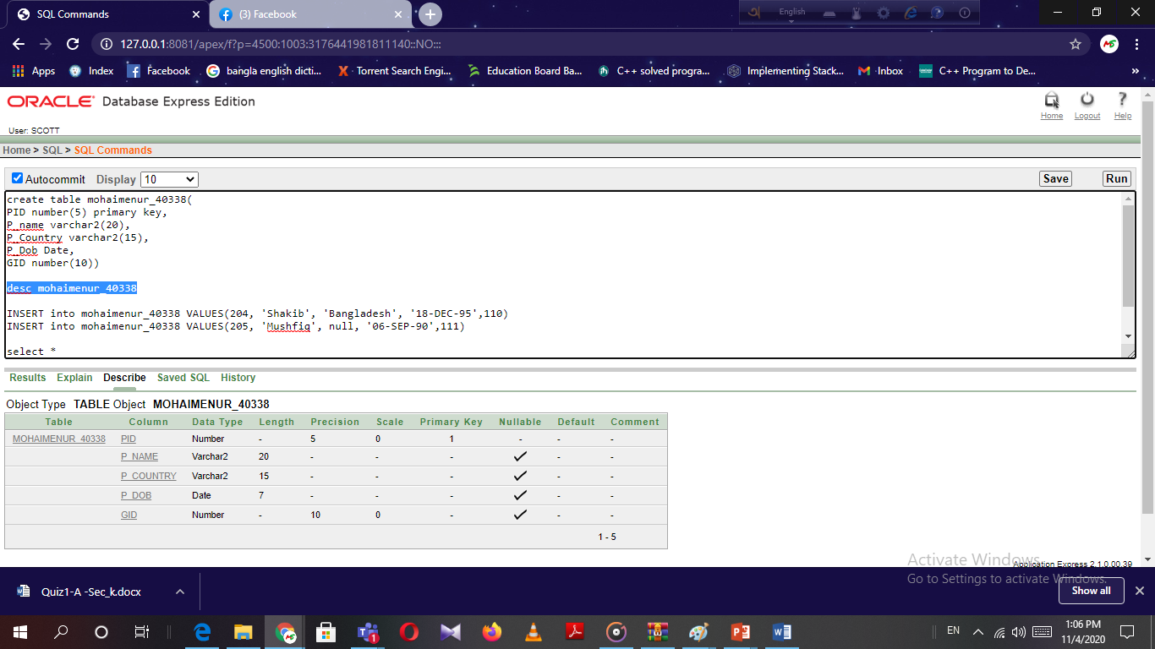

|  |  |  |  |  |
| --- | --- | --- | --- | --- |
| **PID** | **P_Name** | **P_Country** | **P_Dob** | **GID** |
| **204** | **Shakib** | **Bangladesh** | **18-DEC-95** | **110** |
| **205** | **Mushfiq** | **-** | **06-SEP-90** | **111** |

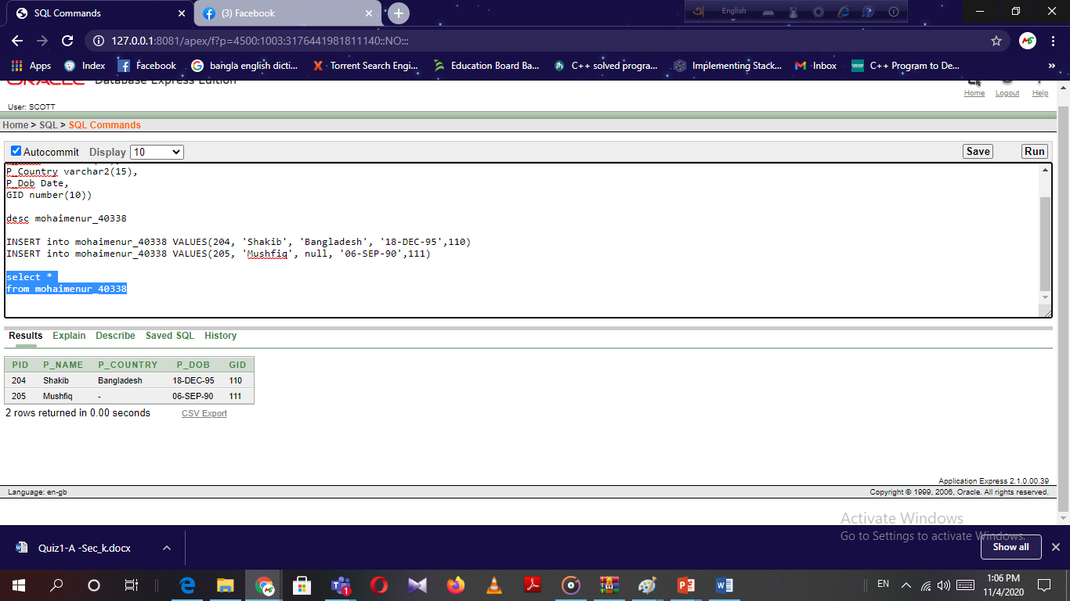

1. **Write a query which displays the information like this- Shakib loves Bangladesh.**

**select P_name||' loves '||P_Country**

**from mohaimenur_40338**

**where P_name='Shakib'**

