**Visualizing TIF Image Sequence**

1. Opening TIF Image Sequence in ImageJ
   1. File 🡪 Import 🡪 Image Sequence
   2. Select the first file in the TIF sequence
   3. A window will appear where you have to specify the number of images to load and other options

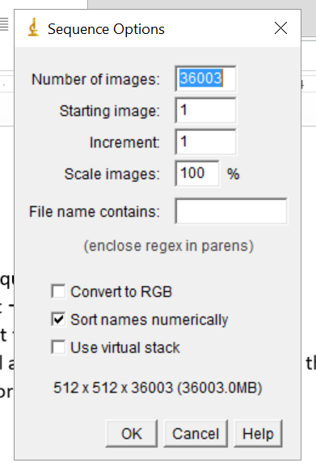

* 1. In “File name contains”, enter the appropriate sub-string of the file name.
  2. Click ok to load the image sequence