1. Create a Flask application with an /api route. When this route is accessed, it should return a JSON list. The data should be stored in a backend file, read from it, and sent as a response.

I have stored the data in the data.json(backend file) I was able to read the dta from with open(‘data.json’, r) as f: -> now the data can be loaded using f
Next line i tried to load the data in the data variable using json.load method
Return the data to see in the browser

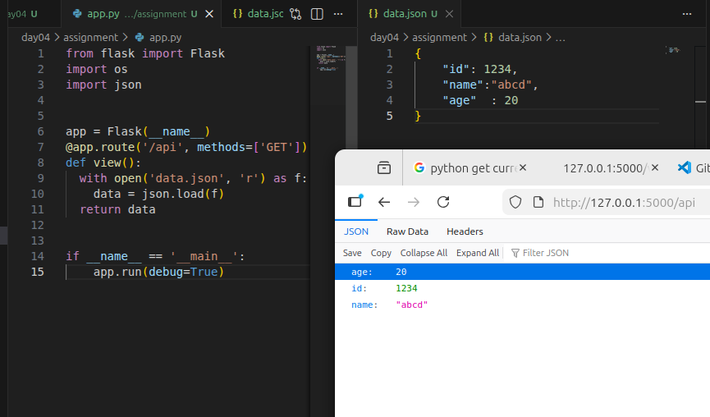

2. Create a form on the frontend that, when submitted, inserts data into MongoDB Atlas. Upon successful submission, the user should be redirected to another page displaying the message "Data submitted successfully". If there's an error during submission, display the error on the same page without redirection.

I have created a templates/signup.html page, where i am taking username, email, password and confirm password. When user clicks on create account button it is redirected to signup page.
I have kept/invoked this html page on /home URI and used /signup URI to insert the data filled on the signup.html in the mongo db. For connection to mongo db I have used the same .env file and load_dotenv() to load the mongo_uri, then used pymongo.mongoclient method to connect to my mongo db.
Used collection=db[‘database name’] -> to create the db in mongodb cluster.

Initially i went to localhost or 127.0.0.1/home to update the info or lets say signup a user account. Once its done then route the traffic to signup method which will wait browser to reach the signup and once its reached it will insert/ send the data into my cluster
