**Q1. What is an activation function in the context of artificial neural networks?**

An **activation function** in the context of artificial neural networks (ANNs) is a mathematical function that determines whether a neuron should be activated (i.e., whether the neuron should "fire" or not). After the inputs are weighted and summed, the activation function decides the output that will be passed to the next layer of neurons.

The primary purpose of an activation function is to introduce **non-linearity** into the network. Without non-linearity, a neural network would only be able to learn linear mappings, limiting its ability to model complex real-world data and relationships.

**Key types of activation functions:**

1. **Sigmoid Function**:
   * Output: A value between 0 and 1.
   * Formula:

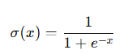

* Use case: Often used in binary classification tasks and the output layer of simple neural networks.
* Problem: It suffers from the "vanishing gradient problem," especially in deep networks.

1. **Tanh (Hyperbolic Tangent) Function**:

* Output: A value between -1 and 1.
* Formula:
* 
* Use case: Useful when the output needs to be normalized around zero.
* Problem: Like the sigmoid, it can also suffer from vanishing gradients in deep networks.

1. **ReLU (Rectified Linear Unit)**:

* Output: 0 if input < 0, and input if input ≥ 0.
* Formula
* 
* • Use case: Common in hidden layers of deep networks due to its simplicity and computational efficiency.
* Problem: Can suffer from the "dying ReLU" problem, where neurons stop activating for some inputs.

1. **Leaky ReLU**:

* Output: Allows a small, non-zero gradient when the input is negative (to address the dying ReLU problem).
* Formula:
* 
* where α\alphaα is a small constant (e.g., 0.01).
* Use case: An improvement over ReLU, widely used in deep networks.

1. **Softmax Function**:

* Output: Converts raw scores into probabilities, summing up to 1.
* Formula:
* 
* Use case: Used in the output layer for multi-class classification problems.

1. **ELU (Exponential Linear Unit)**:

* Output: Similar to ReLU but smoother for negative values.
* Formula:
* 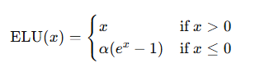
* Use case: Used to address some limitations of ReLU while maintaining the positive attributes.

**Q2. What are some common types of activation functions used in neural networks?**

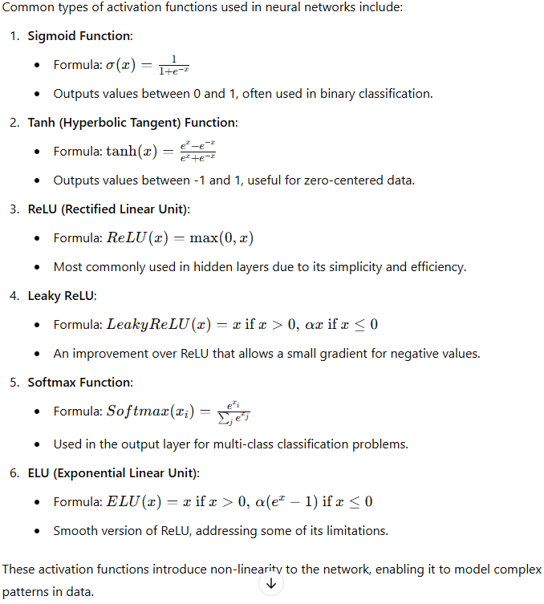

**Q3. How do activation functions affect the training process and performance of a neural network?**

Activation functions significantly affect both the **training process** and the **performance** of a neural network in the following ways:

**1. Non-linearity:**

* Activation functions introduce non-linearity, allowing neural networks to learn complex patterns and relationships that cannot be captured by linear models. This makes them capable of solving tasks like image recognition, natural language processing, and other non-linear problems.

**2. Gradient Flow:**

* Activation functions play a key role in **backpropagation**, where the gradients of the loss function are calculated and propagated back through the network. The choice of activation function affects how gradients flow during training.
  + **Sigmoid** and **Tanh** functions can cause the **vanishing gradient problem**, where gradients become very small during backpropagation, slowing down learning or stopping it in deeper layers.
  + **ReLU** and its variants help mitigate this issue by ensuring that gradients remain non-zero for positive inputs, speeding up convergence.

**3. Training Speed:**

* The efficiency of the training process is influenced by the complexity of the activation function. Simpler functions like **ReLU** are computationally efficient, speeding up the training process. More complex functions (e.g., **ELU** or **Softmax**) might be slower to compute.

**4. Sparsity:**

* Activation functions like **ReLU** promote sparsity in the network, as they output zero for negative inputs. Sparsity can lead to a more efficient network by deactivating certain neurons, improving memory usage, and reducing overfitting.

**5. Output Range:**

* Activation functions determine the range of outputs from neurons, which affects how the network responds to input data:
  + **Sigmoid** outputs between 0 and 1, making it useful for binary classification.
  + **Tanh** outputs between -1 and 1, centering the data around zero, which can speed up training.
  + **Softmax** produces probability distributions, useful in multi-class classification tasks.

**6. Exploding Gradients:**

* While some activation functions (e.g., **ReLU**) address vanishing gradients, they can suffer from **exploding gradients** in certain scenarios, especially when very large weights accumulate in the network. Choosing an appropriate activation function and applying techniques like gradient clipping can help manage this.

**7. Activation Saturation:**

* Functions like **Sigmoid** and **Tanh** saturate for extreme input values, meaning that they produce very small gradients. This leads to slow learning in the saturated regions. Functions like **ReLU** and **Leaky ReLU** avoid this issue by maintaining a higher gradient for larger input values.

In summary, activation functions directly influence how effectively and efficiently a neural network learns, and choosing the right one is essential for ensuring good model performance and faster convergence during training.

**How the Sigmoid Activation Function Works:**

The **sigmoid activation function** maps any input to an output between 0 and 1. It is defined by the formula:



Where:

* x is the input to the neuron (the weighted sum of the inputs plus a bias term).
* e is the base of the natural logarithm.

The sigmoid function takes any real-valued number and squashes it to a range between 0 and 1, making it particularly useful when the output needs to be interpreted as a probability, such as in binary classification tasks.

**Advantages of the Sigmoid Function:**

1. **Probability Output**:
   * The sigmoid function maps input values to a probability range (0 to 1), which makes it suitable for binary classification tasks (e.g., logistic regression, binary neural networks).
2. **Smooth and Differentiable**:
   * The sigmoid function is smooth, continuous, and differentiable, which is important for the backpropagation algorithm. The derivative is well-defined for every input value.
3. **Simple Interpretation**:
   * The sigmoid’s output can be easily interpreted as a probability. For example, if the output is close to 1, the model is confident about a certain class, and if close to 0, it predicts the other class.

**Disadvantages of the Sigmoid Function:**

1. **Vanishing Gradient Problem**:
   * In deep neural networks, the sigmoid function can cause the **vanishing gradient problem**. This occurs because the gradient of the sigmoid for very large or very small values approaches zero. As a result, during backpropagation, the weight updates become very small, slowing down or even stopping the learning process in deeper layers.
2. **Not Zero-Centered**:
   * The output of the sigmoid function is not zero-centered, meaning that the outputs are always positive. This can lead to inefficiencies in training because all the gradients will either be entirely positive or entirely negative, making optimization slower.
3. **Slow Convergence**:
   * The sigmoid function can result in slow convergence, especially when inputs are either too large or too small. The output saturates to values close to 0 or 1, leading to tiny gradient updates.
4. **Exponential Calculation**:
   * The sigmoid function requires computation of an exponential, which can be computationally expensive, especially for large-scale networks or when real-time processing is needed.

**Summary:**

* **Advantages**: Probability interpretation, smooth gradient, easy to understand.
* **Disadvantages**: Vanishing gradients, not zero-centered, slow convergence, computationally expensive.

While the sigmoid function was commonly used in early neural networks, it has largely been replaced by other activation functions (like **ReLU** and its variants) in modern deep learning applications due to its limitations.

**Q5.What is the rectified linear unit (ReLU) activation function? How does it differ from the sigmoid function?**

The **Rectified Linear Unit (ReLU)** is one of the most commonly used activation functions in deep neural networks. It is defined as:



This means:

* If the input x is positive, the output is x.
* If the input x is negative, the output is 0.

ReLU introduces non-linearity into the model while maintaining simplicity. It activates a neuron by outputting the value of the input directly if it is positive, and it “deactivates” the neuron by outputting zero when the input is negative.

**How ReLU Differs from the Sigmoid Function:**

1. **Range of Output**:
   * **ReLU**: Outputs values in the range [0,∞)[0, \infty)[0,∞). It is unbounded for positive inputs.
   * **Sigmoid**: Outputs values between 000 and 111, bounded for both large positive and negative inputs.
2. **Non-linearity**:
   * Both functions introduce non-linearity, but ReLU’s non-linearity is simpler. Sigmoid has a complex, smooth S-shaped curve, while ReLU has a piecewise linear curve.
3. **Gradient Flow**:
   * **ReLU**: Does not saturate for positive inputs. The gradient is 1 for positive inputs, which helps avoid the **vanishing gradient problem**.
   * **Sigmoid**: Saturates for very large positive or negative inputs. For inputs far from zero, the gradient becomes very small (approaching zero), leading to the **vanishing gradient problem** during backpropagation.
4. **Zero-centered Output**:
   * **ReLU**: The output is zero for negative inputs, and non-negative for positive inputs, which helps to sparsify the network.
   * **Sigmoid**: Outputs are always positive (between 0 and 1), which can make training less efficient since gradients are not zero-centered.
5. **Computational Complexity**:
   * **ReLU**: Very simple and computationally efficient because it only requires a comparison between the input and zero.
   * **Sigmoid**: Requires computation of the exponential function, which is computationally more expensive.
6. **Training Speed**:
   * **ReLU**: Typically leads to faster training since it avoids saturating gradients for large inputs and maintains larger, more effective gradients during backpropagation.
   * **Sigmoid**: Slower to train deep networks due to gradient saturation and smaller updates in deep layers.
7. **Sparsity**:
   * **ReLU**: Promotes sparsity in neural networks since neurons with negative inputs become inactive (output zero), leading to fewer active neurons and more efficient learning.
   * **Sigmoid**: All neurons are always active since the output is always between 0 and 1, which can make the network less efficient.

**Summary of Key Differences:**

| **Feature** | **ReLU** | **Sigmoid** |
| --- | --- | --- |
| **Output Range** | [0,∞)[0, \infty)[0,∞) | [0,1][0, 1][0,1] |
| **Gradient Saturation** | Does not saturate for positive values | Saturates for large inputs (vanishing gradients) |
| **Computational Complexity** | Simple (comparison with zero) | More complex (requires exponential computation) |
| **Speed of Training** | Faster due to larger gradients | Slower due to vanishing gradients |
| **Zero-centered** | No (but promotes sparsity) | No |
| **Common Use** | Hidden layers in deep networks | Mostly used in output layers for binary classification |

**Q6. What are the benefits of using the ReLU activation function over the sigmoid function?**

The **Rectified Linear Unit (ReLU)** activation function offers several advantages over the **sigmoid** activation function, particularly in the context of deep neural networks. Here are the key benefits:

**1. Avoids the Vanishing Gradient Problem:**

* **ReLU**: For positive inputs, the derivative of ReLU is always 1, which helps maintain a strong gradient signal as it backpropagates through the network. This avoids the vanishing gradient problem, allowing deeper networks to train effectively.
* **Sigmoid**: The gradient of the sigmoid function approaches zero as the input becomes very large or small, which can lead to **vanishing gradients** in deep networks. This slows down or halts the learning process, especially in deeper layers.

**2. Faster Training:**

* **ReLU** is computationally simpler and more efficient than sigmoid, as it only requires comparing the input with zero. This simplicity speeds up both forward propagation and backpropagation during training.
* In contrast, **sigmoid** involves computing the exponential function, which is more computationally expensive, slowing down training, particularly in large networks.

**3. Sparsity in Neural Networks:**

* **ReLU** promotes sparsity in the neural network by setting the output to zero for all negative inputs. This means that some neurons will not activate, leading to a more efficient and compact model where only a subset of neurons are used at a given time.
* **Sigmoid** does not promote sparsity, as it always produces non-zero outputs (between 0 and 1), which means every neuron remains active, potentially leading to overfitting or less efficient learning.

**4. Better Gradient Flow:**

* **ReLU** ensures that the gradients for positive inputs are always 1, leading to more stable and consistent gradient updates. This allows for faster convergence during training and better performance in deeper networks.
* **Sigmoid** suffers from slow gradient flow for extreme inputs, meaning that small gradients lead to slower learning and poor optimization.

**5. Handling Larger Networks:**

* **ReLU** is well-suited for **deep networks** because it helps mitigate the vanishing gradient issue and enables the network to learn more efficiently, even with many layers.
* **Sigmoid** performs poorly in deep networks due to gradient saturation, leading to difficulties in training large architectures.

**6. Effective for ReLU-based Variants:**

* ReLU has led to several variants like **Leaky ReLU** and **Parametric ReLU** that further address some of ReLU’s weaknesses (such as the dying ReLU problem) while still offering the core benefits of ReLU over sigmoid.
* These variants build on ReLU's core simplicity and effectiveness, further improving network performance, which is not the case for sigmoid.

**7. No Saturation for Positive Inputs:**

* **ReLU** does not saturate for positive inputs, meaning that the gradient does not diminish as the input grows larger. This allows the network to learn more complex patterns without losing the effectiveness of backpropagation.
* **Sigmoid** saturates for large positive and negative inputs, which means that for extreme values, the gradient becomes very small and almost non-existent, leading to slow learning.

**Summary of Benefits:**

* **No vanishing gradient** for positive inputs.
* **Faster training** due to simpler computations.
* Promotes **sparsity** in neural networks.
* **Better gradient flow**, leading to more stable learning.
* More effective in **deep networks** compared to sigmoid.
* Has inspired **improved variants** like Leaky ReLU.

Due to these benefits, ReLU (or its variants) has become the default choice for activation in hidden layers of modern deep learning architectures, while sigmoid is generally only used in the output layer for binary classification tasks.

**Q7. Explain the concept of "leaky ReLU" and how it addresses the vanishing gradient problem.**

**Leaky ReLU** is a variant of the Rectified Linear Unit (ReLU) activation function that addresses one of the main problems with ReLU: the "dying ReLU" problem. In the standard ReLU function, any negative input results in an output of zero, which can lead to neurons that effectively "die" and stop learning, especially if they consistently receive negative inputs.

Leaky ReLU introduces a small slope for negative inputs instead of setting them to zero. This allows a small, non-zero gradient to pass through even when the input is negative.

The **Leaky ReLU** function is defined as:

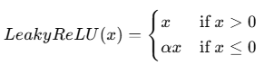

Where α\alphaα is a small positive constant (typically set to 0.01). The small slope α\alphaα ensures that negative inputs still produce a small output instead of zero.

**How Leaky ReLU Addresses the Vanishing Gradient Problem:**

1. **Non-Zero Gradient for Negative Inputs**:
   * Unlike standard ReLU, which outputs zero for all negative inputs (leading to a gradient of zero during backpropagation), Leaky ReLU allows negative inputs to have a small, non-zero gradient. This ensures that neurons receiving negative inputs can still have their weights updated, preventing them from "dying" or becoming inactive.
   * The small slope for negative inputs helps avoid the **vanishing gradient problem** in the negative region. The gradient remains non-zero even for large negative inputs, allowing the network to continue learning.
2. **Prevents Neurons from Dying**:
   * In standard ReLU, if a neuron consistently receives negative inputs, it will output zero and stop learning (since the gradient will also be zero). This can lead to a portion of the network becoming inactive, especially in deeper layers, which negatively impacts the network's performance.
   * **Leaky ReLU** reduces the risk of neurons becoming inactive (dying) by allowing a small gradient to propagate even for negative inputs, keeping the neurons "alive" and learning.
3. **Improved Learning for Deep Networks**:
   * By addressing the issue of zero gradients for negative inputs, Leaky ReLU helps deep networks continue to learn effectively. It ensures that all neurons, even those receiving negative inputs, contribute to the network's learning process.
   * In deeper networks, where the vanishing gradient problem is more prominent, Leaky ReLU improves gradient flow and reduces the likelihood of stagnation during training.
4. **Balances the Benefits of ReLU**:
   * While Leaky ReLU retains the benefits of standard ReLU (such as simplicity and efficiency for positive inputs), it introduces a small modification that allows learning to continue for negative inputs. This makes Leaky ReLU particularly effective in scenarios where standard ReLU might fail due to dying neurons.

**Key Differences Between Leaky ReLU and Standard ReLU:**

|  |  |  |
| --- | --- | --- |
| **Aspect** | **ReLU** | **Leaky ReLU** |
| **Negative Input Output** | 0 | Small negative value (αx\alpha xαx) |
| **Gradient for Negative** | 0 | Small non-zero gradient |
| **Neuron Activation** | Neurons can "die" if inputs are negative | Neurons stay active even with negative inputs |

**Summary:**

* **Leaky ReLU** addresses the vanishing gradient problem for negative inputs by allowing a small, non-zero gradient for negative values.
* It prevents neurons from becoming inactive, which improves the training of deep networks and keeps all neurons contributing to learning.
* By maintaining the benefits of ReLU while introducing a small modification for negative values, Leaky ReLU is widely used in deep learning to avoid dead neurons and ensure better performance.

**Q8. What is the purpose of the softmax activation function? When is it commonly used?**

**Purpose of the Softmax Activation Function**

The **softmax activation function** is used to convert raw output scores from a neural network into a probability distribution over multiple classes. It ensures that the outputs sum to 1, effectively representing the model’s confidence in each class as a probability.

The formula for softmax is:

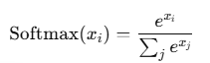

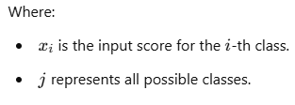

**Key Characteristics of Softmax:**

* **Produces a Probability Distribution**: Each output value lies between 0 and 1, and the sum of all outputs is equal to 1, making it ideal for tasks that require probability interpretations.
* **Amplifies the Largest Values**: Softmax tends to highlight the largest scores, making the model’s prediction more confident in the highest-probability class.
* **Differentiable**: Like other activation functions, softmax is differentiable, enabling gradient-based optimization in neural network training.

**When is Softmax Commonly Used?**

1. **Multi-Class Classification**:
   * Softmax is most commonly used in the **output layer** of a neural network for multi-class classification tasks, where the goal is to classify an input into one of multiple categories.
   * For example, in image classification with classes like "cat," "dog," and "bird," softmax will produce a probability for each class, allowing the model to choose the most likely class.
2. **Probabilistic Interpretation**:
   * When you need a probabilistic interpretation of the output, such as for models that need to make predictions with confidence levels, softmax provides a clear and interpretable output.
   * This is often used in fields like NLP for tasks such as text classification and language modeling, where each word or category is assigned a probability.
3. **Multi-Class Logistic Regression**:
   * In logistic regression for multi-class classification, softmax is often applied to produce probabilities for each class, making it compatible with categorical cross-entropy loss, a common loss function for multi-class classification.

**Example Usage:**

Suppose a neural network needs to classify an image into three categories: "cat," "dog," and "bird." The raw scores from the network might be [2.5,0.3,−1.2][2.5, 0.3, -1.2][2.5,0.3,−1.2]. When passed through the softmax function, these scores are converted into probabilities, such as [0.85,0.10,0.05][0.85, 0.10, 0.05][0.85,0.10,0.05]. This indicates that the model is 85% confident the image is of a cat, 10% confident it’s a dog, and 5% confident it’s a bird.

**Summary:**

* **Purpose**: To convert raw outputs into a probability distribution over classes.
* **Commonly Used In**: The output layer of multi-class classification models.
* **Benefits**: Makes outputs interpretable as probabilities and amplifies the most likely class, helping models make clear, confident predictions

**Q9. What is the hyperbolic tangent (tanh) activation function? How does it compare to the sigmoid function?**

**What is the Hyperbolic Tangent (tanh) Activation Function?**

The **hyperbolic tangent (tanh)** activation function is a widely used activation function in neural networks. It maps input values to an output range between -1 and 1, which makes it a zero-centered activation function. This can be beneficial for faster and more efficient learning, as the outputs are balanced around zero.

The tanh function is defined by the formula:

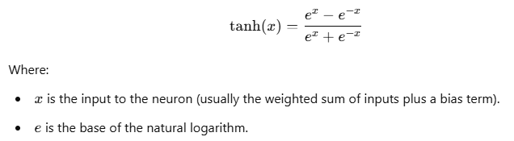

The tanh function has an S-shaped curve, similar to the sigmoid function, but with a wider range that spans from -1 to 1.

**Comparison of tanh and Sigmoid Functions**

|  |  |  |
| --- | --- | --- |
| **Feature** | **tanh** | **Sigmoid** |
| **Output Range** | [−1,1][-1, 1][−1,1] | [0,1][0, 1][0,1] |
| **Zero-Centered** | Yes | No |
| **Gradient Saturation** | Yes (for large inputs) | Yes (for large inputs) |
| **Gradient Strength** | Larger gradient range around zero | Smaller gradient range, especially for values close to 0 or 1 |
| **Common Use** | Hidden layers, especially for zero-centered data | Output layers in binary classification tasks |

**Advantages of tanh over Sigmoid:**

1. **Zero-Centered Output**:
   * Unlike the sigmoid function, which outputs values between 0 and 1, the tanh function outputs values between -1 and 1. This zero-centered output helps to center the data and gradient updates around zero, which can make training faster and more stable by reducing internal covariate shifts.
2. **Stronger Gradients**:
   * Around the origin (near zero), the tanh function provides stronger gradients than sigmoid. This helps the network learn more effectively in the early layers by avoiding extremely small gradient updates for inputs close to zero.
3. **Faster Convergence**:
   * Because of its zero-centered nature and stronger gradients, tanh often leads to faster convergence in training compared to sigmoid, especially in deeper networks where weight updates can be more efficient.

**Disadvantages of tanh:**

1. **Saturation for Large Inputs**:
   * Like sigmoid, tanh also suffers from the **vanishing gradient problem**. For large positive or negative inputs, the gradient of tanh approaches zero, which can slow down learning in deeper networks.
2. **Computationally Intensive**:
   * Similar to sigmoid, tanh requires calculating exponential functions, making it slightly more computationally expensive than simpler functions like ReLU.

**When to Use tanh vs. Sigmoid:**

* **tanh** is often preferred over sigmoid for hidden layers in neural networks due to its zero-centered output and stronger gradients near zero, which help with more balanced weight updates.
* **Sigmoid** is more commonly used in output layers when a probability between 0 and 1 is desired, such as in binary classification problems.

**Summary:**

* **tanh** outputs values in the range [−1,1][-1, 1][−1,1], making it zero-centered and often leading to faster learning in hidden layers.
* Compared to sigmoid, **tanh** has a stronger gradient near zero, which helps with more effective learning but still suffers from gradient saturation for large inputs.
* In practice, **tanh** is generally preferred over sigmoid in hidden layers, while sigmoid is usually reserved for output layers in binary classification tasks.