VELOLOG

Application Flow & Architecture
A visual guide to the Android-first, local-first cycling companion

“Strava tracks you. VeloLog tracks your bike.”
Scope: implemented v0.2 MVP
Prepared from the current repository · 27 July 2026

1. End-to-end application flow
The central path begins in the bike garage. A rider selects a bike, records a GPS ride, saves it, and immediately sees the bike’s odometer, component wear, maintenance status, ride history and journey statistics update from the same local source of truth.
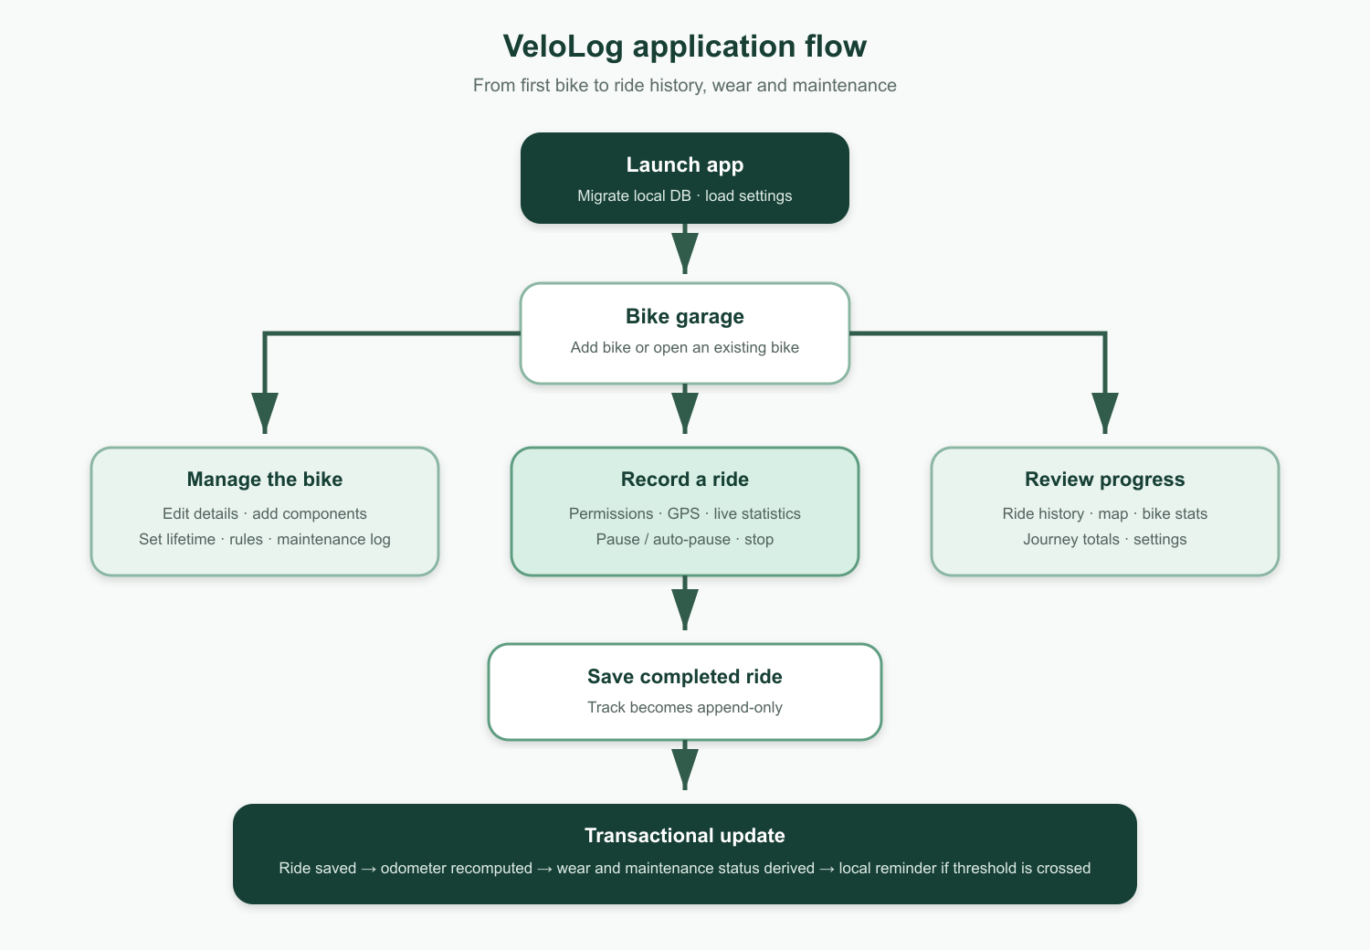
Figure 1. The implemented primary application flow.

2. User-facing navigation

Bike garage and onboarding
- On first use, the empty garage presents onboarding and routes the rider to Add Bike.
- The garage lists active bikes and provides quick access to Journey and Settings.
- Opening a bike shows identity, odometer, components, wear, and maintenance status.

Ride recording and recovery
- Start Ride requests foreground and background location permission.
- GPS points are appended to a local track file while live distance, duration and speed are derived.
- The rider may pause manually; optional auto-pause stops and resumes the session when movement changes.
- An interrupted session is rehydrated after relaunch so the rider can continue, save or discard it.

History, maintenance and settings
- Ride History opens a ride detail view with a MapLibre track, statistics and editable notes.
- Components expose edit/replace, maintenance rules and a maintenance event log.
- Journey aggregates distance, cost per distance, CO₂ savings and calorie estimates across bikes.
- Settings control units, language (English/Swedish) and appearance.

3. Ride lifecycle and derived updates

Recording state
Idle → Recording ⇄ Paused → Completed or Discarded

Saving a ride
- Filter raw GPS fixes for poor accuracy and implausible jumps.
- Calculate distance, moving time and speed with pure domain functions.
- Persist the completed ride and its track locally.
- Recompute the affected bike odometer from non-deleted rides.
- Derive component wear and maintenance due status from the odometer.
- Schedule a local reminder when a rule crosses into Due Soon or Overdue.

Editing or deleting later
Completed GPS tracks remain append-only. Notes and bike assignment may change. Ride deletion is soft deletion; reassignment or deletion recomputes every affected odometer and therefore every dependent wear and maintenance result.

Key invariant
Raw ride distance is the source. Odometer, component wear, bike statistics and maintenance status are derived results—not duplicate counters that can drift.

4. Application architecture
The app uses one-way dependencies and keeps business calculations independent from React Native, Expo and storage concerns.

Presentation and navigation
- Expo Router route stubs render feature-owned screens.
- Screens use shared UI primitives, translations and theme tokens.

Application and persistence
- TanStack Query hooks coordinate reads, mutations, cache invalidation and cross-cutting effects.
- Repositories are the persistence boundary over Drizzle ORM and expo-sqlite.
- Background services own GPS recording and local maintenance notifications.

Pure domain
- GPS filtering, ride statistics, odometer recomputation, units, journey calculations, wear and maintenance rules are pure TypeScript.

Dependency flow
Expo Router → Feature screens → Query hooks → Services / repositories → Pure domain logic

Local-first boundary
Bike management, recording, history and maintenance work without connectivity. OpenFreeMap tiles are used for map rendering when available; a future backend is only a synchronization target.

