VELOLOG

Developer Guide
How the application is organized, how data moves, and where new code belongs

Android-first · local-first · Expo SDK 57 · React Native · TypeScript
Based on the implemented v0.2 codebase · 27 July 2026

1. Architecture at a glance
VeloLog is deliberately layered without importing server-side Clean Architecture patterns. The important rule is one-way dependency flow: user interface code coordinates work through hooks; hooks call repositories or device services; reusable calculations live in pure domain modules.
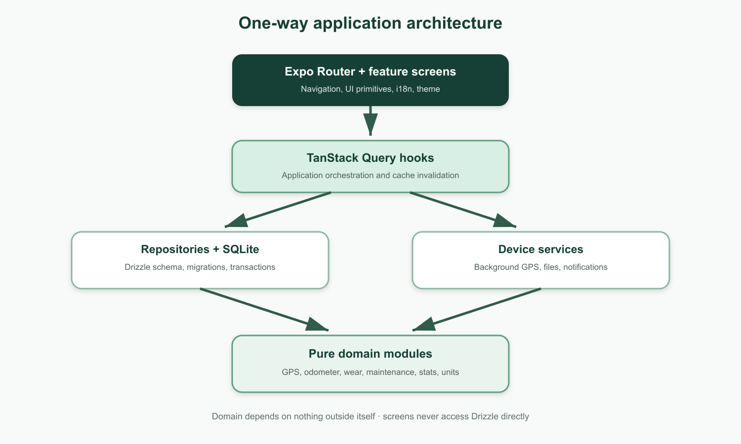
Figure 1. The dependency direction used throughout the application.

Rules that protect the architecture
- src/domain imports no React, Expo, Drizzle, repository or database code.
- Screens never import db, Drizzle or repositories; they consume feature hooks.
- Repositories own persistence behavior, IDs, timestamps and multi-row transactions.
- TanStack Query hooks form the application layer; there is no mediator, CQRS or DI framework.

2. Repository and folder structure

The main source tree
src/
app/ Expo Router route stubs; import and render screens only
components/ Shared UI primitives used across features
data/ SQLite setup, Drizzle schema and repositories
domain/ Pure types and business calculations with colocated tests
features/ Feature-owned screens and TanStack Query hooks
i18n/ i18next setup plus matching en.json and sv.json resources
services/ Background location tasks, ride recording and notifications
theme/ Theme palette, types and useTheme()

Supporting directories
- drizzle/ contains generated migrations consumed during app startup.
- .claude/patterns/ contains templates for domain modules, repositories, hooks, screens and routes.
- docs/ contains project, development and application-flow documentation.
- .planning/ and .claude/current-work.md hold shared project state and milestone continuity.

Ownership rule
A feature folder owns its screens and hooks. A UI pattern moves to src/components only once it is genuinely shared. Route files remain logic-free so navigation stays separate from implementation.

3. Startup, navigation and UI composition

Application startup
- src/app/_layout.tsx opens velolog.db through expo-sqlite and Drizzle.
- Generated migrations run before the application tree is shown; loading and migration-error states are handled at the root.
- SafeAreaProvider and QueryClientProvider wrap the app.
- LocaleSync reads app settings and updates i18next when the stored locale changes.
- ThemedNavigation configures the Expo Router stack and status bar from useTheme().

Navigation model
- src/app/index.tsx renders BikeListScreen, the garage and primary entry point.
- Dynamic bike, component, rule and ride routes live below src/app/bikes/[id]/.
- Journey and Settings are top-level routes opened from garage header actions.
- Each route stub imports one feature screen and renders it; screen code owns params, headers and actions.

Screen conventions
- All user-visible strings use t() and exist in both English and Swedish resources.
- Styles come from useTheme() and a memoized createStyles(colors) factory.
- Scrollable pages include safe-area bottom insets and provide loading and empty states.
- Distance and speed pass through domain unit helpers instead of displaying raw meters.

4. Data model and persistence

SQLite tables
- bikes — identity, purchase data, starting odometer and archive/default flags.
- components — bike ownership, installation odometer/date, expected lifetime and retirement state.
- rides — timestamps, distance, moving/paused time, track URI, notes and deletedAt for soft deletion.
- maintenance_rules — action, interval and last-performed odometer.
- maintenance_records — append-style service history, optional rule link, cost and notes.
- app_settings — singleton row for units, locale and theme mode.

Repository responsibilities
- Generate identifiers with Crypto.randomUUID().
- Own createdAt and updatedAt; every update bumps updatedAt.
- Throw descriptive not-found errors for missing mutation targets.
- Keep cross-row invariants transactional, especially ride save, reassignment and deletion.

Derived values
Current odometer is startingOdometerM plus completed, non-deleted ride distances. Component wear, statistics and maintenance status are calculated from that odometer. They are not stored as duplicate mutable counters.

Tracks
Ride rows store a trackUri. Raw points live in an NDJSON file under the application document directory, allowing safe incremental append and avoiding thousands of SQLite point rows.

5. Background ride recording
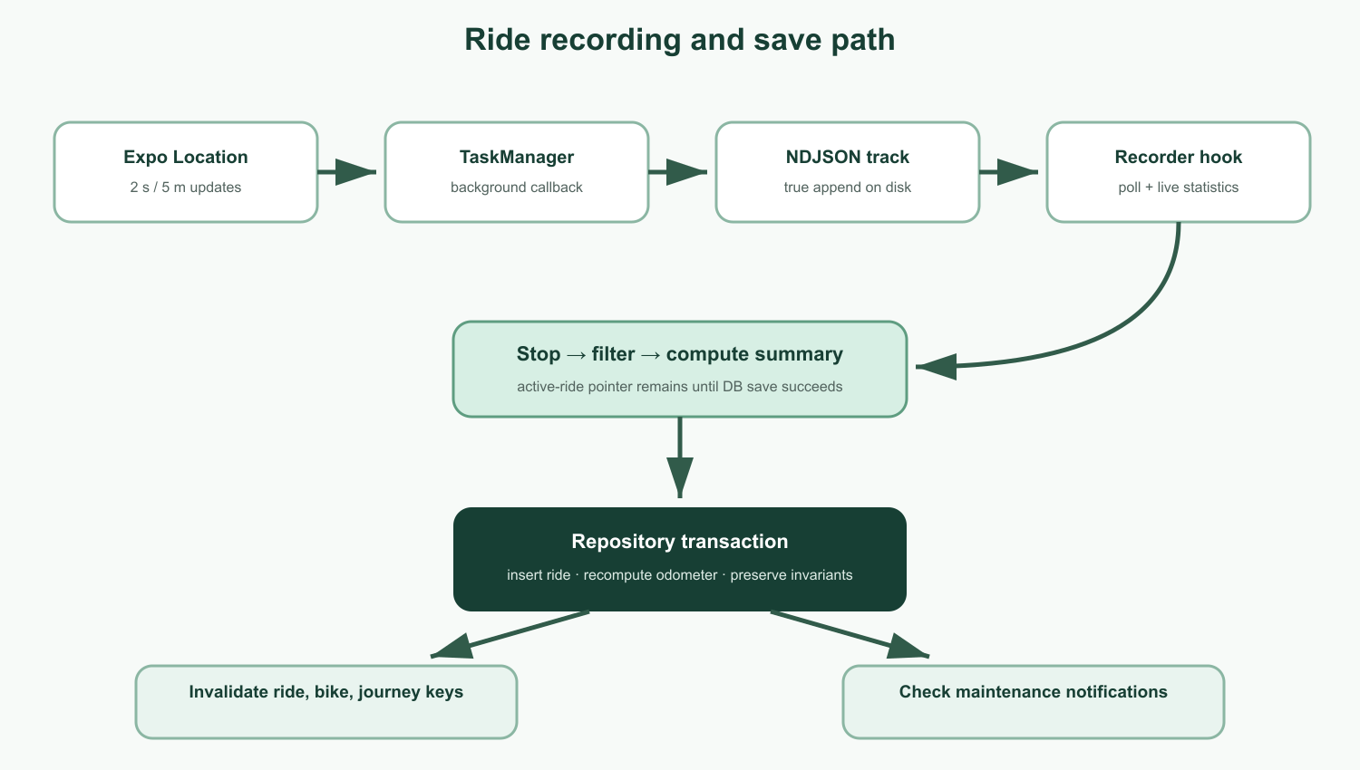
Figure 2. Background capture, safe save and downstream effects.

Capture and recovery
- startRideRecordingAsync creates a unique NDJSON track and writes active-ride.json as a recovery pointer.
- Expo Location starts the named TaskManager task using high accuracy, a 2-second interval and a 5-metre distance interval.
- The background task appends newline-delimited points without reading and rewriting the existing file.
- A truncated final line is ignored on read, limiting kill-related damage to at most the final batch.
- useRideRecorder polls the track, applies GPS filters, derives live stats and rehydrates an active ride after relaunch.

Pause semantics
- Manual pause stops location updates to save battery.
- Auto-pause leaves updates running so new movement can trigger auto-resume.

Safe completion
Stopping location updates does not immediately clear active-ride.json. The pointer is removed only after the ride row is safely persisted; failed saves can therefore be retried without losing the recording.

6. Domain logic, queries and side effects

Pure domain modules
- gps-filter.ts — accuracy and jump filtering, haversine distance, moving statistics and auto-pause rules.
- recording.ts — recording state and reducer transitions.
- odometer.ts and stats.ts — recomputation and ride/bike aggregates.
- wear.ts and maintenance.ts — component lifetime and Due Soon / Overdue decisions.
- units.ts and journey.ts — formatting conversions and whole-garage journey calculations.

Query layer
Hooks call repository interfaces and use the centralized keys in src/features/queryKeys.ts. Detail queries with optional IDs are guarded by enabled: Boolean(id). Mutations invalidate only the affected list/detail keys, plus journey aggregates when rides, bike purchase data or maintenance cost changes.

Cross-cutting effects
Post-mutation effects belong in hook callbacks, not screens. After odometer-changing operations, the hook compares old and new maintenance states and asks the notification service to show a local alert only when a rule becomes more urgent.

Error handling
The root QueryClient owns a global mutation error alert. A mutation with custom failure/retry UX opts out through meta: { suppressErrorAlert: true }, as used by the ride-save flow.

7. How to add or change a feature

Required construction order
1. Domain types and pure logic + edge-case unit tests
2. Schema change, generated migration and repository behavior
3. TanStack Query hooks and exact invalidation
4. Feature screen using shared components, theme and translations
5. Logic-free Expo Router route stub

Before creating files
- Read the matching template under .claude/patterns/ and then inspect neighboring code as the final authority.
- Use src/domain/types.ts as the source of truth for domain types.
- Generate migrations with npx drizzle-kit generate; do not hand-edit metadata unless repairing a verified generator problem.
- Add every user-facing string to both src/i18n/en.json and src/i18n/sv.json.

Verification before handoff
npm run typecheck
npm run lint
npm test -- --watchAll=false
- Review the diff for unrelated changes, secrets, missing translations and missing migrations.
- Check that domain purity and screen/repository boundaries still hold.
- Do not claim emulator, background-location, notification or visual verification unless it was actually performed.

Development client
Background location requires the EAS development client, not Expo Go. Start Metro with npm start -- --dev-client --host lan and follow docs/DEVELOPMENT.md for Android installation, emulator connectivity and JAVA_HOME troubleshooting.

8. Core invariants and debugging map

Invariants that must never regress
- Completing a ride contributes ride.distanceM to its bike’s derived odometer.
- Component wear and maintenance status are derived from raw odometer data.
- Completed GPS tracks are append-only; only notes and bike assignment may be edited.
- Rides are soft-deleted with deletedAt.
- Ride deletion or reassignment recomputes all affected odometers and maintenance outcomes transactionally.

Where to investigate
- Incorrect distance or speed: src/domain/gps-filter.ts and its tests.
- Recording loss or recovery: src/services/rideRecordingTask.ts and useRideRecorder.ts.
- Stale screen data: src/features/queryKeys.ts and mutation invalidation in the relevant hook.
- Wrong odometer or wear: ride repository transaction plus domain odometer/wear functions.
- Missing maintenance alert: maintenance status transition logic and services/notifications.ts.
- Navigation or header actions: route stub and the feature screen’s useLayoutEffect/header menu.
- Theme or translation inconsistency: theme/createStyles usage and en/sv key parity.

Product boundary
The app must retain offline bike management, recording, history and maintenance. A future backend may synchronize repository data, but it must not become a runtime dependency for these core flows.

